


Take food orders and provide table service
D1.HBS.CL5.16
Trainee Manual


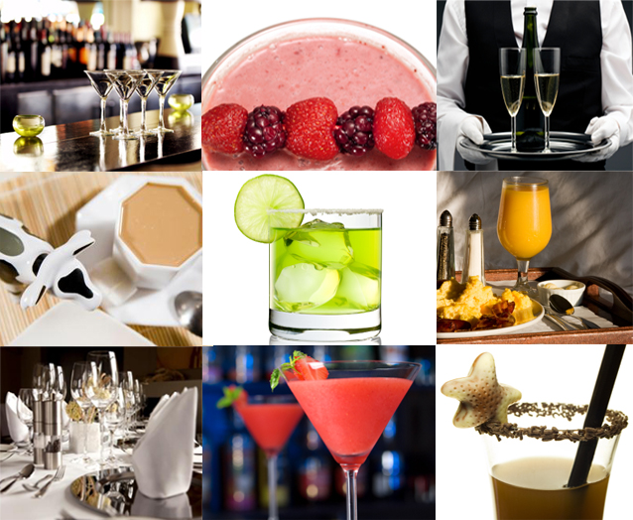



Take food orders and provide table service

D1.HBS.CL5.16

Trainee Manual





Project Base
William Angliss Institute of TAFE
555 La Trobe Street
Melbourne 3000 Victoria
Telephone: | (03) 9606 2111
Facsimile: | (03) 9670 1330
Acknowledgements
Project Director: | Wayne Crosbie
Chief Writer: | Alan Hickman
Subject Writer: | Nick Hyland
Project Manager/Editor: | Alan Maguire
DTP/Production: | Daniel Chee, Mai Vu, Kaly Quach

The Association of Southeast Asian Nations (ASEAN) was established on 8 August 1967. The Member States of the Association are Brunei Darussalam, Cambodia, Indonesia, Lao PDR, Malaysia, Myanmar, Philippines, Singapore, Thailand and Viet Nam.
The ASEAN Secretariat is based in Jakarta, Indonesia.
General Information on ASEAN appears online at the ASEAN Website: www.asean.org.
All text is produced by William Angliss Institute of TAFE for the ASEAN Project on “Toolbox Development for Front Office, Food and Beverage Services and Food Production Divisions”.
This publication is supported by the Australian Government’s aid program through the ASEAN-Australia Development Cooperation Program Phase II (AADCP II).
Copyright: Association of Southeast Asian Nations (ASEAN) 2013.
All rights reserved.
Disclaimer
Every effort has been made to ensure that this publication is free from errors or omissions. However, you should conduct your own enquiries and seek professional advice before relying on any fact, statement or matter contained in this book. The ASEAN Secretariat and William Angliss Institute of TAFE are not responsible for any injury, loss or damage as a result of material included or omitted from this course. Information in this module is current at the time of publication. Time of publication is indicated in the date stamp at the bottom of each page.
Some images appearing in this resource have been purchased from stock photography suppliers Shutterstock and iStockphoto and other third party copyright owners and as such are non-transferable and non-exclusive. Clip arts, font images and illustrations used are from the Microsoft Office Clip Art and Media Library. Some images have been provided by and are the property of William Angliss Institute.
Additional images have been sourced from Flickr and SXC and are used under Creative Commons licence: http://creativecommons.org/licenses/by/2.0/deed.en

File name: TM_Take_food_orders_&_provide_table_serv_refined





Table of contents
Introduction to trainee manual 1
Unit descriptor 3
Assessment matrix 5
Glossary 9
Element 1: Prepare food and/or food and beverage outlet for service 13
Element 2: Take and process orders 47
Element 3: Prepare and pack take away food and beverages 67
Element 4: Provide table service 79
Element 5: Store and handle foods safely 101
Element 6: Handle payment and carry out cash control procedures 115
Element 7: Close down food service area 133
Presentation of written work 145
Recommended reading 147
Trainee evaluation sheet 149
Trainee self-assessment checklist 151

Introduction to trainee manual

To the Trainee
Congratulations on joining this course. This Trainee Manual is one part of a ‘toolbox’ which is a resource provided to trainees, trainers and assessors to help you become competent in various areas of your work.
The ‘toolbox’ consists of three elements:
- A Trainee Manual for you to read and study at home or in class
- A Trainer Guide with Power Point slides to help your Trainer explain the content of the training material and provide class activities to help with practice
- An Assessment Manual which provides your Assessor with oral and written questions and other assessment tasks to establish whether or not you have achieved competency.
The first thing you may notice is that this training program and the information you find in the Trainee Manual seems different to the textbooks you have used previously. This is because the method of instruction and examination is different. The method used is called Competency based training (CBT) and Competency based assessment (CBA). CBT and CBA is the training and assessment system chosen by ASEAN (Association of South-East Asian Nations) to train people to work in the tourism and hospitality industry throughout all the ASEAN member states.
What is the CBT and CBA system and why has it been adopted by ASEAN?
CBT is a way of training that concentrates on what a worker can do or is required to do at work. The aim is of the training is to enable trainees to perform tasks and duties at a standard expected by employers. CBT seeks to develop the skills, knowledge and attitudes (or recognise the ones the trainee already possesses) to achieve the required competency standard. ASEAN has adopted the CBT/CBA training system as it is able to produce the type of worker that industry is looking for and this therefore increases trainees chances of obtaining employment.
CBA involves collecting evidence and making a judgement of the extent to which a worker can perform his/her duties at the required competency standard. Where a trainee can already demonstrate a degree of competency, either due to prior training or work experience, a process of ‘Recognition of Prior Learning’ (RPL) is available to trainees to recognise this. Please speak to your trainer about RPL if you think this applies to you.
What is a competency standard?
Competency standards are descriptions of the skills and knowledge required to perform a task or activity at the level of a required standard.
242 competency standards for the tourism and hospitality industries throughout the ASEAN region have been developed to cover all the knowledge, skills and attitudes required to work in the following occupational areas:
- Housekeeping
- Food Production
- Food and Beverage Service
- Front Office
- Travel Agencies
- Tour Operations.
All of these competency standards are available for you to look at. In fact you will find a summary of each one at the beginning of each Trainee Manual under the heading ‘Unit Descriptor’. The unit descriptor describes the content of the unit you will be studying in the Trainee Manual and provides a table of contents which are divided up into ‘Elements’ and ‘Performance Criteria”. An element is a description of one aspect of what has to be achieved in the workplace. The ‘Performance Criteria’ below each element details the level of performance that needs to be demonstrated to be declared competent.
There are other components of the competency standard:
- Unit Title: statement about what is to be done in the workplace
- Unit Number: unique number identifying the particular competency
- Nominal hours: number of classroom or practical hours usually needed to complete the competency. We call them ‘nominal’ hours because they can vary e.g. sometimes it will take an individual less time to complete a unit of competency because he/she has prior knowledge or work experience in that area.
The final heading you will see before you start reading the Trainee Manual is the ‘Assessment Matrix’. Competency based assessment requires trainees to be assessed in at least 2 – 3 different ways, one of which must be practical. This section outlines three ways assessment can be carried out and includes work projects, written questions and oral questions. The matrix is designed to show you which performance criteria will be assessed and how they will be assessed. Your trainer and/or assessor may also use other assessment methods including ‘Observation Checklist’ and ‘Third Party Statement’. An observation checklist is a way of recording how you perform at work and a third party statement is a statement by a supervisor or employer about the degree of competence they believe you have achieved. This can be based on observing your workplace performance, inspecting your work or gaining feedback from fellow workers.
Your trainer and/or assessor may use other methods to assess you such as:
- Journals
- Oral presentations
- Role plays
- Log books
- Group projects
- Practical demonstrations.
Remember your trainer is there to help you succeed and become competent. Please feel free to ask him or her for more explanation of what you have just read and of what is expected from you and best wishes for your future studies and future career in tourism and hospitality.

Unit descriptor
Take food orders and provide table service
This unit deals with the skills and knowledge required to Take food orders and provide table service in a range of settings within the hotel and travel industries workplace context.
Unit Code:
D1.HBS.CL5.16
Nominal Hours:
80

Element 1: Prepare food and/or food and beverage outlet for service
Performance Criteria
1.1 Check food service area and customer facilities for cleanliness prior to service, in accordance with enterprise procedures, and where required, take corrective action/s
1.2 Check and prepare equipment for service
1.3 Check cleanliness and condition of tables and all table items, prior to service and take necessary corrective action

Element 2: Take and process orders
Performance Criteria
2.1 Provide a helpful and attentive approach to customers
2.2 Take and record orders accurately and legibly
2.3 Convey orders promptly to the kitchen and/or bar
2.4 Give customers advice on product selections, if required

Element 3: Prepare and pack take away food and beverages
Performance Criteria
3.1 Present and pack food and beverage items in accordance with enterprise procedures and relevant health regulations
3.2 Apply safe food handling practices in accordance with enterprise procedures and relevant health regulations
3.3 Dispose of spoiled products in accordance with enterprise procedures and relevant health regulations
3.4 Comply with correct food handling and food safety procedures

Element 4: Provide table service
Performance Criteria
4.1 Receive customer orders
4.2 Check product and/or brand preferences with customer in a courteous manner
4.3 Provide clear and helpful recommendations or information to customers on selection of food or drinks, if required
4.4 Serve food and drink according to enterprise requirements and personal hygiene standards

Element 5: Store and handle foods safely
Performance Criteria
5.1 Comply with personal hygiene standards
5.2 Handle food according to food safety program
5.3 Maintain the workplace in a clean and tidy order
5.4 Comply with workplace measures to prevent pests entering the premises
5.5 Identify and report indicators of pest presence

Element 6: Handle payment and carry out cash control procedures
Performance Criteria
6.1 Receive and accurately check cash float
6.2 Open and close cash register using manufacturer specifications
6.3 Use cash register according to standard enterprise procedures
6.4 Issue receipts according to standard enterprise procedures
6.5 Carry out reconciliation of takings accurately and report errors to supervisor

Element 7: Close down food service area
Performance Criteria
7.1 Store and/or prepare equipment for the next service, in accordance with enterprise procedures
7.2 Clear, clean or dismantle area in accordance with enterprise procedures and safety requirements
7.3 Set up area correctly for the next service, in accordance with enterprise procedures and requirements
7.4 Review and evaluate services with colleagues, where appropriate, identifying possible improvements
7.5 Provide handover to incoming colleagues and share any relevant information

Assessment matrix
Showing mapping of Performance Criteria against Work Projects, Written Questions and Oral Questions
The Assessment Matrix indicates three of the most common assessment activities your Assessor may use to assess your understanding of the content of this manual and your performance - Work Projects, Written Questions and Oral Questions. It also indicates where you can find the subject content related to these assessment activities in the Trainee Manual (i.e. under which element or performance criteria). As explained in the Introduction, however, the assessors are free to choose which assessment activities are most suitable to best capture evidence of competency as they deem appropriate for individual students.
 |  |  |  | Work Projects |  | Written Questions |  | Oral Questions
Element 1: Prepare food and/or food and beverage outlet for service
1.1 |  | Check food service area and customer facilities for cleanliness prior to service, in accordance with enterprise procedures, and where required, take corrective action/s |  | 1.1 |  | 1 |  | 1
1.2 |  | Check and prepare equipment for service |  | 1.2 |  | 2 |  | 2
1.3 |  | Check cleanliness and condition of tables and all table items, prior to service and take necessary corrective action |  | 1.3 |  | 3 |  | 3
Element 2: Take and process orders
2.1 |  | Provide a helpful and attentive approach to customers |  | 2.1 |  | 4 |  | 4
2.2 |  | Take and record orders accurately and legibly |  | 2.2 |  | 5 |  | 5
2.3 |  | Convey orders promptly to the kitchen and/or bar |  | 2.3 |  | 6 |  | 6
2.4 |  | Give customers advice on product selections, if required |  | 2.4 |  | 7 |  | 7
Element 3: Prepare and pack take away food and beverages
3.1 |  | Present and pack food and beverage items in accordance with enterprise procedures and relevant health regulations |  | 3.1 |  | 8 |  | 8
3.2 |  | Apply safe food handling practices in accordance with enterprise procedures and relevant health regulations |  | 3.2 |  | 9 |  | 9
3.3 |  | Dispose of spoiled products in accordance with enterprise procedures and relevant health regulations |  | 3.3 |  | 10 |  | 10
3.4 |  | Comply with correct food handling and food safety procedures |  | 3.4 |  | 11 |  | 11
Element 4: Provide table service
4.1 |  | Receive customer orders | 4.1 |  | 12 |  | 12
4.2 |  | Check product and/or brand preferences with customer in a courteous manner | 4.2 |  | 13 |  | 13
4.3 |  | Provide clear and helpful recommendations or information to customers on selection of food or drinks, if required | 4.3 |  | 14 |  | 14
4.4 |  | Serve food and drink according to enterprise requirements and personal hygiene standards | 4.4 |  | 15 |  | 15
Element 5: Store and handle foods safely
5.1 | Comply with personal hygiene standards |  | 5.1 |  | 16 |  | 16
5.2 | Handle food according to food safety program |  | 5.2 |  | 17 |  | 17
5.3 | Maintain the workplace in a clean and tidy order |  | 5.3 |  | 18 |  | 18
5.4 | Comply with workplace measures to prevent pests entering the premises |  | 5.4 |  | 19 |  | 19
5.5 | Identify and report indicators of pest presence |  | 5.5 |  | 20 |  | 20
Element 6: Handle payment and carry out cash control procedures
6.1 |  | Receive and accurately check cash float | 6.1 |  | 21 |  | 21
6.2 |  | Open and close cash register using manufacturer specifications | 6.2 |  | 22 |  | 22
6.3 |  | Use cash register according to standard enterprise procedures | 6.3 |  | 23 |  | 23
6.4 |  | Issue receipts according to standard enterprise procedures | 6.4 |  | 24 |  | 24
6.5 |  | Carry out reconciliation of takings accurately and report errors to supervisor | 6.5 |  | 25 |  | 25
Element 7: Close down food service area
7.1 | Store and/or prepare equipment for the next service, in accordance with enterprise procedures |  | 7.1 |  | 26 |  | 26
7.2 | Clear, clean or dismantle area in accordance with enterprise procedures and safety requirements |  | 7.2 |  | 27 |  | 27
7.3 | Set up area correctly for the next service, in accordance with enterprise procedures and requirements |  | 7.3 |  | 28 |  | 28
7.4 | Review and evaluate services with colleagues, where appropriate, identifying possible improvements |  | 7.4 |  | 29 |  | 29
7.5 | Provide handover to incoming colleagues and share any relevant information |  | 7.5 |  | 30 |  | 30

Glossary
Term | Explanation
Account | A folio or file in which transactions can be recorded
‘Accoutrements’ | Items used to fit out the tables. Also referred to as centre pieces
A la carte | It is the term used for a menu that has individually priced dishes. A la carte means ‘from the card/menu’
A la carte setting | Basic table setting for an individual cover
Anticipate | To realize beforehand; foretaste or foresee
Balancing | The process undertaken at the end of a shift to determine if actual takings balance or match recorded takings
Bain Marie | A large pan that is filled with hot water and has a heat source: smaller pans can be set in the larger pan to keep food warm or cook food slowly
Briefing | A meeting to discuss an upcoming shift
Cash Float | A specific amount of money, made up of various amounts, used for cashiers to give change
Centrepiece | A large central object which serves a decorative purpose
Charge | A transaction resulting from the sale or use of a product or service
Checklist | List used to identify complete list of activities to be performed
Contamination | Spoilage of safe food: food must be thrown out
Cover | A place setting for a guest OR word used to describe the number of guests
Crockery | A term used to identify plates, cups, saucers and bowls normally made from china
Cruet | French term for salt and pepper shakers or an oil and vinegar set
Customer | A person who purchases goods or services from another; buyer, patron
Cutlery | A term used to identify knives, forks, spoons, teaspoons and service utensils made from stainless steel.
Dining environment | The dining area
EFTPOS | Electronic Funds Transfer at Point of Sale. An electronic method of payment using a credit or debit card
Financial transaction | The monetary dealings between the customer and the establishment
Gueridon trolley | A movable service or trolley from which food be carved, filtered, flambéed or prepared and served
Handover | A period of time in which different shifts will have time to exchange information that will benefit and ensure the smooth continuation of the department.
Hot box | A container used to keep plates warn prior to serve
House account | An account established for a person or company who is not accommodated in a guest room
Maitre d’/Maître d'hôtel | A dining room attendant who is in charge of the waiters and the seating of customers
Mill | Used to grind salt and pepper; a grinding mill grinds solid materials so they are smaller
Mise en place | French term meaning ‘put in its place’- the preparation of items and areas before service
Opening procedure | The tasks, responsibilities or step by step instruction to be performed before the start of service
POS terminals | Point of Sale terminals or cash registers
Post mix | A drink dispensing system for simultaneous dispensing of syrup and water/soda in a single valve chamber to produce a flavored drink
Smorgasbord | An assortment of foods served as a buffet meal
Table d'hôte | A French term meaning ‘host's table’
Table side service | Service that takes place near a customer table
Tableware | Items that are placed on a customer table including cutlery, crockery and glassware
Temperature Danger Zone | Is between 5˚C and 60˚C and is the temperature at which bacteria can grow most rapidly to dangerous levels in food
Tent cards | Cards used for the display of information or advertising folded in a triangular fashion to stand freely on a table
Variance | The difference between the actual takings (total of payments) against recorded payments
Work station | An area where a person works or where items needed for the completion of tasks are kept or stored
X reading | A reading/report on all the financial transactions processed through the cash register during the shift or day
Y reading | A final report on all the financial transactions that have been processed through the register during the shift or day, and this reading also clears the register’s memory of those transactions, leaving the register ready for the next day’s or shift’s transactions.

Element 1:
Prepare food and/or food and beverage outlet for service

1.1 Check food service area and customer facilities for cleanliness prior to service, in accordance with enterprise procedures, and where required, take corrective action/s

Introduction
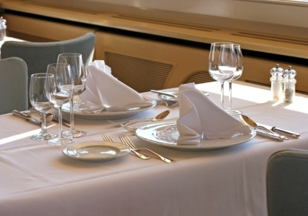
Staff working in a food and beverage facility will be responsible for checking the food and beverage area prior to opening/service to ensure its cleanliness and, where required, to take corrective action.
In most establishments, employees are rostered on a minimum of half an hour depending on bookings and the size of the facility before a shift starts, to prepare a restaurant/dining area for service.
The preparation of a restaurant is vital for the efficient and successful running of any meal shift. Things need to be checked, stocked, positioned and cleaned before a restaurant opens to the public, and if a restaurant is unprepared, service may be slow, inefficient and seen as unprofessional by the customer, who then may decide not to return.
You need to be ready for service when the doors open – otherwise you always seem to be playing catch-up, and never get on top of what needs to be done.

The range and variety of food and beverage outlets
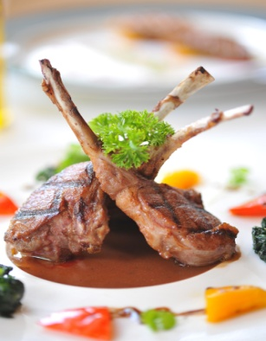
The industry boasts a wide variety of food and beverage outlets.
The notes provided in this manual are intended as a guide to what is generally applicable. However you are advised to identify what specifically applies at your workplace and comply with those requirements where they differ from what is provided in these notes.
In many instances the preferred methods, techniques and protocols will reflect the nature and style of the establishment and the atmosphere, image and environment it wishes to create.
For example, one establishment may aim for a casual dining environment while another aims for a more formal approach.
Neither is right or wrong – they are simply different and it is your responsibility to provide the style of service appropriate for the venue where you work.
If unsure about what applies where you work, speak to your supervisor.

Cleaning and checking the restaurant area
All areas need to be checked for cleanliness or cleaned prior to service.
Most establishments employ cleaners to do the bulk of the cleaning during the hours the area is closed. However, throughout the day, certain areas must be monitored for their ongoing cleanliness and any problem areas must be rectified promptly. These problems cannot wait until the daily major cleaning service.
These procedures follow any establishment schedule. They cover a wide diversity of tasks and equipment. The size of the venue, the number of staff, the number of covers, layout, service style and opening hours will all impact on the cleaning and checking that are required.
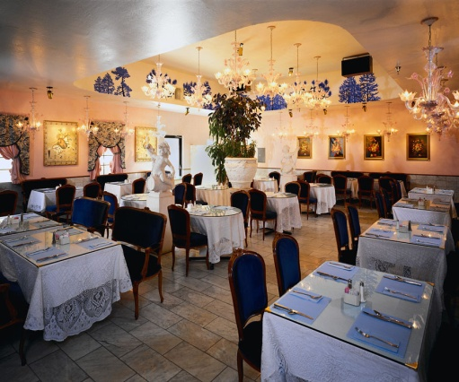
Areas to check for cleanliness may include:
- Furniture – tables and chairs
- Wall hangings – pictures or displays
- Fixtures – light fittings and door knobs
- Plants – indoor plants and pots
- Glass – windows, panels and doors
- Floor – carpet and tiled areas
- Work stations – waiter’s sideboard
- Toilets – rest areas
- Operating equipment such as coffee machine, carving trolley, toaster, bar chiller, bar blender etc..

Checking and cleaning customer facilities
Facilities can say a lot about the hygiene levels and standards of an establishment.
Customers dislike visiting facilities in a venue that are messy or unclean, and often infer things about other areas of the property based on what they find in these public areas.
It is therefore very important to keep these areas clean. Waiting staff cannot afford to adopt a view that says ‘these are not my areas – it’s not up to me’.
They are – and it is!
Customer facilities may include the waiting area, the toilets, non-smoking areas and external areas.

Waiting area
This area is used to seat customers who may be waiting for a table, or waiting for other guests to arrive.
Waiting areas usually have seating, offer written material for customers to read, and have some of view to keep customers engaged while they are waiting.
Waiting areas may also have a cloakroom to store customers’ property. It is vital for cloakrooms to be clean and well-maintained in order to reduce the risk of damaging customers’ property, and to create an initial impression of care and attention to detail throughout the entire property.
Waiting areas are usually near the front entrance, and are often the first area a customer enters. This first impression of the establishment is very important so cleanliness and tidiness is essential.
In addition, staff who work here must realise that their dress, actions and demeanour are likewise critical: they must also realise that customers will see them before they talk to them, and are forming an opinion of the establishment long before the first word is said.

Toilets
The restroom area must be kept clean at all times and well-stocked with the necessary items.
Depending on the number of patrons, some restroom areas can get quite messy during service.
A Cleaning Schedule and Checklist for the individual facility should be prepared and used to guide inspections of toilets.
The following areas in a restroom must be checked for cleanliness and stocked before service and regularly throughout a shift. Checks should include:
- Benches – making sure they are free from water, soap scum, tissues and glassware
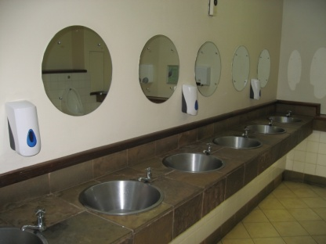
- Toilet cubicles – checking they are stocked with toilet paper; the toilet bowl and seat must be clean
- Urinal – checking they are clean and in good working order and deodorant blocks supplied where appropriate
- Hand towel dispenser – making sure it is stocked with woven paper towels
- Hand dryer – verifying it is clean and in good working order
- Soap and sanitiser – checking to ensure sufficient supply
- Waste paper basket – emptying it as required and ensuring it is not overflowing, and is fitted with a bin liner that is in good order
- Floor – making sure it is clean and free from rubbish and liquid spillage
- Making sure the area has a clean and hygienic smell.
Unfortunately, some customers visiting hospitality establishments could be ill, and if someone has been ill in a toilet or restroom, then the problem must be addressed immediately. Even though it’s a dirty job, you’ve got to fix it. You must not just ignore it.
If you can’t do it, get a cleaner on to it immediately.
When these checks and cleaning duties are being performed, it is also necessary for you to keep an eye peeled for any pieces of furniture, or other items that require repair or which may pose a danger. These should be reported to the appropriate person (supervisor or the maintenance department), and removed from service where warranted.
Work within guidelines for Occupational Safety and Health (OSH) regarding cleaning toilet areas, such as wearing disposable gloves, taking all necessary measures to protect yourself against injury when dealing with chemicals, being alert to the possibility that needles may have been disposed of in the toilet cubicles or in the waste bins.

Smoking areas
The main cleaning of this area should have been done by the cleaning staff but your role may include:
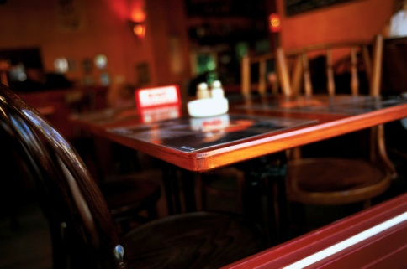
- Checking that the cleaning of this area has been done – and arranging for supplementary cleaning where required
- Doing spot cleaning of areas and items that require it – the cleaners may not always clean this area to the standard you want, or which is required
- Placing ashtrays in the area – on tables, on the floor
- Placing advertising material in the area – to promote the food and beverages available, and to promote upcoming events, special occasions etc.
- Watering plants in the area.
Again a Cleaning Schedule and Checklist for the individual smoking area should be prepared and used to guide inspections.

External areas
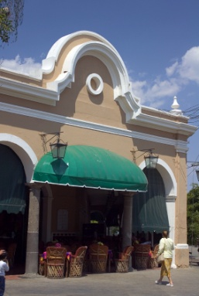
External areas are areas outside the premises and can include footpaths, gardens and car parks.
These areas are often forgotten by staff who normally work inside the premises, but they are very important because these areas are the ones that customers see before they enter the food and beverage area. Once again, they start forming impressions about the food and beverages and the service they will receive based on these factors.
Duties regarding these areas are usually limited to the basics such as:
- Sweeping or hosing an area
- Picking up rubbish
- Collecting any glasses etc. that guests may have taken outside.

Prepare and adjust the environment to ensure comfort and ambience for customers, as appropriate
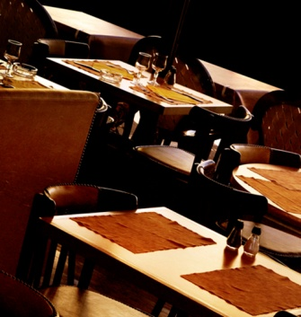
The ambience and comfort level of a restaurant must be taken into consideration when preparing for service.
It should also be continuously monitored during service to ensure it is inline with policy and requirements. Most venues will have set requirements in relation to:
- The temperature settings on the climate control/air conditioning systems
- The lights that have to be turned on or off
- The level at which sound systems operate.

Comfort and ambience
Some of the factors in achieving a high level of customer comfort and creating the required ambience include:
- Restaurant temperature set at a comfortable level taking into account the outside temperatures. Some properties set a constant level year round. An accepted temperature range for dining areas is 20ºC - 26ºC, while other properties will make the room cooler during summer and warmer during winter.
- Generally speaking, the temperature level should be a ‘set and forget’ issue. If the temperature has to be altered, permission to do so may be required from management before adjustments are made.
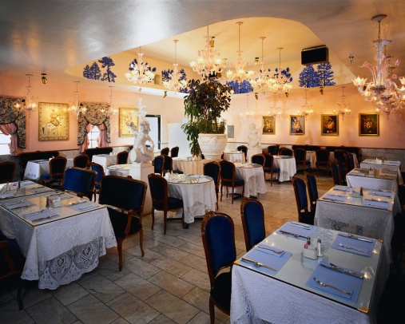
- Lighting adjusted according to the time of day and the establishment style. Lighting is a main way in which ambience is created and the combination of up lights and down lights, the use of dimmer and coloured lights all combine to produce a required setting.
Checks must be made to ensure:
- No blown bulbs
- No flickering fluorescents
- Dimmers are set at the correct setting
- Lights are on or off as required
- A fresh smell. Sometimes it may be necessary to turn on the air conditioning for a short time to clear away stale air and smoke. In some cases the property may use a commercial product to remove bad smells. In some venues, a fresh smell may be achieved by simply opening windows and doors but care needs to be taken to protect against flies and other insects coming in!
- Music organised as appropriate. The type of music played must be in accordance with establishment policies, themes, special events and preferences. For example, Irish music on St Patrick’s Day is appropriate
- Volume of the music should be set at a relatively low level at the start of a session and be adjusted upwards as patron noise and cutlery and crockery noise grows during service. The music should aim to:
- Provide a background to the dining experience
- Mask conversations of other patrons
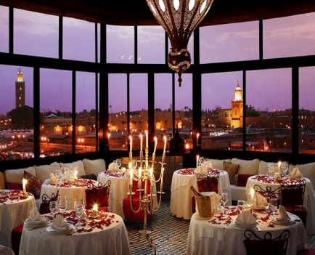
- Create atmosphere.
In some establishments, quick-tempo music is played to encourage guests to eat quicker thereby increasing the possibility of selling a table more than once per session. In other venues, the music is deliberately chosen to provide a more relaxed and slower-paced environment.
There is no room in venues for you to bring in your favourite CDs and use them as the standard music for the dining room!
Table decorations and floor displays
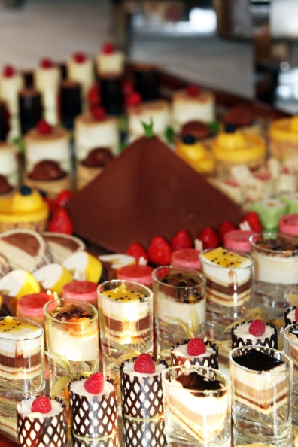
Decorations help create the atmosphere for the room and may be themed to reflect the name of the venue/room, or to reflect the interests of the customers who eat and drink
Floor displays are used to motivate customers to buy products (food and beverage items such as wines, cocktails or a nominated menu item), or to promote another part of the venue or to promote an upcoming special event in the dining area or bar (such as Mother’s Day, a Seafood Night or Valentine’s Day).

Adjusting the environment during trade
Customers sometimes show signs that they are not comfortable in their surroundings. You need to be aware of the body language being sent by customers. Careful observation will let you know if people are too cold, too hot, or if the music is too loud, or the lights too low.
It is a fact of life in dining areas and restaurants that getting the air conditioning or music 100% right for everyone is very difficult, if not impossible.
For someone sitting under an air conditioner outlet the temperature can be too cold, while for someone sitting only a couple of metres away, it can be perfect.
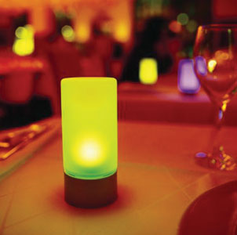
A party of young people may want the music turned up or another style of music played , while an older group may want the music turned down.
Always check with a supervisor before adjusting temperature or music. Some properties will require the set levels to be adhered to at all times, while other rooms may be prepared to alter settings where those requesting the changes are (for example) regular customers or represent the majority of people in the room.

Set up any furniture according to enterprise requirements, customer requests and customer and staff convenience and safety
Another major task in preparing a food and beverage service area for service is to set up the furniture in the room.
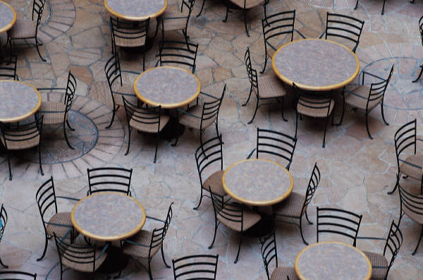
‘Furniture’ primarily refers to tables and chairs.
The room may be set up:
- In a standard fashion – where it is set exactly the same for each session regardless of bookings, day of the week, time of the day
- To reflect the identified service session needs.

Floor plan
A floor plan is a map of how the tables are to be positioned in a dining area or restaurant.
A new floor plan is created in many establishments for each and every service session. While these floor plans may all be similar, there will sometimes be subtle variations, and at other times big differences between them.
Much of what we do in the hospitality industry is based on intelligent and adequate planning: a floor plan is one aspect of that planning.
A floor plan sets out:
- Where the tables will be physically positioned
- The number of covers on each table
- The table numbers
- Which waiters will serve which tables.
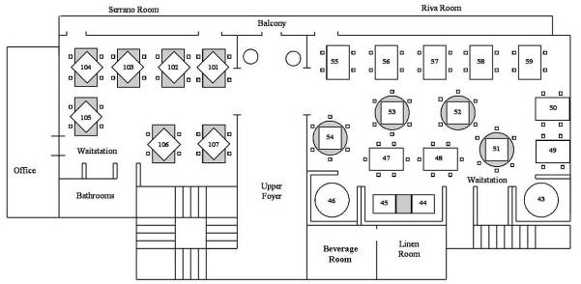
Table arrangement and placement can vary according to the type and style of menu being served, and each floor plan must take a number of points into consideration to ensure customer convenience and safety.
These points may include:
Reservations
- Number of guests – including type of guests. For example, a baby may require a high chair
- Name of guests/party
- Also, the size of some bookings can indicate where their table has to be placed simply because it won’t fit in certain locations
- Customer’s arrival time
- Special requests – such as the guest requesting a specific table number, a table that has a view of the lake, one that isn’t near the entrance door or is close to the dance floor
- Needs of guests, for example, wheelchair access, need for privacy
- Contact details/number for guest or party.
Shape and design of the room
This involves taking into account the structure of the room in relation to issues such as:
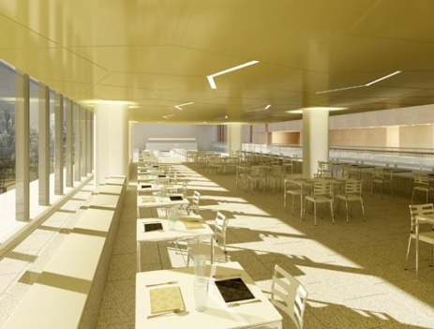
- Tiered floors – split level dining areas are notoriously difficult to prepare a table plan for as they tend to waste a lot of space
- Location and size of dance floors
- Location of windows
- Number and size of entertainment areas
- Required thoroughfares to allow both guest access to tables, toilets etc. and to allow staff sufficient room to move around the floor and service the tables
- The amount of room required for staff movement must reflect the style of service being offered. For example, more room is needed between tables if gueridon trolleys are going to be used as part of the service.
Most floor plans will allow several primary service routes for waiting staff to take on the floor so that all the tables can be serviced
- Location and number of booths or alcoves that exist in the room – if applicable.
Immovable objects
Within most rooms there will be various objects that cannot be moved and there is therefore a need to plan around them. They include:
- Waiter’s stations
- Pillars
- Staircases
- Display cases.
Style of furniture
These will also influence the layout of the floor plan. Factors involved are:
- Shape of tables –– round, square, half-moon, quarter-circle
- Size of tables – two-person, or four-person
- Type of chair used at the tables.
Exits and doors
The location of doors and whether or not they open inwards or outwards must be taken into account in relation to:
- Service doors – to and from the kitchen, bar
- Fire exits
- Restroom doors
- Main entrance to the room.
It is standard practice to try to seat guests away from doors wherever possible as these areas are likely to be high-traffic areas that can detract from the guest’s enjoyment of their dining experience.
Further considerations
Further points that may need to be factored in include:
- Leaving space for guests to move in and out from their table with safety and without having to ask others to stand up
- Providing customers with enough space around the table to grant a level of privacy. Placing tables ‘too close’ to others is to be avoided
- Avoiding placing tables in draughty areas, directly under speakers or air conditioning, or too close to waiter’s stations
- Making provision for hats and coats, where applicable.

Customer and service personnel access
All rooms must be checked prior to service to ensure there is adequate access for both customers and service staff.
A room that is overcrowded has the potential to reduce customer satisfaction. This may be due to being too close to others; service levels are reduced because of the difficulty staff might have in getting to tables.
It can also present a potential danger if there is a need to evacuate the room for any reason.
Access routes into the room and between tables must ensure:
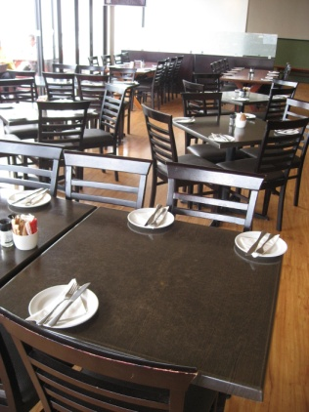
- The ability of all patrons to move freely to and from their tables
- Room for staff to service individual tables – that is, to move freely and easily around individual tables
- Room for staff to wheel service trolleys around the room and to individual tables
- Ease of access to facilities in the room such as toilets, viewing areas and service points such as bars, food pick-up points and dance floor
- Waiting staff can have freedom of movement around their waiting stations.

Display food and beverage items according to enterprise and legislative requirements
Not all food and beverage outlets display their items but many do, especially where they believe they can use the concept of ‘selling by seeing’ to assist and increase sales.
Where food items are displayed for service, they must be handled in such a way that complies with internal requirements and externally imposed legal obligations.

What’s involved?
Both food and beverage items may be displayed in a service room.
Commonly, wines will be displayed so that customers can browse at what is available before they make their selection. These wines may be displayed in bins, on shelves or feature as the centrepiece of a special display.
Other beverages may simply be ‘on display’ almost by default by virtue of where they are stored, such as on shelves behind the bar, or in glass-fronted refrigeration units that are visible to customers.
Food items may be displayed in bain maries or salad counter as follows:
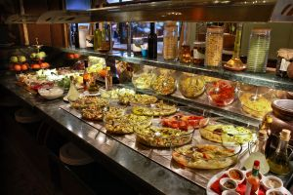
- As raw food – for example, pre-cut steaks, whole fish or fish fillets, raw hamburgers, boutique sausages and other cuts of meat such as chops, cutlets, loins, rashers etc.
- As cooked, ready-to-eat food in premises that want to offer a fast-food service of either cold or hot food
- As foods available to supplement main courses such as salad vegetables, pre-made salads, hot and cold sauces, gravies, hot vegetables, soups and hot and cold desserts.
It is important to note that cold food must be kept at 5ºC or below whilst hot food must be kept at 60ºC or above.
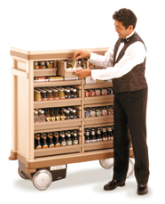
Foods and beverage items may also be displayed via trolleys on the dining floor. These trolleys may be used to present, promote or provide the basis of service for:
- Hors d’oeuvres
- Roasts
- Desserts
- Pre-dinner drinks
- After dinner drinks.

Enterprise requirements
House requirements in relation to the display of food can address issues such as:
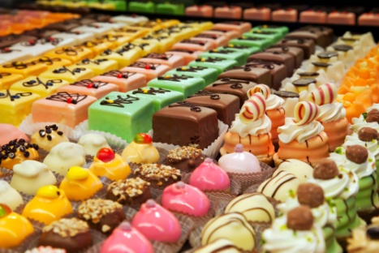
- Location of items – covering the sequencing of items in displays and the location of food display units. Some properties elect to maintain a standard layout where items never change their location within the display, and other venues deliberately choose to alter the location of items on a regular basis to introduce ‘something new’ to the display and possibly encourage customers to see, and therefore try or buy something they haven’t seen or noticed before
- Amount of food etc displayed – limiting the quantities to be displayed
- Restocking of items – providing guidelines regarding the stage at which displays are to be replenished
- Need to comply with legal requirements – see below
- Placement of items within nominated locations. A common requirement, for example, with pre-made food items is to only load the display tray half-full but to ensure that the half-full part of the tray is the section that faces the front of the display
- Appearance of individual items. There are usually requirements that all items on display must be attractive and of saleable quality etc. Any item that is sub-standard in this regard, even though it may otherwise be perfectly fit to eat, must be removed from the display and/or thrown out.

1.2 Check and prepare equipment for service

Introduction
Various pieces of equipment need to be used during the service of a meal shift, and all these should be checked for cleanliness and correct operating efficiency before service sessions commence.
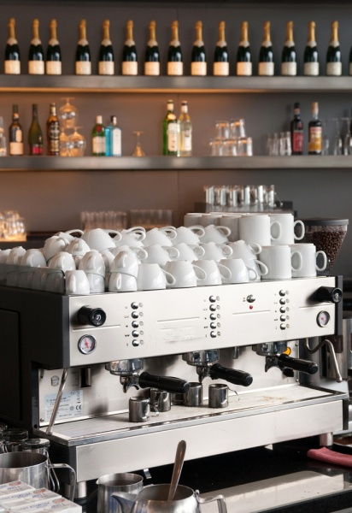
All equipment must be cleaned and used in accordance with the manufacturer’s instructions. Failure to clean or use this equipment as per manufacturer’s instructions can result in expensive damage being done to these items.
Items that are unclean, unsafe or not operating properly should be removed from service.

Coffee machines
The coffee machines should be switched on at least half an hour before service to enable the element to heat up and achieve the required temperature.
The coffee machine should be checked for cleanliness and all required pieces must be in place and fully operational. As mentioned above, the coffee machine must be cleaned and operated in accordance with the manufacturer’s instructions.
Before service, the equipment and ingredients to make coffee should be checked to ensure they are clean and that they are sufficient to last the length of the service session.
Cups and mugs (where appropriate) – all sizes and styles, including saucers
- Teaspoons
- Sugar bowls and sweeteners/sugar substitutes
- Milk and cream jugs – normal and low-fat milk
- Coffee – espresso, instant, decaffeinated
- Plate for after dinner chocolates or cookie biscuits, if applicable
- Napkins and doilies – where used
- Espresso-specific items – tamps, knock boxes, steaming jobs and thermometers, espresso preparation brushes, grinders, group handles and, where applicable, take-away cupping supplies.

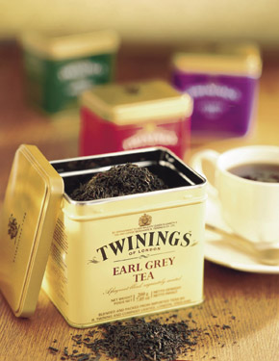
Tea making facilities
Most hospitality establishments prefer to use tea bags when making tea. However there are still a number of establishments that stay with the more traditional method of serving tea in a pot using tea leaves.
Before service, the equipment and ingredients to make tea should be checked to ensure there are sufficient items to cater for the service session.
Items may include:
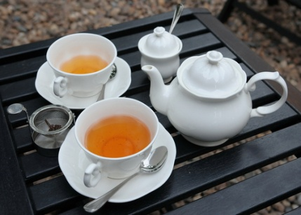
- Cups and saucers
- Teaspoons
- Urns for water
- Tea bags or tea leaves – black tea, semi-black tea, blended tea, green tea, scented tea, herbal tea
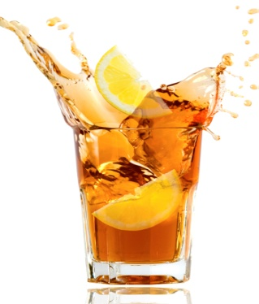
- Teapots – two and four-cup, including cosies where applicable
- Milk jugs
- Sugar bowls and sweeteners/sugar substitutes – sugar tongs
- Wedges of lemon
- Tea strainer
- Hot water jugs
- Holders or plate for used tea bags.

Bain-maries
The bain-marie is used to keep hot food at the right temperature during the service period. It must keep the hot food at 60°C or above.
It must be cleaned and operated in accordance with the manufacturer’s instructions, and as the bain-marie is often accessible to customers, or on public view, it should be cleaned with this in mind.
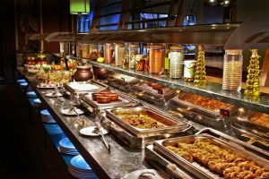
Before service, the bain-marie should be switched on so that the water covering the heating elements can achieve the required temperature. It is the hot water and rising steam that keeps the food hot.
Glass on a bain-marie should be checked for cleanliness, as should the stainless steel casing. Many customers will infer things about the food, from the condition of the bain-marie.
The bain-marie trays must also be clean and may require your attention during the shift: you may be required to cover food as the need arises, replenish it and ensure its eye appeal.

Toasters
Toasters may be used during any shift, but particularly during breakfast.
Toasters should be clean and free of crumbs. Crumbs can smoke and may even catch alight causing alarm to customers.
Before service, toasters should be checked that they are in good working order, with special attention paid to electrical cords to ensure they are not frayed or do not have any wires exposed.
Once again, they should not only be clean, but they must look clean, shiny and spotless.
Signage relating to supervision with children using toasters may also be necessary.
Tunnel toasters are usually set at the setting determined as ‘correct’ and there is usually a sign asking customers not to alter that setting.

Salt and pepper shakers
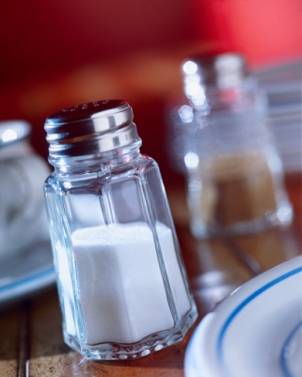
Before each shift, salt and pepper shakers must be checked to ensure they are clean and filled appropriately.
Blocked holes should be unblocked. This can be done with a toothpick.
The exterior of the shakers must be clean, and the tops free from residual salt or pepper. A few uncooked rice grains are sometimes added to salt shakers to absorb any moisture that may get into the salt.
Check the tops of the shakers are firmly in place as some customers take delight in loosening to the extent that the next person who uses them will find the top comes off and their meal is covered in salt or pepper!

Cutlery
A wide range of cutlery can be used in a food and beverage facility: the following are commonly used items:
Cutlery Chart
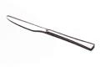 | Large Knife – Main course. | 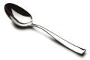 | Large Spoon. – Serving.
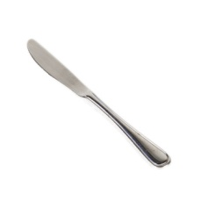 | Small Knife – Entrée course, buttering, pâté, cheese and fruit. | 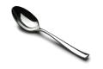 | Medium Spoon – Desserts and pasta.
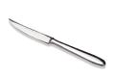 | Steak Knife – Steak. | 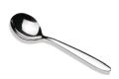 | Soup Spoon (round) – Soup.
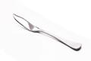 | Fish Knife – Fish (and some seafood items) and lifting delicate items. | 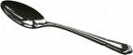 | Small Spoon (tea) – Teas, coffee, prawn cocktails, ice cream, sugar coupes and sorbets.
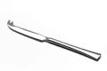 | Cheese Knife. | 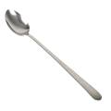 | Parfait Spoon (long handle) – Desserts and ice cream.
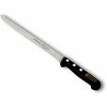 | Carving Knife – Slicing roast and cutting large items. | 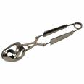 | Escargot Tongs – Snails.
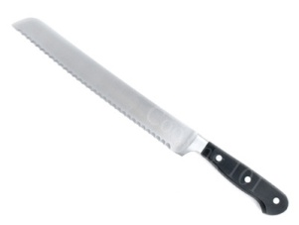 | Bread Knife – Slicing bread and rolls. | 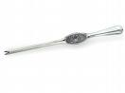 | Lobster Picks – Lobster/crayfish.
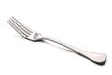 | Large Fork – Main course and serving | 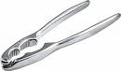 | Lobster Cracker – Lobster/crayfish/
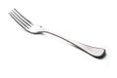 | Small Fork – Entree, pasta, salad, dessert and fruit. | 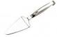 | Gateau Slice – Cakes and flans
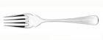 | Fish Fork – Oysters and prawn cocktails. | 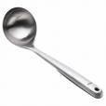 | Ladle – Soup and sauces
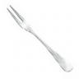 | Long Pronged Fork – Snails (Escargot).

A common procedure to polish cutlery is as follows:
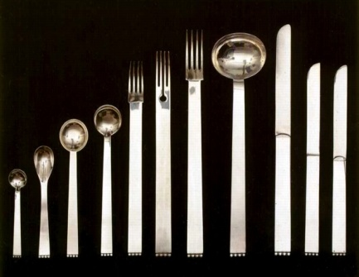
- Separate the cutlery into the different types
- Take a handful of cutlery, holding it by the handles, and dip the ends into a bucket full of hot water and lemon
- Using a clean, lint-free cloth, polish the service end of the cutlery
- Continue this procedure until all cutlery is polished
- Place the cutlery, handles up, in the service position, either on a table or at the waiter’s station. Polished cutlery should always be placed on an underplate to be taken to the table for set up
- Do not touch the top of the item that goes into the customer’s mouth.
Certain cutlery items must be cleaned and polished according to manufacturer’s instructions.

Crockery
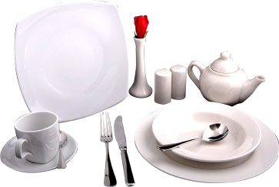
The type of crockery used by an establishment can vary depending on the menu items offered, the style of service provided and the required image the property wishes to create.
Crockery may be ‘badged’ with the name of the venue, or be unbadged.
Traditionally, crockery is white, but many colour options exist that can be used to blend with a theme.
Standard types of crockery are:
Crockery Chart
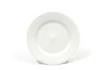 | Side Plate | 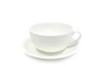 | Cappuccino Set
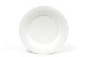 | Fruit Plate | 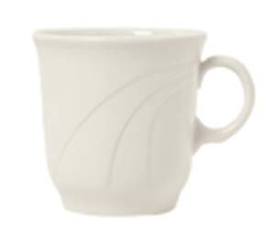 | Tall Tea Cup
 | Dessert Plate | 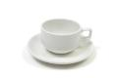 | Stackable Set
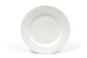 | Entrée Plate | 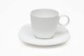 | Coffee Set
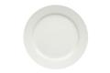 | Main Plate | 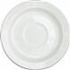 | Saucers
 | Show Plate | 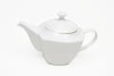 | Tea Pot
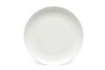 | Platter | 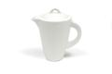 | Coffee Pot
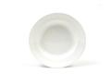 | Soup Bowl | 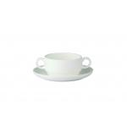 | Consommé Bowl
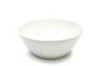 | Breakfast Bowl | 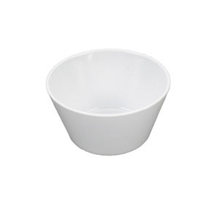 | Bouillon Cup
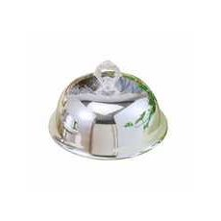 | Cloche/Dome | 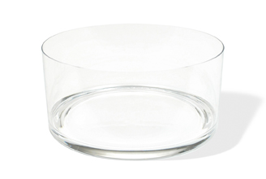 | Salad bowl
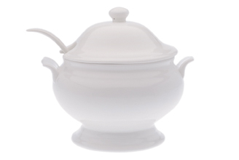 | Soup Tureen | 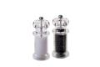 | Salt and Pepper Grinders
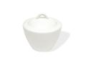 | Sugar Bowl | 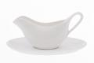 | Sauce Boat
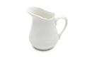 | Milk Jug | 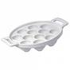 | Escargot Plate
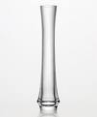 | Bud Vase | 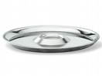 | Oyster Plate

Glassware
Usually, wine glasses and water glasses are set on tables in the room and it may be the waiter’s responsibility to do this, ensuring the glassware is clean of marks, chips, cracks and lipstick.
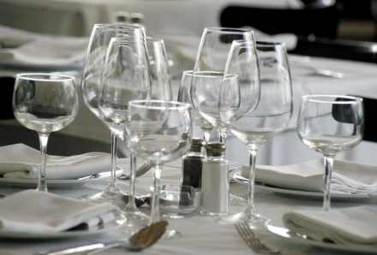
Hold up to light and check for water marks.
The restaurant glassware should be polished before going on to tables. This is achieved by placing a glass over a bucket of hot steaming water and then polishing with a lint-free cloth.
Clean glassware should always be handled by the stem to avoid finger marks and placed upright on a tray to be taken to the table for set up.
Many types of glassware exist but it is the responsibility of the bar staff to determine what is used for which drink.
Glass can be plain or decorated. Variations in glass types are available for:
- Beer glasses

- Wine glasses – still and sparkling
- All-purpose glasses – for soft drink, fruit juice, long mixed drinks, short mixed drinks, shots, straight nips/spirits served on ice
- Cocktail glasses
- Liqueur glasses and fortified wine glasses
- Carafes – for the service of house wines to table
- Jugs – for beer, soft drink and mixed drinks
- Irish coffee/liqueur-spirit coffee mugs.

Condiments
Condiments are served with a meal to enhance or complement the flavour.
From the perspective of preparing for food and beverage service, the preparation of condiments is confined to the preparation of ‘proprietary’ condiments. These are the bought-in, pre-prepared condiments that all venues use.
They need to be prepared before service and, where appropriate, covered.
Some establishments prefer to serve their condiments in the original bottle, so it is important for that to be checked for cleanliness as well, especially around the neck and the cap.
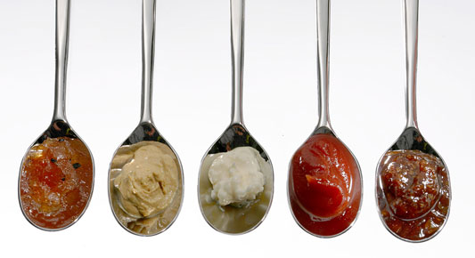
Condiments include:
- Tomato and barbecue sauce
- Sweet chilli/ chilli sauce
- Tabasco sauce and mustard
- Soy and fish sauce.

Butter and lemons
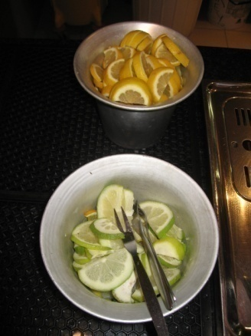
Butter is also a condiment and it is usually the responsibility of waiting staff (not kitchen staff) to prepare the butter for service.
Butter can be served in:
- Cubes
- Curls
- Triangles
- Butter pots.
Some premises use the pre-packed, portion-controlled, foiled rectangles.
Service staff may also be responsible for:
- Slicing lemons for cups of tea or bar drinks
- Making lemon wedges to accompany the service of fish dishes.

Napkins
Linen napkins or paper serviettes are commonly used in food outlets.
Remember that napkins cost money, so they should be handled and treated with this in mind.
There are a number of different napkin folds commonly found including:
- Cone
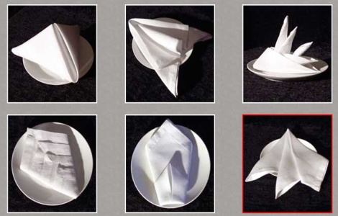
- Envelope
- Bishop’s Hat (also called Mitre)
- Fan
- Opera House
- Sail.
It is important that you can fold serviettes as required, because folding serviettes is an activity that can be done during quiet periods.
There may also be times when you have functions for 300 – 400 people, and all staff may be asked to help fold serviettes.

Waiter’s station
The main purpose of a waiter’s station is to provide the service staff with a location on the floor from which they can work.
Items commonly found at a waiter’s station will reflect the service to be provided and can be expected to include:
- Menus and wine lists
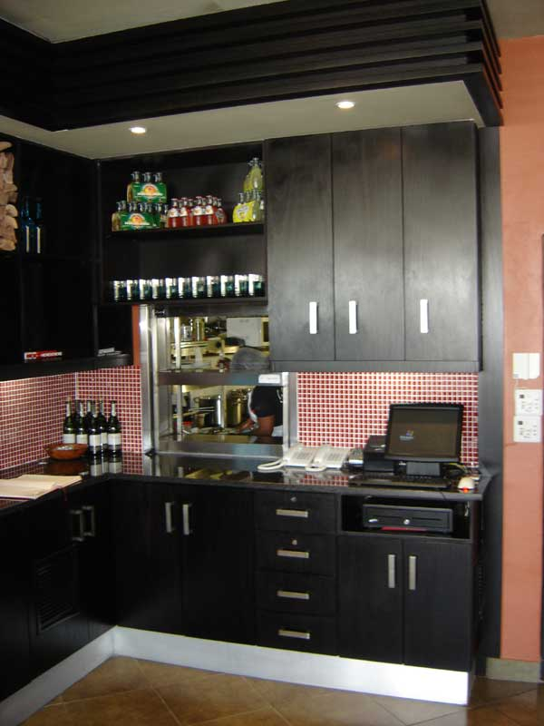
- All main types of cutlery – usually held in drawers
- Service plates, cups and saucers
- Napkins
- Service trays
- Salt and pepper shakers
- Sugar bowls
- Docket books and pen – or electronic equivalents
- Toothpicks
- Condiments – sauces, Tabasco, mustard, extra butter
- Spare glassware

Removing, cleaning or replacing items

Removing unwanted Items
Equipment or items may be required for the breakfast shift, but may no longer be required for lunch or dinner, and vice versa.
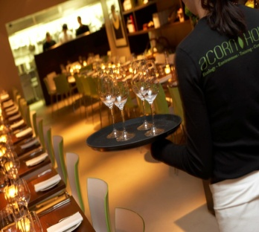
You must know what these items are and remove them from the service areas prior to the next session.
Possibilities include:
- High chairs
- Trestle tables
- Bain-maries
- Coffee urns
- Equipment used only for the breakfast shift – toasters, fruit juice containers, cereal containers, newspapers
- Glassware – glasses set for breakfast are nearly always different from what is needed at lunch or dinner
- Broken equipment or furniture
- Used customer comment forms
- Stock (food and beverage items) that are no longer required
- Displays
- Mobile trolleys.
It may be the case with some items such as displays, floral arrangements and promotional exhibits, that a ‘refresh’ is required after every session. This is to give the area a new look for every sitting, by removing rubbish, replenishing items and getting rid of any unattractive elements that detract from the visual appeal of the room.

Reporting problems
There may be times when service staff identify a problem they cannot rectify, or come across a recurring problem in the room.
When this occurs, it is necessary for the appropriate person to be notified immediately. The appropriate person will be the supervisor, duty manager, manager or owner.
Reporting these problems by phone or face to face are the preferred options as they enable immediacy: in some instances a written report or special form may need to be completed.
Recurring problems may be:
- A piece of equipment keeps failing
- Refrigeration that fluctuates in temperature or doesn’t reach the required temperature
- Always running out of a crockery, cutlery or glassware
- Always running out of forms or pens
- Circuit breakers constantly cutting in and cutting off power
- Heating or cooling that doesn’t seem to respond to thermostats
- The floor plan always gets lost
- The need for a new piece of equipment to complete a specific task more efficiently. Perhaps the present method could be too slow and may not keep up with the demands of increased trade
- Any health and safety issues
- Always running out of a particular product
- Always running out of ice for the ice buckets or beverage service
- Always running out of menus or wine lists
- Need for more cleaning items and equipment.
Now that the restaurant area and equipment are ready for service, it is time to concentrate on the tables.

1.3 Check cleanliness and condition of tables and all table items, prior to service and take necessary corrective action

Introduction
Once the room setting and equipment is set up it is time to set the tables to meet the expected trade for the meal period.

Setting tables
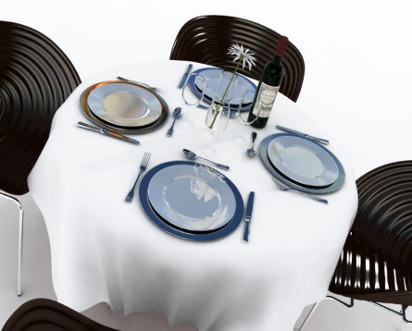
The presentation of a table says a lot to customers about the level of service they can expect to receive in an establishment.
It is important that all tables are set in accordance with the establishment standards and set up within the timeframes required by the venue.
A place setting for one guest is commonly known in the industry as a ‘cover’. ‘Cover’ can also be used to indicate the number of guests, as in the phrase “we served 50 covers today”.
Covers will vary depending on the menu, the reservations and specific customer requests.

Types of Covers
A la carte cover
A la carte is the term used for a menu that has individually priced dishes: these dishes are divided into entrées, salads, mains and desserts.
A la carte means ‘from the card/menu’.
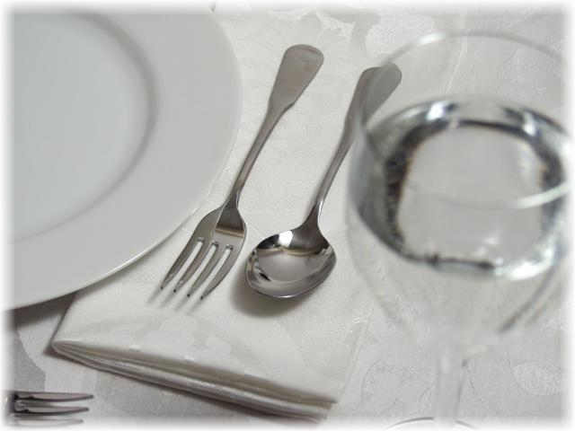
This type of cover is popular and usually consists of:
- Main course knife
- Main course fork
- Side plate
- Side knife
- Wine glass
- Napkin
- Centre pieces – salt and pepper shakers, table numbers, vases or tent cards.
Table d’hôte cover
A table d’hôte menu is a menu that has a set price for a number of courses.
‘Table d’hôte’ means ‘table of the host’.
All courses are included in the price and must be paid for by the guests even if they don’t eat every course.
A typical set menu may have two to four choices of an entrée, two to four choices of a main and two choices of a dessert.
The cover for this menu would be:
- Main course gear (cutlery) – this is a term meaning main course knife and fork
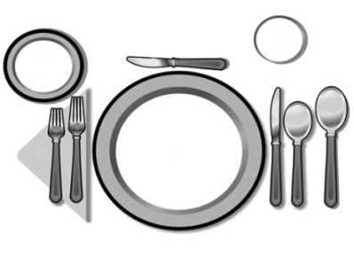
- Entrée gear – entrée knife and fork
- Dessert gear – dessert spoon and fork
- Side plate
- Side knife
- Wine glass
- Napkin
- Centre pieces – salt and pepper shakers, table numbers, vases or tent cards.
If a soup was the first course, a soup spoon would be set instead of the entrée gear.
If a soup was one of the two first course choices, it may or may not be set depending on house policy.
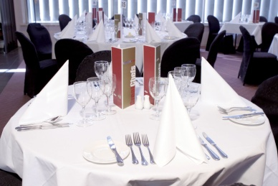
If fish was offered, a fish knife and fork would be included.

Tips for setting a table
The following provide guidelines that may be adopted when setting a table – check with individual house requirements and follow those where they differ from the following:
- Use the chair as a guide to centre the cover
- Side plates should always be placed to the left of the fork
- Knife blades should always face left
- Sufficient space should be left between the knife and fork for the meal to be placed down. This is approximately 25 – 30cms depending on the size and shape of the main course plate
- Entrée cutlery should always be placed on the outside of the main course cutlery
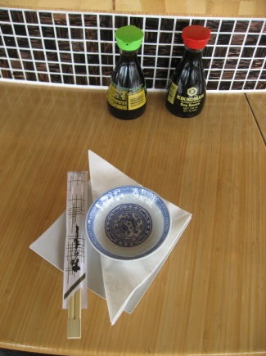
- In a la carte dining, the dessert cutlery should be placed where the main course knife is usually positioned
- Wine glass should be placed directly above the main knife.
After the table setting has been completed, step back and look at the overall impression - it should look attractive, balanced and uniform.
When setting tables ensure that all crockery, cutlery and glassware used on a table are the same. There should never be a ‘mix-and-match’ of items from different canteens of cutlery or patterns of crockery.
For breakfast settings, a coffee cup is placed where the wine glass is usually positioned.
At all times, centre pieces should be kept to a minimum to avoid cluttering a table, unless management or house policy specify otherwise. This may be the case during certain promotional periods, specific celebrations or as part of some other initiative.
Remember, all crockery and cutlery placed onto a table should be clean and match; all cutlery must be placed in a straight and parallel fashion, consistent around the table for each and every setting.
Note: it is standard industry practice for all tables in the room to be set for a service session. If the room seats 100 and you only have bookings for 50, you don’t just set half the room.

Clothing Techniques

Linen
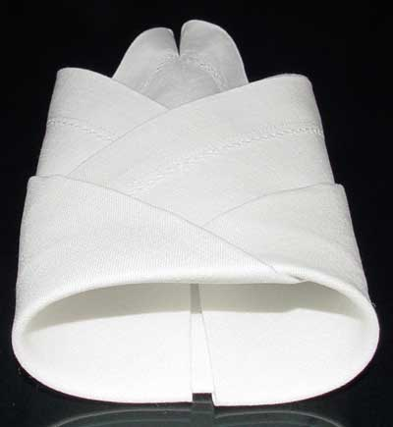
Many dining rooms hire tablecloths from a linen supplier who supplies and launders the required linen items including napkins and table cloths.
When hiring linen, the room will be allocated a par stock level of items from the supplier. If any of the stock is lost, too badly spoiled or stained, the room will be invoiced for the replacement cost of that particular item.
When handling linen, it is important to remember that each item costs money to launder. A tablecloth can cost $5.00 or more to launder, linen napkins around $1 each.
They are also expensive to replace if the property buys and launders their own linen.
For these reasons, it is important never to use linen napkins for cleaning around the bar, or for cleaning up spills that will stain them forever.
Linen should only be used for the purpose it was designed for – to cover a table, or to provide a customer with a cloth serviette.
The cloth serviette may also be used as a ‘service cloth’, carried by service staff who are carrying or handling hot food items, and used to enhance presentation and service of both various food items and wine bottles.
The service cloth is often carried folded over the left arm.

Clothing a table
With clothing a table (that is, laying a tablecloth on a table), it is important that you use the method approved by the establishment..
The following points in laying a cloth should be observed:
- Never let the cloth touch the floor, and handle the cloth as little as possible
- Make sure the cloth is laid the right side up. Check the hem to identify which is the right side if you are in doubt
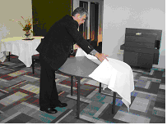
- The overhang should be equal all the way around the table. Cloths come in various sizes and you must use the right size cloth for each table
- On large tables it is usual to use more than one cloth. The industry standard is that the overlap of cloths runs away from the main entrance door to enhance presentation by ‘hiding’ the join/overlap
- Creases in clothes should also run away from the door where possible
- Try to use the cloth to cover the legs of the table where possible, making the dining area more attractive.

Dressing tables
On special occasions, or as part of standard operating procedures, tables may need to be dressed.
Dressing takes place as part of the set up and enhances presentation of the table.
It is time consuming, and frequently requires additional items to be used, so it is an uncommon activity, rather than a common one.

Boxing tables
Tables can be boxed to enhance their appearance.
It is usual to box head tables at functions, display tables on the dining floor, and tables that carry name tags of representatives at conferences.
Boxing involves folding a table cloth around the vertical fall of the table so that the sides of the table and the legs are hidden from view.
Many establishments have specially prepared (pleated or plain) boxing sheets that are simply held in place with drawing pins, or fitted exactly to the size of individual tables.

Table accoutrements
‘Accoutrements’ are the items used to fit out the tables.
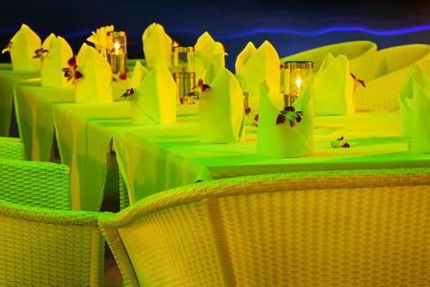
In some situations you may be required to dress tables with accoutrements such as:
- Candlesticks
- Candelabra
- Bud vases
- Overlays – a second table cloth, smaller than the first, overlaid to provide a contrast in terms of colour or pattern
- Floral arrangements
- Placemats
- Display and promotional material for functions such as product launches, etc.
- Printed materials, business cards as above.

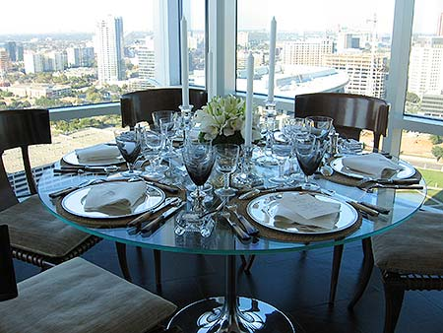
Functions
In some functions, especially wedding receptions, conventions and product launches, there is likely to be a strong demand from the client to have access to the dining area to dress the tables themselves.
They may ask to do the total dressing of the tables, but more usually will want to add their own touch (flowers, brochures, samples, kits etc.) to what you have already prepared.
Be warned, working in conjunction with outsiders under these conditions can be very demanding and very trying. They seem to be constantly asking ‘annoying’ questions, requesting bits and pieces and making suggestions that would involve you departing from standard operating procedures.
Extreme patience and commitment to the service ethic is required in these instances.
Allocating one person dedicated solely to dealing with these people, has a lot to be said for it, as opposed to making all staff responsible for assisting the client.

Checking cleanliness and checking tables prior to service
Cleanliness and the condition of the tables and the table items must be checked prior to service to ensure the guests enter a proper and correctly prepared room.
Checking may involve walking around and scanning each table to ensure all is correct. Waiting staff may be required to do this in situations where they are asked to check the tables of other waiters rather then check their own tables, or it may be the job of the supervisor.
Things to look out for in this process include:
- Crumbs on chairs left from the previous session. Cleaners will clean the floor of the room but rarely be required to clean chairs

- Lop-sided, creased, dirty or otherwise unsuitable tablecloth
- Missing items from the cover or table – crockery, cutlery, centre pieces, glassware, napkins, tent cards
- Missing, damaged or unstable tables and chairs
- Incorrect covers set on a table. The covers must reflect the number of guests for each table as indicated on the floor plan. Where tables exist that do not have bookings, most venues will prepare tables to suit the size of walk-in numbers or parties that can be reasonably expected. This means they may set up a number of tables for two, some tables for four people and some for perhaps six or eight people
- That the actual table positions reflect the set floor plan
- Rubbish on the floor, in pot plants etc.
- Flies or insects – alive or dead, with special attention being paid to window ledges.
Establishments always want the dining area set up before the advertised service time, so problems can be sorted out before guests arrive.

Check any furniture for stability
Tables and chairs must be checked for stability before customers arrive to ensure that they do not pose a danger to customers, and to ensure they are not annoying when the customers are seated at the table.
Occupational safety and health laws impose a legal requirement on premises to take care of the welfare and safety of their customers.
The common law concept of ‘duty of care’ also requires businesses to take whatever action is necessary to avoid causing foreseeable harm to them.

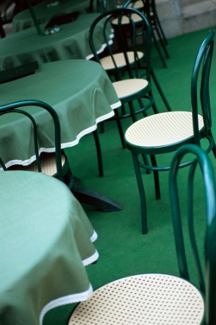
Checking furniture
Prior to service, tables and table settings must be checked not only for proper location and cleanliness but also for:
- Safety – we need to make sure that chairs are not compromised such that they may collapse when a customer sits on them. We also need to check that the chair does not pose a physical danger to the customer by virtue of a loose part, a projecting piece of wire or component
- Stability of chairs – so they won’t topple when used
- Stability of tables – so that customers are seated at a table that provides a firm surface that doesn’t move or rock when they lean on it.
We need to also physically check the room (entrance area, high traffic areas and the general floor area) to ensure a safe environment. Check to make sure there is:
- No frayed carpet, and nothing for patrons or staff to trip over
- No extension cords on public access areas
- No projections into the area that could harm customers.
What must happen if a problem is detected?
If you identify a problem you must take action to address that issue.
It is not enough to simply know there is a problem – you have to do something about it.
Actions may involve:
- Notifying the supervisor
- Removing the dangerous item from use
- Adjusting the table to make it stable. This can involve adjusting the legs of the table or placing a chock under one or more legs.

Verifying the menu prior to service

Types of menus and wine lists
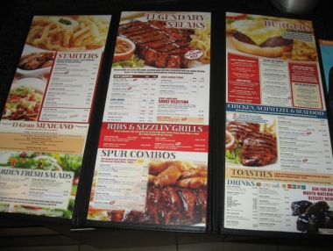
Before and during service sessions, the menu and wine lists should be checked for cleanliness and wiped clean with a damp cloth, if necessary.
Any damaged or badly soiled menus should be removed from service.
Dining areas usually have a single, standard wine list, with enough copies to service every table.
However, there can be a variety of food menus, such as:

A la carte menu
A common style of menu found in the majority of full-service dining areas, its characteristics are:
- Dishes are prepared to order
- Can offer appetisers, entrées, salads, mains, desserts and snacks
- Can offer a large selection of items within each category
- Each item is individually priced – customers pay only for what they select or eat.
Where an à la carte menu is used, waiting staff will not know what the guest is going to select and therefore the setting is basic, focussing on only the main course knife and fork because we can safely assume that most guests will, at least, partake in a main course.
When the guests select their food, the cover is then adjusted to reflect the menu items they have chosen. This may mean:
- A soup spoon is added if the guest orders a soup
- The main course knife is swapped for a steak knife where the guest orders a steak
- Fish gear is added if the guest orders a fish entrée
- The main course gear is swapped for fish gear if the guest orders a fish main course
- Dessert gear is added if the guest orders a sweet
Table d’hôte menu
This is a popular and common menu where the guest has the choice of a limited number of dishes or courses for a set price.
The guest pays the full set price regardless of what they choose to eat.
Where a table d’hôte menu is used, the setting will reflect this style of menu. We can safely assume that most people partaking in a table d’hôte will eat every course offered on the menu so the set up reflects that by laying cutlery for each of the courses available.
Once again, the cover is adjusted when the order for the guest has been taken.
This may involve:
- Removing cutlery if the guest elects not to eat a certain course
- Swapping main course knife for a steak knife where the guest orders a steak
- Swapping main course gear for fish gear if the guest orders a fish main course
- Swapping the entrée gear for a soup spoon if the guest selects a soup as opposed to an entrée.
Buffet/smorgasbord
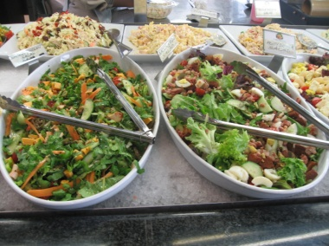
This menu is very popular in family style restaurants or taverns and hotels, and is often used at functions:
- Items are all prepared in advance and placed on display for customers to view, and make their selection
- Menu usually offers all items at the one set price, regardless of how much a person eats. Children may be half-price
- A buffet usually offers a range of soups, cold and hot meats, salads, vegetables, seafood, desserts, and tea and coffee. Sometimes soft drink is included
- Buffets are generally self-service, with waiting staff involved in replenishing dishes, and clearing plates from the buffet and guests’ tables.

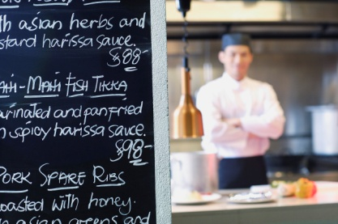
Contact with kitchen staff
The menu can change daily, depending on the availability of the menu items and the chef’s choices.
It is vital for all service staff commencing a service session to be aware of any menu variations and know what the daily specials are.
In addition, the kitchen may require service staff to ‘push’ certain dishes to clear them, or because they represent an especially profitable dish.
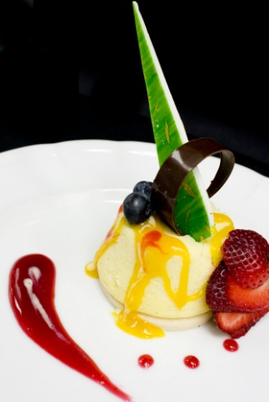
Some specials or variations that could occur on a daily or service by service basis may include:
- Fish of the day
- Soup of the day
- Specials of the day
- Vegetables of the day
- Dessert of the day
- Specific constraints on this individual upcoming session
When the guests are presented with the menu, they should be informed of any changes, specials or limitations at this stage to avoid disappointment and frustration should they order items that are unavailable.
Changes and specials may also be written up on a board, and brought to the guest’s attention upon seating. Chalkboards should be kept clean and all handwriting should be neat and legible.
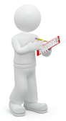
Lots of different menu presentation options exist, from print-based options, through hand-written boards to electronic displays.

Conclusion
As this section shows, there are a lot of activities that need to be conducted and checked before the first customer walks in.
It is essential that both staff and management pay close attention to their duties and ensuring the environment is prepared in a safe, hygienic and appealing manner.

Work Projects
It is a requirement of this Unit that you complete Work Projects as advised by your Trainer. You must submit documentation, suitable evidence or other relevant proof of completion of the project to your Trainer by the agreed date.
1.1 To fulfil the requirements of this Work Project you are asked to research how to check food service area and customer facilities for cleanliness prior to service including:
- The range and variety of food and beverage outlets
- Procedures for cleaning and checking the restaurant area
- Steps involved in checking and cleaning customer facilities
- How to prepare and adjust the environment to ensure comfort and ambience for customers
- Items and methods to set up any furniture
- Methods to ensure adequate customer and service personnel access
- Common food and beverage items that are displayed.
1.2. To fulfil the requirements of this Work Project you are asked to research how to check and prepare equipment for service including:
- Coffee and tea making facilities
- Bain-maries
- Toasters
- Salt and pepper shakers
- Cutlery and Crockery
- Glassware
- Condiments, butter and lemons
- Napkins
- Waiter’s station
- Removing, cleaning or replacing items
- Reporting problems.
1.3. To fulfil the requirements of this Work Project you are asked to research how to check cleanliness and condition of tables and all table items, prior to service and take necessary corrective action including:
- Setting tables
- Clothing Techniques
- Dressing tables
- Table accoutrements
- Checking cleanliness and checking tables prior to service
- Verifying the menu prior to service
- Contact with kitchen staff.

Summary

Prepare food and/or food and beverage outlet for service
Check food service area and customer facilities for cleanliness prior to service, in accordance with enterprise procedures, and where required, take corrective action/s
The range and variety of food and beverage outlets
Cleaning and checking the restaurant area
Checking and cleaning customer facilities
Prepare and adjust the environment to ensure comfort and ambience for customers, as appropriate
Set up any furniture according to enterprise requirements, customer requests and customer and staff convenience and safety
Customer and service personnel access
Display food and beverage items according to enterprise and legislative requirements.
Check and prepare equipment for service
Coffee machines
Tea making facilities
Bain-maries
Toasters
Salt and pepper shakers
Cutlery
Crockery
Glassware
Condiments
Butter and lemons
Napkins
Waiter’s station
Removing, cleaning or replacing items
Reporting problems.
Check cleanliness and condition of tables and all table items, prior to service and take necessary corrective action
Setting tables
Clothing Techniques
Dressing tables
Table accoutrements
Functions
Checking cleanliness and checking tables prior to service
Check any furniture for stability
Verifying the menu prior to service
Contact with kitchen staff.

Element 2:
Take and process orders

2.1 Provide a helpful and attentive approach to customers

Introduction
This section starts to explore the activities that take place when the customer arrives at the food and beverage establishment. Whilst the steps undertaken may differ depending on the nature of the venue there are still some common, acceptable practices:

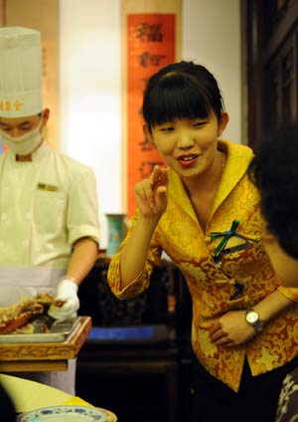
Greet customers on arrival
When customers arrive, it is the responsibility of the service staff to promptly meet them with a smile and an appropriate greeting at the door.
Remember that customers like to feel important and they should always be treated accordingly. Besides, first impressions count and as they say “You only get one chance to make a first impression”.

Checking reservations
When guests arrive in your dining area, the first two steps should be:
- To greet or welcome them
- To enquire whether or not they have a reservation or booking.
Check at your workplace to see if this is Standard Operating Procedure or not.
Where guests say that they have a reservation, you should confirm this in your reservations book, to identify the table they have been allocated on the table/floor plan.
Check with them the number of guests expected. Often there can be an extra one, and sometimes there are one or two who will be cancellations. Where there are cancellations, the chair and cover should be removed from the table so that the table is not embarrassed by empty places.
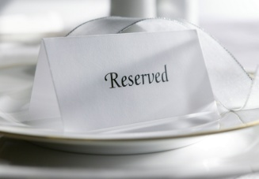
Where an extra person has presented with the booking, staff should immediately set another place and add a chair where possible, or another table should be quickly identified for the party. The key is to ensure that guests do not feel, in either case, that they have done the wrong thing, or inconvenienced staff.
When confirming the reservation, also confirm any details that may be written against that booking – “And you’re off to the cinema, so you’d like to be away by 8.30, is that right?”, “And you requested a high chair, I believe?”
Where there is a note that a birthday cake, or similar, has been arranged, this should also be discreetly checked with the host, either at the table or elsewhere.
A visit to the table informing the host that there is a phone call at reception for them can aid in getting them away from the table. If the guest has no reservation, check the floor plan to see if they can be accommodated.

Be alert to the opportunity to maximise sales
For instance, by asking someone who comes in at 6:30 PM without a booking, whether they could be finished by 7:45 PM, so that you can strip their table and re-.set it for the 8:00 PM booking.
Using a table for two seatings per session – a 50-seat restaurant can quite easily serve 70 – 80 covers per session.
There are some people who will breeze in to a restaurant, claiming they have booked when in fact they never made one. If you have a vacancy, then this really isn’t a problem, but where no vacancy exists, the potential for trouble exists.
All you can do is apologise profusely, and offer another session.
Your house policy may dictate some other form of additional gratuity (a discount voucher, voucher for a free item or a free drink), but many establishments adopt the stance that says ‘If we can’t find your booking, you didn’t make one’
If the situation looks like getting out of hand, call your supervisor or the duty manager.

The greeting on arrival
What you say by way of welcome to your guests may be determined by house policy with certain required statements and facts to be covered, or you may simply be expected to use your common sense and good judgement on a person by person or party by party basis as indicated by:

- The weather. A genuine comment: “Isn’t it cold today?” can be a great ice-breaker and help strike up a conversation
- Sporting events – “Did you watch the game today?”
- Special events – “Happy Festival Day”
- The season – “Isn’t it getting dark early these days?”
- A special in-house event – “Welcome to our Grand Winery Tour Dinner, it will be a night to remember!”
In some establishments, guests may be able to leave their overcoats, umbrellas or other items at the reception area. If this is the case, ask the guests if they would like you to take their coat or assist with other items.
Greeting guests on arrival and accompanying them to their table to seat them is known in the industry as ‘greet and seat’.

Special needs customers
Some guests may have special needs and simple observation will identify many of these. Don’t wait to be asked if you think there is a special need. Get proactive and offer:
- Alternative easy access to their table because of a disability
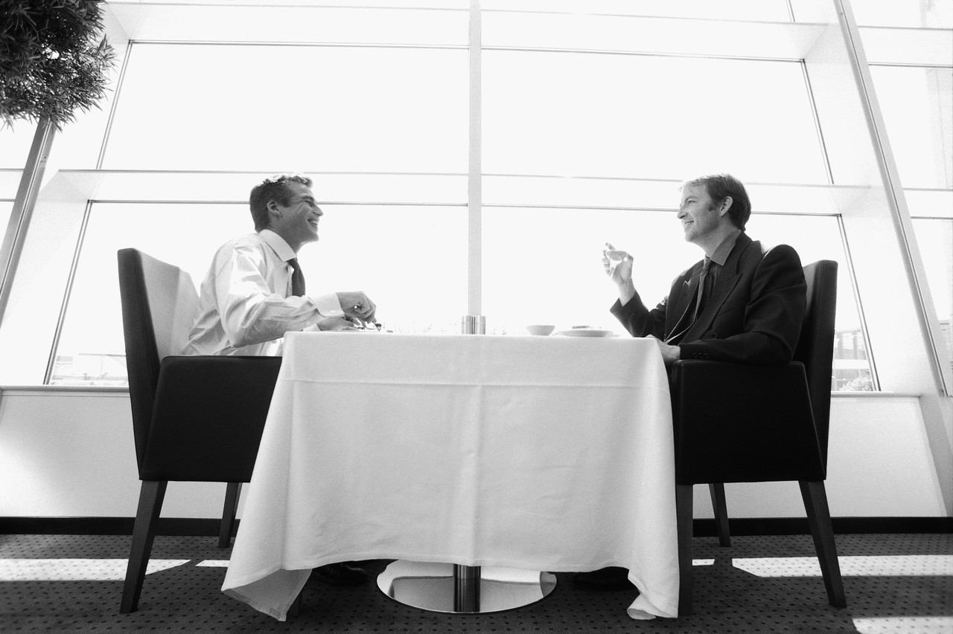
- A high chair for infants
- Warming of a bottle for babies
- Appropriate food for those with special dietary needs as indicated in the reservations book
- Privacy for romantic couples, and business people – to the best extent possible given other bookings
- Room on a table to spread out where business looks as if it is going to be conducted
- A table near the door for someone with a walking stick
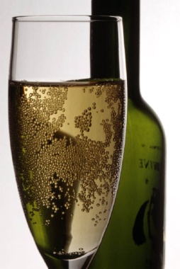
Sometimes special offers have been made or vouchers will be used by guests to pay for their meal. It is a usual condition that guests notify you of this on arrival so that you know what billing process to use, and what other services or products they are entitled to. This could include a free glass of champagne, the set menu only, a choice of entrée and main or main and sweets, and so on.
Extra effort must be made with guests who are using vouchers or participating in deals. Many expect to be treated as second class and get quite snaky when this happens. So treat them with even extra care, respect and high quality service!
And finally, when greeting guests, it is likely that you will know their name. They will either tell you, or you can get it from their room number/key, or the reservation book. It is quite simply music to their ears to hear the sound of their own name and it shows civility, manners and an individual orientation to them as honoured guests.

Offering pre-meal services
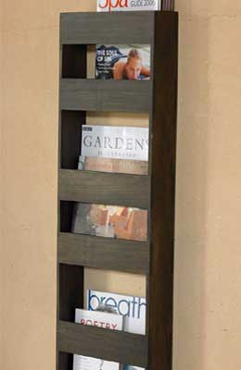
As and when circumstances dictate, or opportunities present themselves, pre-meal services can be offered to guests;
These services include:
- Bar service – it may be appropriate to offer guests the services of your bar before they go to their table. Especially where the bar has a special feature or aspect, this can be a valuable service to offer.
- Lounge and waiting areas. Where your guests are part of a larger party and they are the first ones to arrive, they may be pleased to be offered the benefits of waiting in a lounge area or a special waiting area, rather than being made to sit alone at their dining table. This saves your guests possible embarrassment, demonstrates excellent customer service and indicates that you are tuned in to individual needs. You can offer the customer something to read
- Valet services. These services can embrace almost anything, and are often a variation of the concierge desk. Common services for diners include valet parking and car retrieval, booking theatre or other tickets, arranging for taxis or limousine hire, and even secretarial services for business people. It is not uncommon to be asked to send a fax, or email if these services are offered, especially by people who are out of their home city.
- Participation in special displays or promotions. Where the venue is conducting an in-house competition, or survey, or other promotional activity it is wise to at least notify your guests of what is happening

Escorting and seating customers

Greeting and seating guests
The following steps are industry acceptable standards for greeting and seating guests.
Of course, house rules should take precedence where they differ from the following.
- Promptly acknowledge the guests and welcome them with a greeting. An example of this may be: “Good morning, welcome to Jack’s Bar and Grill”
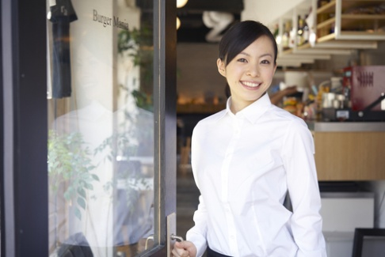
- Establish if the customer has a reservation. A number of customers don’t have a booking – they are called ‘walk ins’. To accept a walk in, make sure that there is a table available. If the guests do have a reservation, check the number of guests to determine if a table is available
- Hats, coats, umbrellas or parcels and presents should be taken from the customer if this is standard house policy, or if guests request it
- Show guests to their table, while walking at a rate that would be comfortable for the guests to keep up with. It may be appropriate to engage them in some form of light conversation while doing this
- At the table, pull out one chair to signal to the guests that they are free to claim a seat and sit. Assist guests with being seated, and pushing in chairs.
Seat ladies first with best view of restaurant.

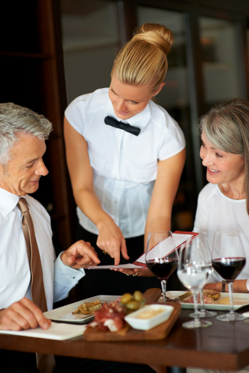
Presenting menus and drinks lists
After the guests have been seated, various other rituals are observed, including presentation of the food menus and the drinks list.
An accepted sequence is:
- Lap napkins if required; from the right-hand side, remove the napkin that has been provided as part of the setting and unfold it. Refold it into a triangular shape and drape it across the guest’s lap, pointed side facing away from them. Note that some guests will prefer to place their own napkin, so be aware of the guest’s body language at all times, and certainly don’t force this service on anyone. A comment such as “Excuse me, sir” may be appropriate
- Ensure any special needs are taken care of such as a high chair for children
- In some establishments, the greeter or establishment host or head waiter will at this stage return to the reception desk to seat further guests. A service staff member then takes over the table to complete the next few steps, courteously introducing themselves and engaging in some small talk, if appropriate
- Distribute menus to the guests from their right-hand side, and leave the wine list with the host, if applicable
- Ask customers if they would like herb, garlic or plain bread, if applicable, and according to available menu items.
The wine list is often presented after guests have decided what they want to eat, but many establishments present the menu and the wine list together so that guests can better match their food and wine combinations.

Provide information to customers, giving clear explanations and descriptions
Most customers will rely on you to provide them with information about the meal, the choices available, prices, service styles and/or any waiting times that can be expected.

Providing food-related information to guests
When all the guests are seated, and the menus have been distributed, your next task is to inform the customers of the Specials of the day and any alterations or deletions to the menu.
Make sure you speak clearly, confidently and audibly.
When describing items, make sure you make them sound appealing by using descriptive words like “succulent”, “delicious”, “fresh this morning”, “made fresh this afternoon”, but also make sure you are not misleading in what you say. All descriptions must be honest and truthful.
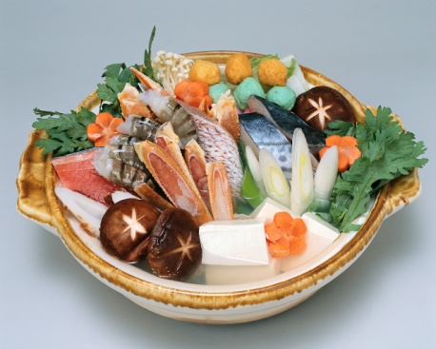
If you know the steak is tough, then don’t describe it as “juicy and succulent, melt in the mouth”.
Items that may need to be covered include:
- Soup of the day
- Fish of the day
- Roast of day
- The vegetables for the session and how they are cooked
- Any other available specials.
After these have been put on the table, you should retire from the table while guests browse the menu and make their selection.
Keep an eye on them for cues that they are ready to order. These clues may include menus closed or put down on the table or guests looking around and trying to catch your eye.
Many guests will be able to work out what they want to eat, but there are usually some who have difficulty deciding and ask the predictable question, “What do you recommend?”
When this occurs, you have four basic options:
- Recommend what it is you like. This can be less than useful because this may not suit them or be to their liking
- Recommend what is popular. Again they may not like this style of dish but the benefit of this approach is that you know it is popular with a large cross-section of diners
- Recommend whatever it is that the kitchen have asked you to push. Again, this may not suit them but will benefit the venue
- Ask some questions first to determine whether they are after a big meal or a snack and then recommend an appropriate dish that complies with their responses.


Additional information
In some dining experiences you may also be required to provide additional information such as:
- Recommendations regarding food and wine combinations – this will be explained later in the manual
- Location of customer facilities within the venue – such as telephones, toilets, car parking, the gaming room, reception etc.
- Information about the local area – including points of interest, tourist attractions, local facts and statistics.
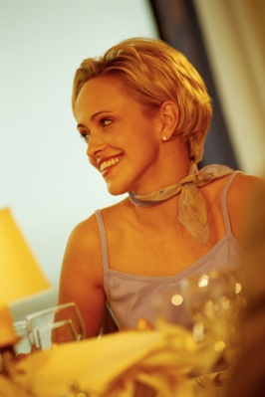
Many venues, especially those where guests are also in-house guests staying in rooms in the property, management may require all their customer-contact staff to actively promote the local area to guests.
The idea behind this is that if the staff can convince the guest to see more of the local area and attractions this will increase the likelihood that they will stay an extra day or two at the property. This, naturally, increases revenue for the business.
In these situations it is useful to engage guests in conversation that includes questions such as “What did you do today/What did you see today?”
This allows you to work out what they have seen and what they haven’t yet seen or visited. You then share the experiences they have had, and use this knowledge to recommend they also go and see whatever they haven’t seen yet.

2.2 Take and record orders accurately and legibly

Introduction
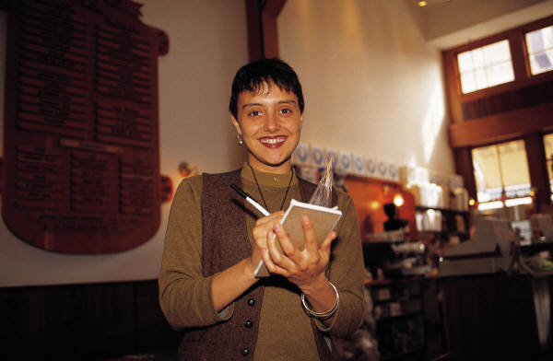
Customer orders need to be taken accurately.
Various formats exist for the taking and recording of orders and these must be adhered to in accordance with establishment or department requirements and forwarded quickly to the kitchen or bar so that the order can be processed.

Taking orders

Options available
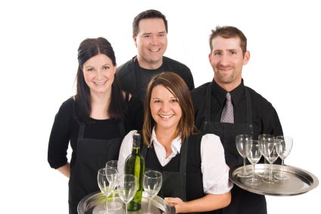
The method of taking orders may vary from establishment to establishment, and can vary within the one business.
Staff may be required to:
- Remember orders relying solely on their memory, as is the case at most bars and in some restaurants
- Record orders on paper-based order forms such as waiter’s dockets and order pads
- Record orders using electronic means such as small hand-held computers (PDAs – Personal Digital Assistants) which also send the orders to the kitchen or bar and interface with point of sale registers to facilitate account tracking, processing and payment.

The role of the order
The order serves four different purposes:
- Informs the kitchen or bar staff of the order so that they can produce the items required by the customers
- Informs the service staff of any changes needed to the cutlery. Some may need to be removed, some may need to be added or exchanged
- Identifies who is eating or drinking the items ordered so that the right item can be served to the correct guest
- Provides the basis from which an account can be made up and presented to the customer at the end of the dining experience.
Whatever the method used, orders should be taken promptly and accurately with minimal disruption to the customers. You need to pay attention to what is being said, and use positive body language and verbal communication when taking the order.

Guidelines for taking the order
There are a number of rules you should try to follow when taking and recording an order:
- Be aware of signs given by the guests that they are ready to order. This could be guests looking around for attention, guests who have closed their menus or guests looking anxious
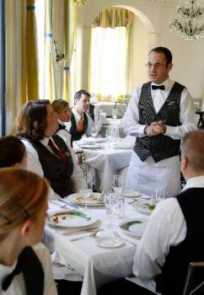
- Ensure all orders are recorded accurately and legibly. Using the appropriate terminology and abbreviations and making sure that the written order does not:
- Omit any important parts of the order such as how the steak is to be cooked (see below), whether the main course is to be entrée size or the fact that the main meal is to be served with mash potato rather than French fries
- Confuse the person reading or having to interpret it. There is no point requesting ‘two fish’ from the kitchen if there are three fish dishes on the menu. Similarly, just asking the bar for ‘a beer’ doesn’t tell them the size, brand, style, or whether the beer is to be a packaged one or a draught one

- Orders should be taken with minimal disruption and interruption to guests. There needs to be sensitivity in how the table and the customers are approached so that they don’t feel they are being pressured or their private conversations are being listened to.
- Recommendations or suggestions are made to the customers to assist them with drink and meal selections. Even where you have provided assistance when the menu or the drink list was presented, when it comes to actually taking the order guests may still need extra help or need you to repeat information previously given
- Service staff should always take the guest’s order from the right. This is an industry standard but check to see what applies where you work. This obviously can’t happen in situations where:
- There is an obstruction – such as a wall that prevents you standing to the guest’s right-hand side
- The guests are involved in conversation or looking at something between them that would make it impractical, rude or otherwise difficult to take the order
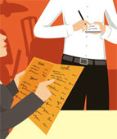
- Guests should be numbered. The host of the party or table or some other person, as identified by you as being Guest No 1, becomes number one and the numbering is worked clockwise around the table, allocating every person who orders a number.
Doing this and getting this right is important as it guides both the adjustment of covers to reflect what they have ordered, and the actual delivery of meals and drinks to the correct person without having to ask “Now, who’s having the veal?”
The Number One person may be the guest who is sitting closest to the front entrance, or they may be sitting closest to the central pillar in the restaurant. It’s up to you to:
- Leave adequate space on hand-written food dockets, between the entrées and mains, to clearly define the break in the order. Note that dessert orders are usually taken after the mains have been served and cleared away, unless otherwise stipulated
- Repeat the order to the guest to ensure you have got it right. Always ask for clarification if unsure of a particular order.

Degrees of ‘doneness’ of steaks
It is important to note on the order how the guest wants their steak cooked.
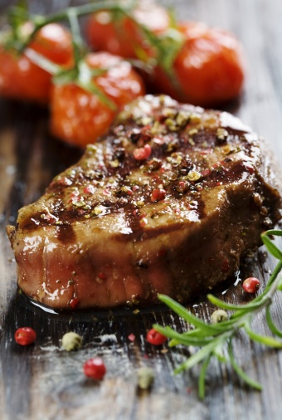
Degrees of doneness are:
- Blue – steak is seared on both sides then served
- Rare – steak is served when browned on both sides, and meat still contains blood
- Medium rare – steak has less blood than a rare steak, though blood is still just present
- Medium to well-done – steak is cooked all the way through, no sign of blood
- Well-done: steak is cooked very well – a little burnt on the outside and definitely no sign of blood.

Operate the ordering system according to enterprise procedures
The ordering system in operation where you work must be used in accordance with enterprise procedures and, where appropriate, in compliance with manufacturer’s instructions.
Most employers will provide training on how to take orders and operate their system even if the system is paper-based system.
Where the system is electronic, there will definitely be in-house training (unless you have indicated you have experience with that system on your job application or at the job interview).

Operating ordering systems
All transactions should be undertaken within establishment guidelines relating to:
- Honesty and integrity. Guidelines cover policy such as not charging for items that were not delivered or not charging person X for something that person Y received
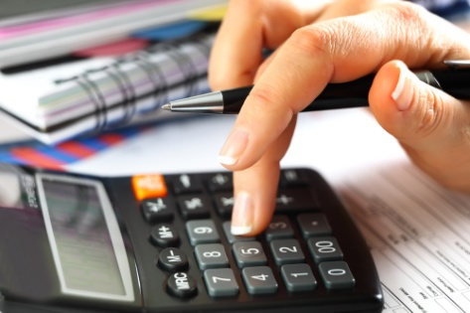
- Accuracy – checking all entries, extensions, additions and other calculations to make sure that the customer isn’t overcharged and that the venue captures all the revenue to which it is legitimately entitled
- Speed – ensuring that accounts are compiled and presented in a timely manner consistent with honesty and accuracy. Never sacrifice accuracy for speed
- Explanation and description of charges. This should detail fully the nature of all charges so that no confusion or suspicion about charges exists
- Customer service – treating customers with the courtesy they merit in relation to the taking of the order, processing of the order and presentation of the account for payment.
The manual system
Dining order systems can vary greatly.
The type used largely depends on individual establishment’s preferences based on matters such as:
- Their previous experience with using an ordering system – including evaluation of how existing systems are performing
- The number of orders processed – bigger numbers may encourage the establishment to use an electronic system
- Skills of staff and the availability of skilled staff – most premises dislike having to train staff, but will do so where they have to.
For educational purposes, the following explains how to write a manual food order. Check what applies where you work and stick to establishment procedures where they differ from what is presented.
Below is an example of an easy to read food docket: note how each person has been numbered to identify their meal selections.
Date | Time |  | Table |  | Number |  | Server
7/5 | 7:30 |  | 6 |  | 6 |  | Mary
Qty |  | Item |  |  |  | Cover No.
2x |  |  |  | Garlic Bread
2x |  | D/F Calamari |  |  |  | 1, 3
1X |  | Beef Kebabs |  |  |  | 2
2X |  | W-Chicken Salad |  |  |  | 4, 5
1X |  | S.O.D. |  |  |  | 6
1X |  | Seafood Bskt |  |  |  | 1
2X |  | Spaghetti Mar |  |  |  | 2, 3
1X |  | Chick-Avocado |  |  |  | 4
1X |  | Calamari (Ent) |  |  |  | 5
1X |  | Scot-Steak M/R-No Sauce |  |  |  | 6

Points to note about this order
- The writing is clear and legible to avoid any costly mistakes
- The time allows for monitoring of service
- The inclusion of the server’s name allows the chef to know who placed the order if issues arise and questions need to be asked
- The number at the table allows cross-referencing with the number of items ordered
- The chef can clearly read the quantities of each menu item
- Additional requirements have been noted
- Abbreviations have been used
- Guests have been numbered to immediately identify who is having which meal and that changes to the cover may be necessary
- There is a sufficient gap separating the entrées from the main meals for the kitchen to see clearly the break between the courses.

Appropriate software applications
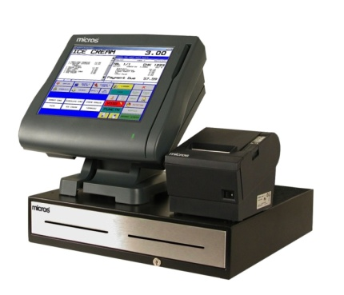
There are various software applications in the workplace, many of which have been designed and developed for the hospitality industry, with some specialising in sectors such as accommodation and restaurants.
The sector-specific options contain many features, some of which are brilliant, but many of which are not used.
Without doubt, the best advice is to read the manual.
There is so much variation between this software that general statements are difficult to make. Ask your supervisor to show you the system, explain what it does, and arrange for some down-time training before you go ‘live’.
Some systems have a dedicated ‘training’ option enabling you to practice on the actual equipment during working hours without interfering with the working orders.
Software applications
This computerised system enables electronic management of food and beverage orders.
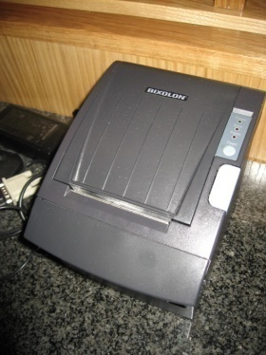
A main terminal enables data input to the system. This data comprises the menus for all the restaurants hooked up to the system, along with prices of each item. This information could be input by the F & B Manager or receptionist.
Each outlet has its own terminal that displays the menu. This is a touch screen as there is no keyboard like a normal computer. Printers are an integral part of the system and they are present in each of the food outlets, as well as in the kitchen.
Checks must be made before shifts to ensure the screens are ‘up’, and the printers have toner and paper.
As an order is taken by waiting staff, the order is entered into the system, via the touch screen terminal. A ‘table tracking’ facility is activated so that dishes can be added to the initial order, and a track can be kept of the order for the nominated table number.
The system also has a facility for each table to have seat numbers assigned to their particular order.
The order is then sent to the required service point, which will normally be the kitchen and may include the bar. The order is printed out in the service area, detailing not only the items required, but also the table number, time and the name and/or number of the waiter.
Orders may be changed as guests change their minds, or as other circumstances dictate.
Food and beverage orders can be entered at the one time, or using the table tracking facility, separately by different waiters.
Items that have been incorrectly entered can be deleted and items can be voided. Both food and beverage can be added to the account during the meal.
Entering a dish or a beverage automatically triggers the designated selling price.
When the guest requests their account, the system enables printing of their bill. Various adjustments can be made to the account enabling discounts and vouchers to be used.
The system allows payment by cash, cheque, and credit card or via account. Payment may also be made by any combination, such as half in cash, half by credit card.
At the end of the shift, a summary can be printed detailing various aspects of the takings for that period. A breakdown of cash sales, credit card sales, voucher sales, cheque sales, cash out, discounts and gratuities. Sales by table and staff member are also available.
The system also enables the handling of advanced deposits.
Normal reconciliation, cash handling and security procedures apply during the shift, and at the end of trade.

Hand-held electronic order pads
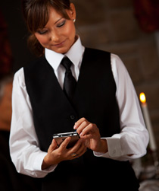
These, as the name suggests, are small hand-held ordering devices (PDAs) that waiters take to tables instead of using handwritten order pads.
A pointer is used to navigate the screen and ‘key in’ the order which is then communicated to a printer:
- In the kitchen to let the kitchen staff know what is required
- To a point-of-sale terminal to generate the account for the customer.
Opinion appears divided as to the relative benefits and disadvantages of this system with many users pointing to the need for sufficient training in their use before they can be competently and professionally when taking an order.
These devices integrate with other establishment systems such as the POS register and kitchen and bar printers and may:
- Reduce the errors that occur when orders are taken
- Improve customer service levels
- Increase service speed.

2.3 Convey orders promptly to the kitchen and/or bar

Introduction
As discussed in the previous section, many orders will go directly to the kitchen or bar through the use of a software system. Regardless of whether an electronic or manual ordering system is used to take an order, there are many times when waiter staff will need to speak directly to the person preparing items, normally the chef or bartender, to explain special requests and to clarify the order.

Relaying information manually
In the event that a manual system is used, it is imperative that orders are:
- Given directly to the person responsible for its preparation
- Ensure they receive the order
- Ensure they understand the order
- Explain any special requests relating to an order – see below.

Relay information about any special requests or dietary or cultural requirements
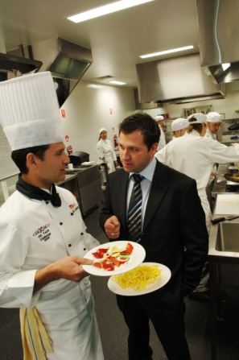
Where customers make special requests in relation to the dining requirements, whether these are based on personal preference, dietary needs or cultural requirements, it is important that these special requests are communicated clearly to the relevant person.
The relevant person may be:
- The head waiter – to determine whether or not the special requests can be accommodated
- The head chef – to inform them of the specifics relating to the food order that is being placed
- The bar manager or a nominated bar attendant – to clarify the order.

Relaying information
When delivering the order to the kitchen or bar, details about any special orders must be passed on to the appropriate person quickly and unambiguously.
You need to bear in mind that the person you will be speaking to will have more staff than you to deal with, you are likely to be just one of many. For this reason you have to take the time and make the effort to get your message across correctly, first time, every time.
To achieve this you need to make sure you:
- Have got their full attention when relaying the order. The kitchen may require you to say ‘Ordering chef’ or ‘Order in’ when placing the order
- Point out the special request on the actual docket physically locating the written information that you have put on the docket. It is standard practice in establishments using a manual ordering system for special requests to be circled on the docket to highlight them
- Verbally describe what is needed – clearly and accurately. A response should be heard from the chef after you have placed the order. If no response is heard, repeat the order.
If possible get them to repeat it back to you to verify they have understood what is required!
While you need to ensure that your special order is understood, you must be sensitive to the other things that are going on. It may pay you to hold off for 30 seconds or a minute while the kitchen person clears some meals that are ready, helps with plating a large order, or remedies an immediate problem. Remember that team work, not individual plays, are the key to overall service success.
The same applies at the bar. Take a moment to see if the person you want to speak to is realistically able to listen to what you have to say. If they can’t, then wait for a minute.

What information may need to be relayed?
Information that may need to be relayed involves:
- Timing issues – informing the kitchen/bar of those who are in a hurry, or those who want to stretch their meal out over several hours
- Co-ordination of service – telling the bar about the food that a table has ordered so that wines selected to accompany certain dishes can be presented, opened and served before the food has been served. It is very annoying and disappointing for a guest to choose a special wine to accompany their fish main course only to find that wine is served when they are halfway through that dish
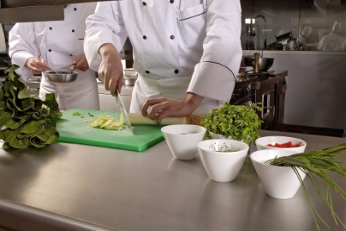
- Cultural issues – notifying the kitchen/bar of cultural food and drink needs. Sometimes patrons expect you to know what these needs are, but in other instances individuals will advise you of what they want
- Dietary requirements
- Special requests – in relation to serving size, extra serves or deletions, or a special way of cooking that is not listed on the menu
- How steaks are to be cooked
- Entrees required as main courses – or vice versa
- Explanation of tables and their orders. For example, a table of six people where four are having entrees, and three are having soup and two are not having soup or entrees, what is required and when.


Dietary Considerations
It is extremely important to make sure that special requests that relate to dietary issues receive extra attention and care as there can be severe medical consequences if dietary needs are not met.
These consequences, such as the possibility of anaphylactic shock, increased blood sugar levels (and other reactions that diners may have to various foods or substances) can result in the property being sued.
Remember that all properties have a common law duty of care towards their patrons and this obligation definitely extends to situations where customers have asked for a certain meal or food and are served something that does not comply with their stated requests and this then results in injury to those persons.
The keys in relation to this situation are:
- Always check with management or the kitchen to determine whether or not a specific stated dietary request can be accommodated or not
- Make doubly sure that those preparing the dish know the specific dietary requirements that have been requested
- Never assume that the kitchen can accommodate dietary needs of patrons even if you have accommodated similar requests in the past
- Double check with the kitchen when you pick up a dish for service to the table. Ask them if they have prepared the food as requested and obtain positive confirmation before taking the dish to the table
- Ensure appropriate emergency procedures are in place to manage situations where customers are adversely affected by foodstuffs while on the premises. These procedures may be included in the Emergency Management Plan for the premises.

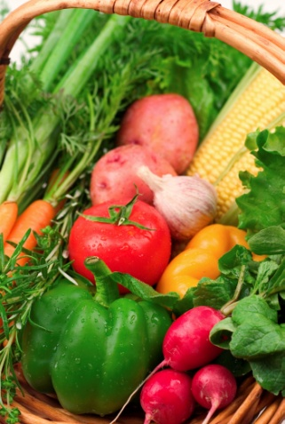
Types of special dietary needs
- Vegetarian requests. This is probably the most common dietary-related request
- Lacto-ova vegetarians/Ova-lacto vegetarians. These are the majority of ‘vegetarians’. They eat dairy products and eggs but not meat of any kind including red and white meat, poultry or fish
- Lacto-vegetarians. They don’t eat meat, poultry or fish. They don’t eat eggs but they eat dairy products
- Pescatarians. These are people who don’t eat meat, poultry or animal flesh but do eat fish
- Vegan. This definition is open to various interpretations so it is best to check exactly what the diner means when they say they are a ‘vegan’. Generally a vegan can be seen as anyone who doesn’t eat meat, poultry, fish, eggs or dairy products and doesn’t eat foods derived from animals such as gelatine. The person may also stipulate that they are served only raw/unprocessed foods, or foods that have not reached a temperature of above 46ºC (because they believe foods above this temperature have had some of their dietary goodness removed or be harmful to the human body)
- Requests for low-salt meals
- Requests for low-sugar or no sugar meals for diabetics
- Requests for lactose-reduced milk for those who are lactose intolerant
- Requests for gluten-free food from patrons who have celiac disease
- Requests for a macrobiotic diet. For those who are especially health-focussed they will request unprocessed vegan foods, no oil and no sugar.
Regardless of the request, the accuracy of recording and delivering customer meal requests is a key element of a successful dining experience for the customer.

2.4 Give customers advice on product selections, if required

Introduction
One of the key areas of customer service which a waiter can provide customers with is advice or recommendations to help ensure the customer is able to order a food or beverage item to suit their needs.
Whilst information is often provided to customers before they decide on a meal, its importance warrants a section which focuses solely on this important practice.

Answer customer questions on menu items
A major part of the service staff’s role is to respond to guest questions regarding menu items. Doing this provides not only an opportunity to be of service but also to promote items in line with the kitchen’s advice.
A high level of product knowledge is needed to answer guest questions, and in the majority of cases, you will need to ask questions yourself to make sure you have the necessary information to pass on to customers or guests.
All information provided to guests in response to their questions must be truthful and conveyed in a courteous manner.
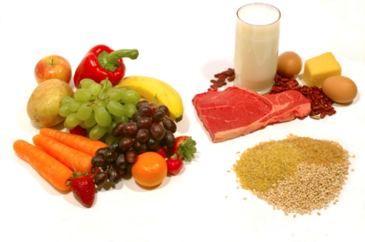
Common customer enquiries include:
- Dish ingredients
- Cooking / preparation time
- MSG and flavourings
- Serving sizes
- Freshness of ingredients (seafood)
- Cooking styles
- Meat or meat stocks
- Menu and cookery terminology
- Side dishes
- Calorie/fat content.
This information is vital in enabling you to effectively promote dishes and respond to questions from customers.
However, regardless of how much work and research you do, there will always be occasions when you are asked a question you can’t answer. When this happens, don’t get upset, annoyed or embarrassed. Treat it as a learning experience and:
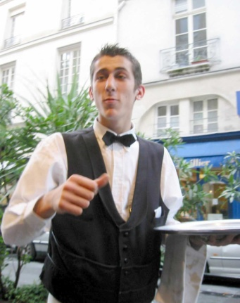
- Apologise to the guest
- Tell them you don’t know the answer to their question
- Tell them you will go and find out, ask the kitchen etc.
Go back to the guest and pass on what you have found out. As well as giving information to the kitchen and bar, you will be required occasionally to pass on information from the kitchen and bar to patrons.
This information can be:
- Finding out from the kitchen answers to questions asked by guests – such as the ingredients in a certain dish
- Clarifying cooking methods, temperatures, side dishes or sauces that were not recorded on an order
- Passing on to guests the bad news that their mains will be delayed
- Letting the guests know that unfortunately all of a certain item has been sold out, and that they need to order something different.

Make recommendations and optimise sales
As a food and beverage attendant it is your role to make the eating experience as enjoyable as possible. Quite often customers experience indecision and any helpful suggestions or recommendations from you could be beneficial.
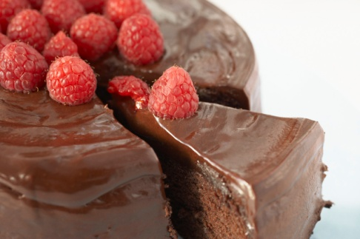
Customers do not have the same in depth menu knowledge as you do so try to put yourself in the customer’s shoes and make recommendations based on what you think they would like.
Don’t be shy about asking probing questions to help with your recommendation.

Sale of additional items
It is your role to increase revenue for the outlet and the organization as a whole. When customers are ordering food, don’t be shy about suggesting an additional item that would complement the meal. Some examples include:
- Side salads, vegetables or French fries
- Starch foods like wedges, fries, rice or other potato formats
- Beverages to compliment meals
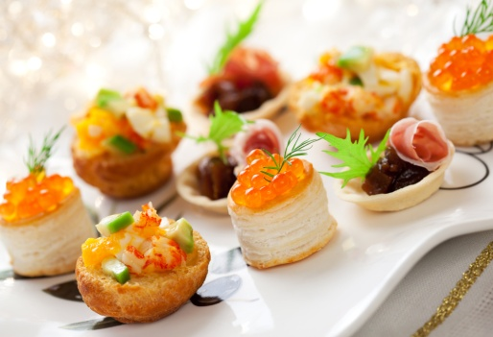
- Additional sauces or condiments
- Desserts

Upsizing/upgrading meals
Many food companies now sell different sizes of the same item to offer a greater choice. With the incentive of a larger meal for a small increase in price, many customers like this option.

Package meal deals
Many popular fast food companies employ this concept where for a set price you get three or more food and beverage items. Not only does this make ordering and preparing food easier, it also guarantees a minimum of three items being sold.

Suggestive selling
In addition if customers are sure about a certain meal (e.g. chicken) but aren’t sure of a specific dish, whilst you may not directly suggest the highest price dish, many attendants know of items that have a higher profit margin, which they may be trained to suggestive sell.
Work Projects
It is a requirement of this Unit that you complete Work Projects as advised by your Trainer. You must submit documentation, suitable evidence or other relevant proof of completion of the project to your Trainer by the agreed date.
2.1 To fulfil the requirements of this Work Project you are asked to research how to provide a helpful and attentive approach to customers including:
- Methods to greet customers on arrival
- Range of pre-meal services that can be offered
- Steps associated with escorting and seating customers
- Provide information to customers, giving clear explanations and descriptions.
2.2. Research how to take and record orders accurately and legibly including:
- Procedures when taking orders
- Information and activities associated with operating the ordering system according to enterprise procedures.
2.3. Research how to convey orders promptly to the kitchen and/or bar including:
- Relaying information manually
- Relay information about any special requests, dietary or cultural requirements
- Common types of dietary considerations and how to cater to these.
2.4. Research how to give customers advice on product selections including:
- Answering common customer questions on menu items
- How to make recommendations and optimising sales.

Summary

Take and process orders
Provide a helpful and attentive approach to customers:
Greet customers on arrival
Offering pre-meal services
Escorting and seating customers
Provide information to customers, giving clear explanations and descriptions.
Take and record orders accurately and legibly:
Taking orders
Operate the ordering system according to enterprise procedures.
Convey orders promptly to the kitchen and/or bar:
Relaying information manually
Relay information about any special requests or dietary or cultural requirements
Dietary Considerations.
Give customers advice on product selections, if required:
Answer customer questions on menu items
Make recommendations and optimise sales.

Element 3:
Prepare and pack take away food and beverages

3.1 Present and pack food and beverage items in accordance with enterprise procedures and relevant health regulations

Introduction

‘Take away’ service in simple terms is food and beverage that has been prepared for customers that will be transported to an outside location for consumption.
With this in mind, it is different to eat-in customers, as it poses some new challenges that must be successfully negotiated by outlet staff including:
- Food and beverage is prepared in its desired state
- Food and beverage can be transported to another location easily
- Food and beverage can maintain its quality during transportation, within a suitable time frame
- Customers have all the necessary items required to enjoy the meal.
Another challenge in preparing and providing for ‘take away’ service is that this style of service incorporates high volume sales which must be performed in a quick and efficient manner.
Therefore preparation must be carefully explored, with all food and beverage and their accompanying items necessary for consumption, in a ready state and easily accessible for distribution.

Maintain food safety and quality of pre-prepared foods

Monitor temperatures of food in hot food displays
Hot food is a key element of any take away service. In most take away outlets, hot food is pre-prepared and placed in food displays or is cooked to order from scratch from a par-cooked state, usually requiring minimal cooking.
It is different from a la carte service, where food is taken to the customer immediately upon cooking. In ‘take away’ service there is a time lag between when the food or beverage is prepared and when it is presented, and ultimately consumed by the customer.
If food or beverage is pre-prepared and placed in a display area, besides maintaining consistency and quality, maintaining temperature is essential.
Hot food and beverage ideally should be retained outside the Temperature Danger Zone. This means that food and beverage must be kept at about 60 degrees celcius.
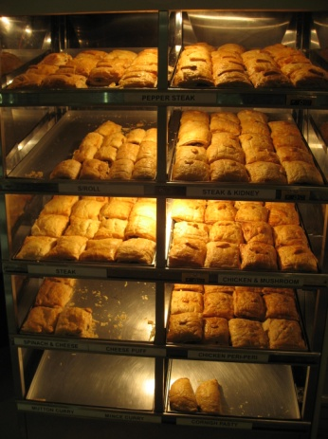
This can be achieved through the use of:
- Hot boxes
- Bain maries
- Pots and pans
- Heat lamps
- Hot plates
- Steamers
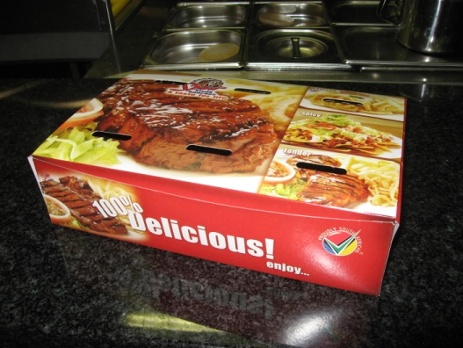
- Heated display ovens.
In addition the food or beverage container can be used to maintain heat. This could include the use of boxes, concealed cups and containers, foil or plastic wraps, or bags.
It is important to ensure that not only the outside of the food or beverage item is hot, but that the temperature has been retained throughout the item. This can be achieved through the use of temperature reading gauges and thermometers.

Monitor temperatures of food in cold food displays
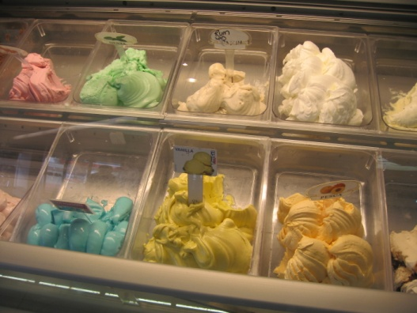
Like hot food and beverage, one key requirement of storing cold food and beverage items is to ensure that cold food ideally should be retained outside the Temperature Danger Zone. This means that food and beverage must be kept below 5 degrees celsius.
This can be achieved through the use of:
- Fridges
- Freezers
- Ice and dry ice.
Again it is important to ensure the area the food and the food or beverage items are kept in remains below 5 degrees. Again the use of temperature reading gauges and thermometers are advisable.

Protect displayed food from airborne and other contamination
Whilst prepared food and beverage is awaiting sale in display areas, there is an ever increasing risk of contamination with food maintained within the Temperature Danger Zone at most risk.
There are many ways to reduce the risk of contamination including:
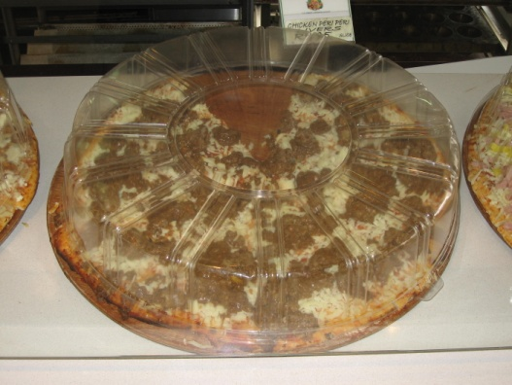
- Keeping items in their correct temperatures
- Keeping items displayed for minimal time periods
- Keeping items in closed vessels
- Keeping items in closed display areas
In addition the use of safe and hygienic practices by staff will help maintain food and beverage items in their desired state.

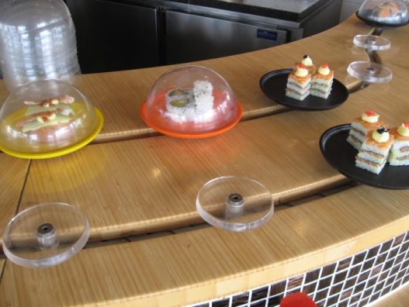
Display items attractively
The primary concept of ‘take away’ service, and that of any food and beverage outlet, is to attract customers and to make a sale.
Therefore it is important to present items in a manner that will visually entice the customer, provide all the desired information to make an informed decision and to finally ensure a sale.

Visually enticing the customer
Nothing entices the customer more that seeing the final product. Where possible allow the customer to see the end product on display.
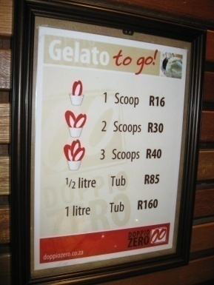
When this is not possible, the use of posters, pictures, descriptions or an ‘artificial’ display can provide the potential customer with an accurate depiction of what is on offer.
The use of displays and signs can also appeal to the customer. Special promotions and easily priced items can help customers decide the value aspect of a potential purchase.
Smells and aromas can also appeal to the customer. Some outlets keep access open to allow smells to travel further distances. In addition music and temperature of the outlet can appeal to the customer.

Providing accurate information
It is important that customers are made aware of all the information relating to an item. This could include the identification of:
- Cost, promotions or sales information
- Weight or size
- Ingredients
- Preparation method
- Health information including calorie or cookery methods
- Allergy warnings
- Spice content.

Placement of items
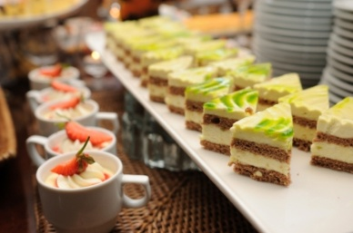
Most outlets place high profit margin or highly popular items in an area that has the greatest visual impact. This helps to entice customers to the outlet or display.
In addition, place items in a logical order to help facilitate a timely transaction and experience. Place appropriate containers and accompanying items close to the item for sale. The display of items should be arranged to ensure a smooth and efficient travel path for customers.

Use appropriate food wrapping and packaging materials
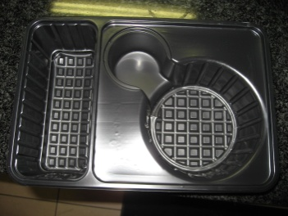
Food wrappings and packaging materials are used to safely maintain and transport take away food, beverage and their accompanying items and may include:
- Plastic, paper, waxed paper or foil wrappings
- Plastic, cardboard or foam food containers
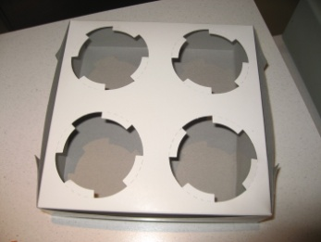
- Foam, plastic or wax paper beverage vessels
- Beverage vessel lids
- Cardboard carrying containers
- Plastic cutlery
- Napkins
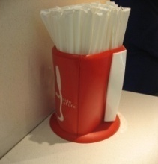
- Toothpicks
- Pre-packaged condiments
- Condiment containers
- Straws.
It is important to keep food and beverage items themselves clear of potential hygiene risks and it is also important that food wrappings, containers and packaging materials are kept in a hygienic environment.

Select appropriate wrapping and packaging materials for orders to be processed
When wrapping and packaging food and beverage items, it is important to keep in mind that items must be stored in a manner that maintains the quality and temperature of the item purchased by the customer.
Please refer to outlet and organization guidelines for using and packaging food and beverage items.

Apply appropriate stock rotation practices when replenishing displays
When replenishing items it is important to ensure that the items that have been on display and prepared earlier are kept in an area for first sale.
Therefore rotating stock is essential to maintain consistency and freshness of all items on display.
Some organizations will have an identification marker or sign to help identify the time items have been prepared.

3.2 Apply safe food handling practices in accordance with enterprise procedures and relevant health regulations

Introduction
Most ‘take away’ outlets are self service in style, with the extent varying for different outlets.
In general, food items are prepared in advance by the kitchen or service staff and displayed in appropriate display units where customers can select from, with payment to be made once the customer has selected all their items.
This service style is favored by many take away operations as it requires less staff to operate, customers have greater choice and the eating experience is kept to a minimum.
The type of food provided is normally cheaper in cost, bulk prepared and they are high profit margin items.
The attention to detail in managing a self service outlet may differ in its preparation and attention from a traditional a la carte restaurant, however the principles of providing an enjoyable eating experience comprising value and quality offerings delivered in a clean and hygienic environment by friendly and professional staff remains the same.
The following are steps an attendant must follow when maintaining a clean and hygienic environment in this high volume traffic area:

Verify sneeze guards are in place and clean
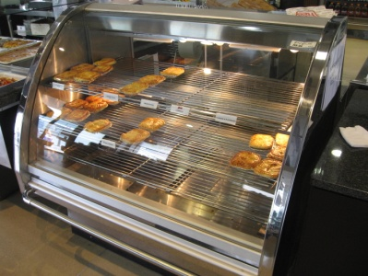
Before any food is placed in a display area, whether it is a fridge, table, buffet or hot food display it is vital the surfaces in the area are clean.
As self-service implies that customers help themselves to items, there is minimal separation between customer and food and the hygienic risks they bring with them.
Sneeze guards are designed to stop germs, dust and other hygienic risks from falling on the food. However they must also be clean to enable customers to see the food.

Place service utensils on food display
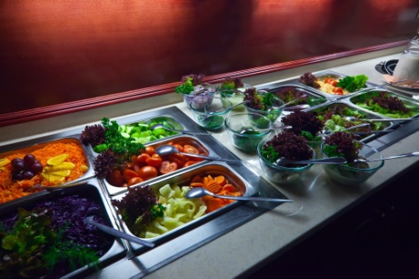
Service utensils must be placed with a suitable underplate to prevent spills and drips directly onto food display areas. Separate utensils must be selected for each individual food item to prevent cross-contamination and must be suitable for the dish and how it is displayed.
Careful consideration must be made to the composition of service utensils. Whilst metallic utensils are more aesthetically appealing, they can be dangerous when used near electrical points and equipment such as toasters, especially when handled by children.

Position safe food handling posters and signs in public view
To help prevent safety and hygienic risks it is wise for organizations and staff to have signs appropriately placed to help remind customers and staff of the importance of maintaining safe hygienic practices.

Protect food from contamination
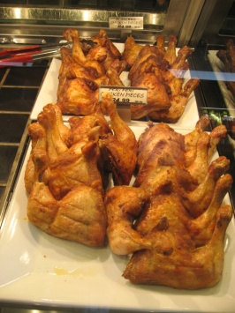
As food is displayed in a food and beverage outlet, it is not only a requirement that food appears fresh and appealing but that it actually is fresh and free from contamination.
To help keep food free from contamination there are some simple steps to follow:
- Keep food in its correct temperature zone
- If food is to be kept in the ‘Food Temperature Danger Zone’ which is between 5-60 degrees celsius, it must be covered or replaced on a regular basis.
It is advisable to prepare smaller amounts of food that can be replenished on a frequent basis.

Monitor the activities of customers at the display
Since hygiene and safety are not the primary concern of customers, they will partake in activities that may affect the quality and safety of the food and themselves.
By keeping a close eye on the display area or taking responsibility for issuing certain food items we can easily identify and rectify potential problems in a timely manner.
As a staff member, any time that you pass a food display or buffet area have a detailed look to see if items need replacing, serviceware needs changing or cleaning duties need to be performed.
By keeping a close eye of activities, it also prevents problems that may occur such as theft.

3.3 Dispose of spoiled products in accordance with enterprise procedures and relevant health regulations

Introduction
As identified in previous sections the importance of hygienic handling of food and beverage is essential to ensure that all products are maintained in a condition that is safe for human consumption.
To date, we have focused on how to keep food and beverage safe for consumption, but it is important to also manage practices which can lead to food becoming contaminated or spoilt.

Discard contaminated food and/or service utensils

Discarding contaminated food
As a general rule, any food that is left in the Temperate Danger Zone should be replaced after 30 minutes. However this may need to be done sooner for a number of reasons:
- Food appears to be spoilt, unappealing or has physically deteriorated from its desired state
- This could include:
- Food that has dried out or developed a crust
- Food that has sweated or thawed
- Food that has changed color of consistency
- Food items have been compromised due to hygiene risks, by staff, customers or the environment.
- This could include:
- Customers have touched, sneezed or coughed directly onto food
- Customers have tasted food
- Food has dropped on the floor
- Food items have been mixed together at the buffet or display table.

Discarding contaminated service utensils
Hygiene and safety risks are not only caused by food itself, but can be tainted by service utensils that come in contact with food. It is important to change service utensils that:
- Have been dropped on the floor
- Have been used to serve more than 1 food item
- Have dried food items on its surface
- Have been used as a tasting spoon by customers
- Appear unhygienic
- Have been used for longer than 30 minutes.
In general, as a staff member if you have any concerns about the safety of food or service utensils being offered to the customer, it is better to be safe and remove it from a display area or buffet.

Replenish food and other items on display as required

Replenish food
A buffet or display is designed to not only provide an accurate and appealing visual of menu items, it is also a means of providing food to customers.
The aim of any buffet or display area is to present the food in its most desirable state in the right quality.
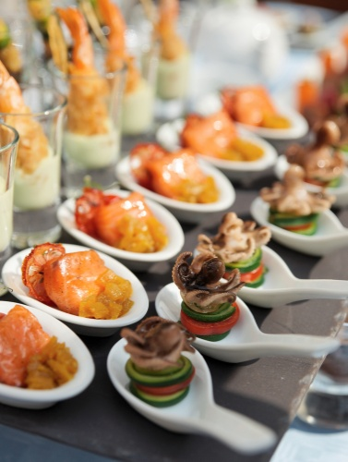
As a staff member you can gauge, through constant monitoring, if the quality standards or quantity amounts are appropriate for the service period.
Communication between the kitchen and front of house area is vital as, depending on the layout of a food outlet, some kitchen staff are not able to view the buffet or food display area on a constant basis and rely on service staff for information.
If certain items are running low or need changing, notify the appropriate kitchen staff member in advance so that customers are not kept waiting.

Replenish other items
Depending on the designation of duties, other items that affect a buffet or display area need to be replenished on a regular basis. This may include:
- Service utensils
- Crockery including plates, bowls and side plates
- Cutlery including knives, forks and spoons
- Glassware or containers for beverages
- Napkins
- Service trays
- Condiments including sauces, salt and pepper, sugar and milks.

3.4 Comply with correct food handling and food safety procedures

Introduction
Every food and beverage outlet will have their own policies and procedures in relation to handling food in a safe and hygienic manner.
Many of these policies and procedures are based on local laws and regulations.
It is important that all trainers, trainees and any persons working with food understand the local laws and regulations that apply in their country and region.
Legal requirements
Regardless of the content, all food legislation, food safety plans or programs and food standard requirements must be adhered to.
Whilst these may differ, commonly you will be required to ensure that:
- All personal hygiene practices are followed when handling food at any time
- Display units must be kept clean and cleaned after every service session
- Food items are not topped-up when they run low. For example, in a bain-marie fresh stock should not be mixed with existing food in the display. Where replenishment is required, the old tray and any food in it should be removed, and a new, clean tray with fresh food should be added to the display unit
- Display units are used only to hold cold or hot food at the required temperatures. Bain-maries and pie warmers, for example, should be turned on half an hour before service and allowed time to reach their required temperatures, and then pre-chilled or pre-heated food should be placed into the unit. Bain maries and pie warmers are not heating devices; they are holding devices
- Hot food should be held at 60ºC or above
- Refrigerated foods should be held at 5ºC or below
- Any food that is not held outside the Temperature Danger Zone must only spend 4 hours in that Zone. It must be thrown out when it has been in the Temperature Danger Zone for 4 hours
- Separate utensils (tongs, spatulas, spoons, forks etc.) should be used to handle different foods in the display
- Any doors on the display units must be kept closed to help keep the correct temperature, and to keep flies and other airborne contamination out.

Work Projects
It is a requirement of this Unit that you complete Work Projects as advised by your Trainer. You must submit documentation, suitable evidence or other relevant proof of completion of the project to your Trainer by the agreed date.
3.1 To fulfil the requirements of this Work Project you are asked to research how to present and pack food and beverage items in accordance with enterprise procedures and relevant health regulations including:
- Maintain food safety and quality of pre-prepared foods
- Attractively display items
- Use appropriate food wrapping and packaging materials
- Apply appropriate stock rotation practices when replenishing displays.
3.2. Research how to apply safe food handling practices in accordance with enterprise procedures and relevant health regulations including:
- Types of sneeze guards that can be used
- Types of service utensils on food display
- How to position safe food handling posters and signs in public view
- Ways to protect food from contamination
- How to monitor the activities of customers at the display.
3.3. Research how to dispose of spoiled products in accordance with enterprise procedures and relevant health regulations including:
- Discard contaminated food and/or service utensils
- Replenish food and other items on display as required.
3.4. Research how to comply with correct food handling and food safety procedures including:
- Understanding of local legal requirements, laws and regulations.

Summary

Prepare and pack take away food and beverages
Present and pack food and beverage items in accordance with enterprise procedures and relevant health regulations:
Maintain food safety and quality of pre-prepared foods
Display items attractively
Use appropriate food wrapping and packaging materials
Apply appropriate stock rotation practices when replenishing displays.
Apply safe food handling practices in accordance with enterprise procedures and relevant health regulations:
Verify sneeze guards are in place and clean
Place service utensils on food display
Position safe food handling posters and signs in public view
Protect food from contamination
Monitor the activities of customers at the display.
Dispose of spoiled products in accordance with enterprise procedures and relevant health regulations:
Discard contaminated food and/or service utensils
Replenish food and other items on display as required.
Comply with correct food handling and food safety procedures:
Legal requirements.

Element 4:
Provide table service

4.1 Receive customer orders

Introduction
In section 2 of this manual, the steps associated with a common ‘dine in’ service cycle were explained up to and including the point where the order has been given to the respective person who will prepare the food or beverage items.
Naturally the processes of preparing food and beverage items are too detailed to include in this manual as they are responsibilities often performed by specialist chefs or bar staff.
This section will continue to follow the logical steps performed by service staff after the order has been lodged.
Provide glassware, service ware and cutlery suitable for menu choice
Throughout a meal there can be a need to provide guests with certain items of glassware and service wear depending on the dishes and drinks they have ordered.
There is also a need to adjust the cutlery that has been set as part of the cover where their orders necessitate this being done.

Providing glassware
Most table set ups will include standard wine glasses, with many establishments also setting water glasses.
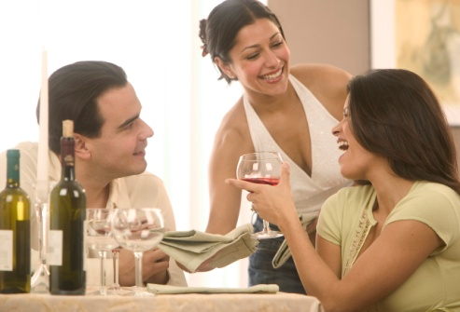
Where the guests order certain drinks and the correct glassware is not already set this will require you to:
- Remove the glassware that is not needed
- Replace it with the appropriate glasses.
It is standard industry practice that all glasses be removed from a table, and carried to a table, on a tray. Glasses should be removed and set/re-set from the guest’s right-hand side.
Practical examples of the need to adjust glasses may include:
- Removing all wine glasses where guests elect not to order any bottles of wine
- Removing the white wine glass that was set and replacing it with a (larger) red wine glass if the guest orders red wine
- Adding a red wine glass if only a white wine glass was set and the table has ordered both red and white wine
- Removing the set glasses and replacing them with champagne flutes where a sparkling wine is ordered.

Providing service wear
Depending on the dishes ordered and the style of service being used, there can be a need to provide various items of service wear to individual tables.
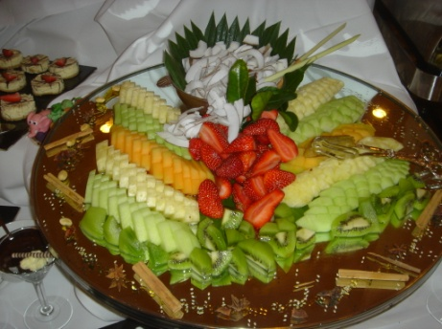
Service wear may need to be provided as follows:
- Where the service style presents, for example, the vegetables to the entire table, as opposed to plating vegetables onto individual guest plates in the kitchen, there will be a need to use service platters
- Where customers order sauces/gravy there may be a need to provide sauce boats
- Where the guest has brought in their own cake or arranged for the venue to supply one, there may be a need to use a cake stand
- Where guests order snails there will be a need to provide snail forks and tongs
- Where guests order lobster there may be a need to provide lobster picks and crackers
- Where a soup is served to the entire table, a soup tureen may be required.
- Where venues use silver service, semi-silver service or gueridon styles of delivery there will be an increased need to provide additional service wear.
Adjusting the cover
After the order has been taken and a copy transferred to the kitchen, either manually or electronically, the service staff will have to make any necessary changes to the cover to reflect the dishes that diners have ordered.
Always remember that cutlery should be carried to and from the table on a clothed service plate. Cutlery may only be carried in the hand if it is an establishment requirement.
It is a requirement that all covers are adjusted before any menu items are delivered to the table. Note however that some establishments require that dessert cutlery is only adjusted after the guests have completed their main course, and some establishments have a standard requirement that covers are not adjusted at all. If the guest doesn’t order a certain course, the cutlery stays on the cover until the table is cleared.
Your copy of the order for the table provides the basis for determining what needs to be adjusted for each diner.
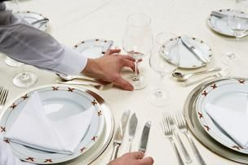
Adjusting the cover may mean you have to:
- Remove cutlery for courses that have not been ordered
- Exchange cutlery where necessary – such as swapping the main course knife for a steak knife where steak has been ordered and swapping the main course gear for fish gear where fish has been ordered
- Add cutlery for dishes that have been ordered where no suitable cutlery has been set. For example, if the cover did not include a soup spoon and the guest ordered soup, there would be a need to adjust the cover by adding a soup spoon.

Process for adjusting covers
The process requires you to:
- Identify what needs to be removed from each cover
- Identify what needs to be added to each cover
- Obtain the necessary cutlery which should be stored in your waiter’s station
- Load them onto a clothed service plate ready for carrying to the table
- Carry the clothed plate with all the required cutlery to the table
- On arrival at the table, begin adjusting the cutlery by starting at the Number One guest, working clockwise around the table. Change the knife first, then the fork, and don’t forget to place the cutlery down on the table so that it is parallel with all others
- The knives should be removed or replaced from the right-hand side of the guest, and the forks from their left-hand side. Never place cutlery by leaning across in front of a guest
- Always handle cutlery by the handles.

4.2 Check product and/or brand preferences with customer in a courteous manner

Introduction
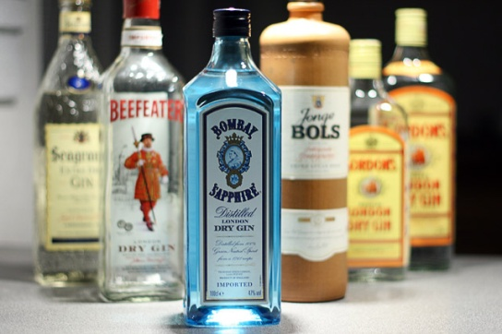
As part of the ordering process, customers will identify which item they desire, be it a food or beverage item.
Quite often, it may be up to the waiter to help explain or recommend what is available. This will be explored in more detail in the next section.
Most food items will be specifically identified on a menu, however many people will order a drink without refering to a menu.
Therefore the focus on this section will be based around clarifying beverage orders.
At times customers will indicate a specific drink in a generic manner. For example, they may ask for a ‘gin and tonic’ without specifying a particular brand.
As can be seen in this picture, there is a wide selection of gin products.
There are many different products and brands available, with more coming on to the market seemingly everyday.
It makes good sense and excellent customer service, to check with the guest regarding their preference.
Personal preference
Some people are devoted to a certain brand and simply won’t drink anything else. Examples may be Jim Beam bourbon, Gordon’s gin and a diverse range of Scotches.
Some people consider the price and are happy to drink a cheaper, domestic brand if one is available. They will appreciate your pointing this out to them.
Pour and call brands
Behind the bar, most venues stock a ‘pour’ brand, as well as several ‘call’ brands. You must know what these are in order to answer customer questions, and to provide the drink that satisfies their identified need and preference.
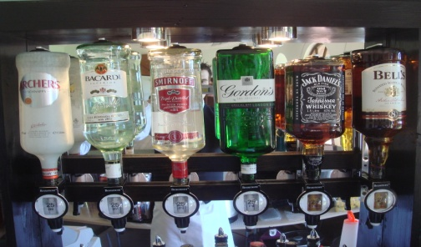
A ‘pour’ brand, sometimes referred to as a ‘house’ brand, is the brand of beverage that will be poured if someone doesn’t specify a brand name.
If the customer simply asks for a ‘Scotch’, then they haven’t indicated a preference for one particular brand, so it doesn’t matter what brand you pour them just so long as it is Scotch. In these cases the ‘pour brand’ will be supplied.
Usually pour brands are cheaper alternatives to recognised national brands, but sometimes they are the better known, better quality, premium national brands.
A ‘call’ brand is the brand ’called out’ by the customer.
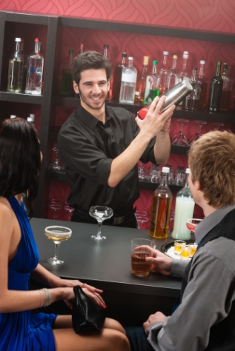
Instead of just asking for a Scotch, the customer would ask for a specific brand, perhaps a ‘Dewars’ or ‘Chivas Regal’. Most bars will stock a range of call brands, but no bar can stock them all.
You need to become familiar with the ones you stock so that you can accept an order straightaway, or inform the customer that you don’t stock their preferred brand.
Always be alert to the possibility to upsell the customer to a more expensive brand.
Where you don’t have the call brand that the customer asks for you should:
- Apologise for not having the brand asked for
- Offer an alternative.

This will be explained in more detail in the next section.
4.3 Provide clear and helpful recommendations or information to customers on selection of food or drinks, if required

Introduction
As has been mentioned earlier, waiting staff may be required to assist guests in making their selection from either the menu or the drinks list.
Lots of customers or guests come to the room, bar or venue knowing exactly what they want to eat or drink. Perhaps they have eaten at your dining room before and want to experience the same dish again that they had last time, or perhaps they have a standard meal or drink that they always have when they dine out.
This section should be read in conjunction with all other notes regarding the provision of information to customers or guests.
Recommending Food
As mentioned previously, options include:
- Recommending what it is you like – this may not suit them or be to their liking
- Recommending what is popular – they may not like this style of dish
- Recommending whatever it is that the kitchen have asked you to push – again, this may not suit them
- Asking some questions first to determine whether they are after a big meal or a snack, whether they like chicken, meat or pasta or whether they prefer plain food or dishes with sauces and added flavour and then recommend an appropriate dish.
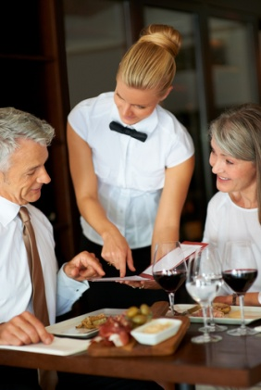
Keys in making recommendations are:
- Ensuring information is honest and truthful
- Ensuring customers/guests do not get the impression you are rushing your delivery of this information
- Ensuring guests don’t feel they are imposing on you by asking these questions
- Giving customers/guests time to make their decision without appearing to put pressure on them to ‘make up their mind’
- Providing extra information as required. There can be many times when the information you give to customers in the first instance is insufficient for their needs. For example, you may have described the ingredients of the dish and described how delicious it is but the guest may want to know about cooking style, preparation/cooking time or serve size
- Tailoring your information to suit the person you are talking to. The way you present information to young and old may vary in terms of the speed you deliver the information, the words you use and the comparisons you make with other products.
Recommending Beverages
In relation to drinks, advice or recommendations may be needed when:
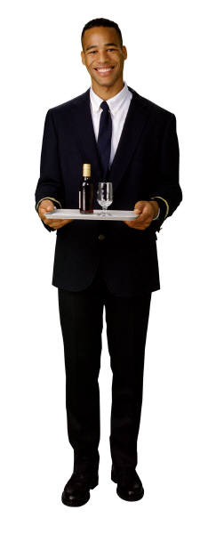
- Customers are unsure about exactly what they would like. Sometimes regular customers come in and they are just bored with their normal drink, and want something a bit different perhaps just for that session
- The drink or brand they have ordered is unavailable. After apologising you must be able to recommend an intelligent alternative for them
- It’s a special occasion – maybe they’ve just won a promotion, had a baby or are celebrating a birthday
- You have a new product in stock. Let the customers know. Tell them what it’s like, what it goes with, how much it costs, how strong it is, and so on. Perhaps the boss will let you give away a few free samples
- The customer is feeling off colour or a bit low. You may want to suggest some refreshing style of drink, or a non-alcoholic alternative to their usual
- They are dining. While a detailed knowledge of wine falls outside this unit, a very basic rule of thumb that continues to apply today as it did decades ago is “White meat – white wine, red meat – red wine”. Nonetheless, many, many people drink a nice white (say, a Chardonnay) with a steak
- They don’t want to drink alcohol, or when they need to limit their alcohol intake. You have both a moral and very much a legal duty to assist patrons who don’t want alcohol, or want a little. Be prepared to offer fruit juices, waters, mocktails (non-alcoholic cocktails), alcohol-free wine and aerated waters.
When advising customers, it is useful if you can give them information about:
- Taste, colour and aroma
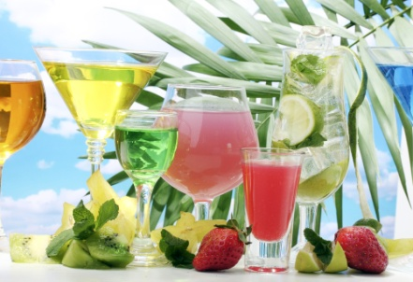
- Whether it is imported or domestic
- How it may be consumed – describing options available to enjoy the product
- The alcoholic strength
- Any special points about it – things like the worm in certain tequilas, a special advertising campaign or competitions that may be running if people buy it.
Food and Wine Combinations
There may be times when you are asked to recommend a wine to go with a meal.
Some basic suggestions include:
Food | Wine
Seafood | Semillon, sauvignon blanc, Riesling
Game | Cabernet sauvignon, shiraz, chardonnay, semillon
Red meat | Cabernet merlot, cabernet sauvignon, shiraz, malbec
Poultry | Chardonnay, chenin blanc, Verdelho
Salads | Chenin blanc, verdelho, chardonnay, Riesling
Antipasto | Chardonnay, rosé
Pasta | Chardonnay, Riesling, shiraz
Cheese platters | Cabernet merlot
Desserts | Dessert wines
You should also be sufficiently familiar with the wines on the drink list to make intelligent recommendations to compliment the food.
It is very useful to have winery representatives do a tasting of all wines on the wine list with staff, and to develop a written list (kept on display for staff behind the bar) of what wines to recommend with what menu items.
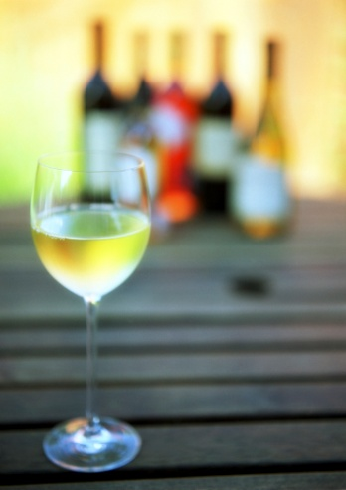
When complementing food with wine, try to select wines that will harmonise well with the dishes and their ingredients. General guidelines are:
- Whites with fish, chicken, veal and pork
- Reds with dark meat
- Reds with cheese
- Delicate wines with delicate food
- Full-bodied wines with full-bodied food
- Sweet wines with sweet food
- Sparkling wine can generally go with anything and with any course.

4.4 Serve food and drink according to enterprise requirements and personal hygiene standards

Introduction
When food and beverage items have been prepared they must be delivered to the customer. This section will focus on the steps associated with collecting and delivering items to the table, ensuring the customer is happy with the selection.
Collecting food and beverage selections
The need to collect ordered items from the kitchen or bar as soon as they are ready for service cannot be stressed too strongly.
Prompt collection of food and drinks enhances customer service in two primary ways:
- It reduces guest waiting time. Most customers prefer to receive their food and beverages as soon as possible consistent with not being rushed or pressured
- It gets the product to the guest in the best possible condition – neither menu items nor drinks improve while they stand waiting to be served.

Beverages
Traditionally a drink is the first thing to be served to the guests.
Your standard practice must be to get the first drink in front of the guests as soon as possible. This helps them settle in, and lets them know they are actually being served.
Do not simply give the order to the bar and then wander off to do something else for 10 minutes. By all means go and do something else, but only do something that will take 1 or 2 minutes at most.
When picking up the drinks to put on the tray to take to the table, make sure:
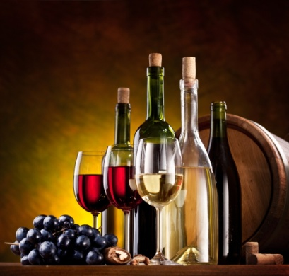
- They are what was ordered – check correct wines (vintage, brand, grape varieties), no ice where requested, long glass where ordered etc.
- Correct number have been supplied in terms of actual drinks, and empty glasses for wine
- They are suitably presented
- The correct glassware is used
- Garnishes are appropriate
- Glasses aren’t overflowing such that they will drip down the front of guests’ clothes when being consumed
- Where the drinks are not as required, you should politely point this out to the bar person who prepared the drinks and make sure the issues are rectified before taking the drinks to the table.

Food
The two service areas – cold larder and hot section – must be attended and monitored at all times to ensure prompt pick up of food.
If food is not picked up promptly the following may apply:
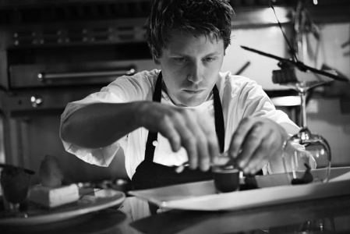
- Hot food could go cold and spoil
- Cold food could lose its chill factor
- Risk of food contamination increases
- Customers have an unnecessary wait
- Room to place down newly prepared items becomes restricted.
Before any food is taken out to the table it must be checked in the same way that drinks are checked prior to be taken and served.
Checks should include:
- Checking that the right meal has been prepared and any requested preferences have been accommodated. Dishes must reflect the order that was taken at table and given to the kitchen
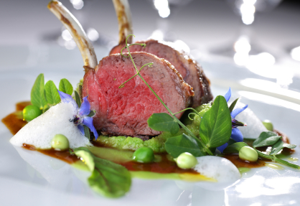
- Checking the plate to make sure there are no marks, spills or drips. Advise the chef and ask for the plate to be cleaned where these are identified
- Checking the quality of the item
- Checking with the chef to identify how a particular item has been cooked. Which is the medium steak and which is the medium rare?
- Checking if special condiments need to go with the order
- Checking to make sure there is uniformity between dishes. If three people on a table are having the same menu item then all three plates should look the same
- Ensuring correct temperature of the dish. Hot dishes should be hot, and cold dishes must be cold.
Delivering items to the table

Loading a drinks tray
Regardless of whether you are left or right-handed, trays should be carried in the left hand, and the drinks served from it with the right hand.
Some premises allow left-handed people to reverse this but many do not because when left-handed people pour a bottle using their left-hand, the left-hand will cover the label of the bottle.
Trays should not be held by their rim and they should not be held with two hands; your left hand should be held under the tray.
When loading the tray, secure the tray on your left hand. Your hand should be flat and your fingers should be spread out with only the tips of your fingers raised to support the base of the tray.
Load the tray so that:
- The tallest glasses are nearest to your body
- The heaviest glasses are in the centre of the tray
- The smaller, lighter glasses are around the tray’s edge
- The placement of the drinks on the tray facilitates their service at the table. In practice some of the above rules may not apply because it would make it too hard for you to take the drinks off the tray.

Carrying the drinks tray
The right hand can assist in balancing the tray, especially when walking to the table, or when waiting for someone to move past you where there is the potential for them to knock either you or the tray.
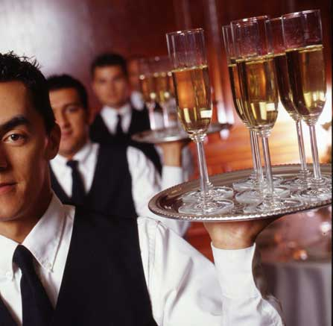
Try to keep the tray at waist level and close to your body. This will help to avoid knocking into passing traffic and optimises your control over the tray.
Even though carrying the drinks tray high above the head with one hand looks quite spectacular, this method is not recommended as the risk of disaster is quite high.
When carrying a tray, always look where you are going, not at the tray.

Carrying plates to a table
Commonly, plates may be carried in the hands using various plate carrying techniques – see next section.
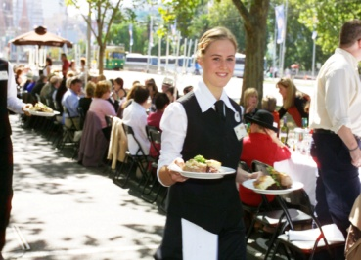
Alternatively, plates may be loaded onto rectangular food trays which are carried to the waiter’s station where they are either unloaded into the hot box or delivered straight to the table.
All items should be carried in such as way that prevents contamination by making sure:
- You don’t put your fingers on to food
- You don’t place your fingers around the top of glasses
- Long hair is appropriately tied back or controlled.
Serving food and beverage
The actual food and beverages that the guests consume is only part of the total dining experience.
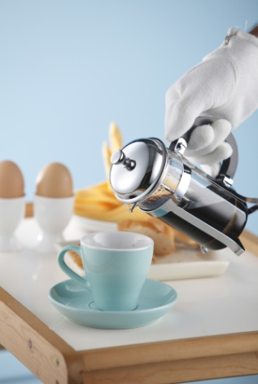
The service of those items is another vital part of the experience.
It is often the service provided to guests that separates one venue from another and is the determining factor about whether or not those people will return and tell their friends about us.
Two keys when serving food and beverage are:
- Do it quickly without giving the guest the impression they are being rushed or you are in a hurry
- Do it professionally. Serve the correct items to the correct diners, be polite, identify items as they are served, communicate and interact with guests, smile, answer any questions that are asked and check that the items presented are acceptable to the guests.

Placing the food on to the guest’s table
Always serve the meal from the guest’s right (the same side that beverages are served from) and announce the meal as it is being placed down. Consistency in service is important.
Make sure the dish is placed down so the main item on the dish – the steak, the slices of meat, the piece of fish, the chicken breast – is closest to the guest (at the 4 o’clock – 8 o’clock position).
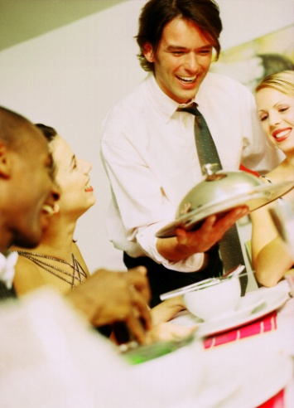
Where a steak is being served, the kitchen should have presented the steak on the plate with the fat toward the centre of the plate, and not facing the guest so they have to cut through the fat to get to the meat.
It is professional to place the right meal down in front of the right person, without having to ask, “Who’s having the chicken?” The guest numbering system comes into play when identifying which meal is to be placed in front of a particular guest. It is usual practice to announce each guest to confirm that each diner is receiving what they ordered. For example, “The Grand T-Bone, rare with extra chips. Enjoy!”
Place the dishes on to the table in such as way that the noise made by contact with the table is minimised.

Serving Food
One of the most important skills a waiter can master is the art of carrying plates.
There are two methods to choose from and proficiency in using either method can only be gained in the same way as gaining competency in carrying a drinks tray – practice, practice, practice.

Plate carrying techniques
Two Plate Carrying
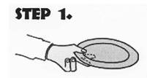 | Hold the first plate between your thumb, index finger and the middle finger.
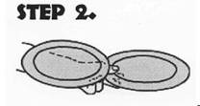 | Place the second plate above the first plate, supporting it by your fourth finger, your little finger and the base of your thumb and forearm. A third plate can be carried in the right hand.
Three Plate Carrying
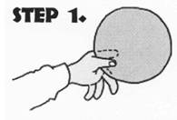 | Hold the first plate between your thumb, index finger and the middle finger.
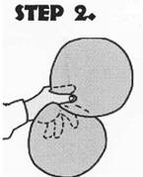 | Place the second plate into the crease of the palm of your left hand under the edge of the first plate, supporting it by your ring and little fingers.
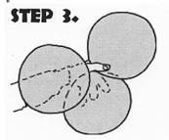 | Carry the third plate on the flat of your forearm and rim of the second plate. A fourth plate can be carried in the right hand.

Serving beverages
There are a number of points to note when serving drinks.
Always serve to the right of the seated customer, unless this is obviously impossible.
It may be impossible to serve from the guest’s right-hand side if two people are talking intimately head to head, or if there is something such as a pillar or plant in the way to the guest’s right.
Other points include:
- Trays are carried on the palm of the left hand with the tips of the fingers slightly raised – do not hold the tray by its edges
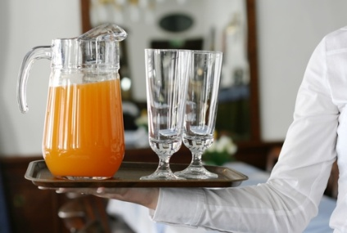
- Drink trays are usually held on the left hand so that the right hand is free to serve the drinks
- If the tray does not have a non-slip surface, then a tray liner or mat should be used to prevent glassware from slipping. The tray mat may be kept in place by smearing a few drops of water on the tray’s surface
- Service staff should handle glassware by the base or the stem. Never handle glasses by their rims, never put fingers in the glasses
- Trays are usually loaded with the heaviest glass in the centre, and the lighter glasses placed around the outside. In most cases, the last drink on the tray should be the first drink off
- Trays should be carried at waist level through the room walking with a straight back and shoulders. Don’t carry the tray above your head!
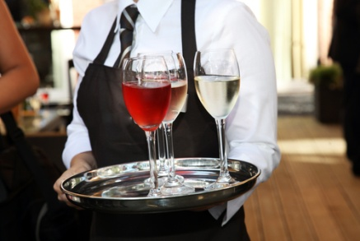
- Trays should be carried close to, and ‘within’, the body to avoid knocking into someone or something
- When unloading trays, you may have to slightly twist your body with the tray positioned slightly away from your side. This is to enable the right arm and hand to reach in towards the table and safely position the customer’s drink
- All drinks should be announced when being placed on the table. This provides an element of customer service as well as providing the guest with an opportunity to check that they are being served the drink they ordered. “Excuse me sir, your Whisky and Coke. Thank you.”
- Remember to bend your knees when serving from a tray
- Work anti-clockwise around the table, repeating the above procedures until the last drink is served
- Drink waiters should work anti-clockwise around the table, and food waiters should work in a clockwise direction. This means that they will only cross paths once at the table, saving service time and reducing the potential for accidents between staff
- Use coasters or napkins under drinks when and where required.
Checking customer satisfaction

Checking satisfaction with food
All service staff must monitor patrons during service for signs of dissatisfaction. This means keeping alert for non-verbal cues that indicate displeasure, and listening for negative comments that can be overheard.
Checking customer satisfaction must apply to both food and beverages.

The 3-minute check
When a meal has been served to the customer, it is important for service staff to revisit the table a few minutes later to check that the meals are to the customer’s satisfaction.
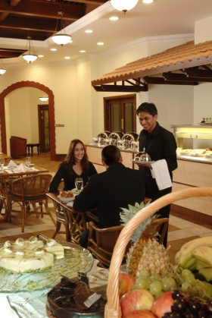
This is commonly known as the ‘three-minute check’.
It involves approaching the table approximately 3 minutes after the last meal was placed on the table and making an enquiry along the lines of “Is everything to your satisfaction?” or “How are your meals?” Individual venues may have standard statements for you to use when making this 3-minute check so check with your supervisor and adhere to specific enterprise requirements.
It is assumed that after three minutes, a customer will know if they are satisfied with their food.
If they are dissatisfied, then they can tell waiting staff and a course of action can be set in place to rectify the problem.
Remember, if you are going to ask guests whether or not they are satisfied, you have to be prepared for those who tell you they aren’t!
Don’t treat these guests as ‘complainers’, but view the situation as an opportunity to turn a problem into a positive service experience: listen to their complaint, apologise and act quickly to fix the problem.
Problems may include:
- The steak is tough
- The meal is cold
- The steak is not cooked as ordered
- Special requests have not been met.
When you replace the ‘problem’ meal, apologise again and implement another three-minute check to ensure that the replacement meal is to the guest’s satisfaction.
Speed is very important, especially where the guest is part of a group, as we do not want one diner eating their meal long after their fellow guests have finished. This can be embarrassing for them, and is a very public indication that we have got something very wrong.
It is commonplace for guests to respond positively to your enquiries about their meal at the 3-minute check and this is great.
Where you get such feedback, you should feed it back to the kitchen:
- “Table 7 say the roast is superb”
- “Everyone loves the lasagne”
- “Lady with the big party wants the recipe for the duck sauce!”
Your three-minute check also presents guests with an opportunity to order or re-order.
This may not fit in with the plans or the timing you have predetermined for your station, but these orders must be taken, or dealt with, politely and promptly.
You may be the food waiter, but the three-minute check may well result in a drink order being given. It is totally unacceptable for you to say “I’m sorry; I’m the food waiter, not the drink waiter”.
You should take the order and pass it on to the appropriate person. If there is some confusion on your part about exactly what the order is, let them know this and they can follow it up.

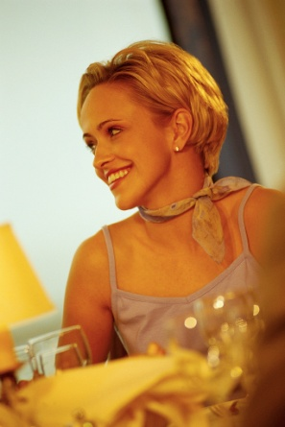
Checking satisfaction with beverages
Commonly there are fewer complaints about drinks than there are with meals.
Nonetheless, there can be occasions when drinks are less than acceptable so you need to be alert to the need to keep an eye on customers to identify when they have a problem with their drinks.
Common problems may relate to:
- The beer or white wine is warm
- The wrong mixed drink has been served – the ‘rum and coke’ is actually ‘brandy and coke’
- The wine tastes ‘off’.
In practice, the 3-minute check provides an opportunity for diners to complain about beverages as well as the food but the monitoring of drinks needs to be more frequent than just this one check.
Tips on checking customer satisfaction with drinks include:

- Monitoring the non-verbal language of drinkers – being alert to facial expressions that indicate something is wrong and being tuned in to customers who beckon you to their table
- Making eye contact with people when at or passing their tables to encourage them to speak to you if there is a problem
- Making verbal statements. In some ways this is similar to the 3-minute check concept, about their beverages, especially wine, such as “How’s the Chardonnay?”
Offering additional food and beverage
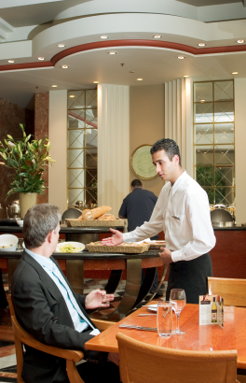
Throughout the meal the opportunity arises to offer additional food and beverages.
Selling additional items is what the employer expects you to do, and providing these items can also meet customer expectations in terms of service needs.
Offering and providing additional items that are not being sold is part of the service provision that creates customer satisfaction and meets expectations in terms of high levels of service delivery.
Additional items should be offered at appropriate times such as:
- The three-minute check
- When glasses are nearly empty
- When bottles are nearly empty
- When most bread or rolls on the table have all been consumed.
The service of additional items should be in accord with normal service practices. There should not be a lesser standard of service simply because the items are ‘additional’.
Items may include the service of condiments and side dishes such as:
- Tomato sauce
- Tabasco sauce
- Fish sauce
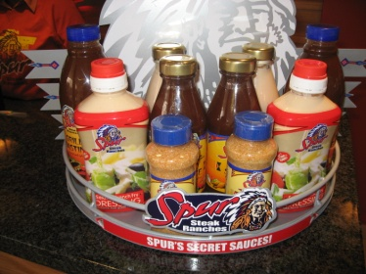
- Soya sauce
- Chilli
- Mustards
- Tartare sauce
- More butter
- More bread or rolls
- Side salad
- Bowl of fries
- Onion rings
- Rice.
Some additional equipment items that may need to be provided can include:
- Extra cutlery – to replace items that guests may have dropped on the floor
- Extra crockery
- Extra glassware
- More serviettes
- A finger bowl
- A scrap bowl – depending on the menu item being served.
Clearing tables
Used and unwanted items should be removed from tables throughout the meal.
It is never acceptable to allow used or unwanted items to build up on the table and clear the table only at the end of the meal.
Removing items progressively throughout the meal provides expected customer service, and maintain a clear ‘work surface’ to allow food and beverages to be more easily placed on the table.
When guests place their knife and fork together in the centre of the plate this is the usual sign that they have finished their meal.
Of course, not all customers will do this, so you must be aware of other signs. The most obvious being an empty plate.
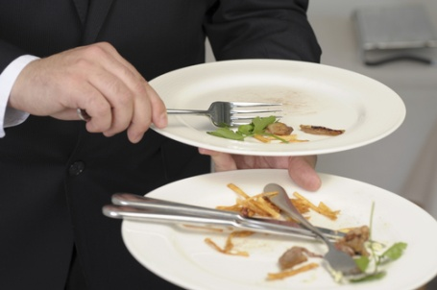
Before clearing any plates away, ask the customer if they have finished to ensure the plate can actually be cleared away. A simple question such as “May I take your plate, madam?” or “Have you finished, sir?” is all that is required.
Traditionally, with tables of up to eight people, all guests should have finished their meal before the table is cleared. This is to avoid some guests feeling they have to rush to finish their meals just because others around them may have already finished.
With tables of eight people or more, plates are traditionally cleared randomly as the guests finish their meal.
Naturally all clearing of plates must be done in accordance with establishment standards and practices, with minimal disruption to customers. If you are unsure about what applies at your workplace, then ask your supervisor.

Steps to clearing a table
The following protocols commonly apply when clearing a table:
- Try to start with the guest who has the most scraps left on their plate. This will act as the base plate for clearing
- Always clear from the right of the guest - the same side that you should have served from
- Pick up the first plate, complete with cutlery, with your right hand and transfer and secure it in your left hand
- Secure the end of the fork handle under your thumb
- Slide the knife, cutting end first, under the fork to secure it and stop it from sliding away
- Moving clockwise around the table, clear the next guest’s plate. Make sure the left hand is held back to avoid being too close to the customer, especially their head and shoulders
- Secure the second plate into position over the wrist, and scrape any food scraps onto the base plate (plate positioning will be as previously described in the Two-plate serving method)
- Secure the knife by sliding it under the securing fork
- Place the second fork parallel to the securing fork
- Continue this procedure until all the plates and cutlery are cleared for that particular course.

Remember
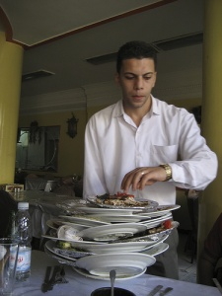
- Clearing must be done at the appropriate time (see above for guidelines) and with minimal disruption to the customers. Clearing should be ‘part of the process’ and not an interruption to it
- Clear away all unwanted or unused cutlery when removing matching course plates. If a guest has not used their main course knife for instance, it must be cleared when the main course plate is cleared
- Clear away the side plate and the side knife when clearing away the main meal plate. This is cleared from the guest’s left-hand side so as not to reach across in front of the guest
- Clear away anything that is unwanted or unused on the table at that stage
- Clear away any condiments associated with the course that is being cleared. The salt and pepper shakers, butter dish and bread basket should be cleared when the main course items are being cleared. You may however, elect to clear away breadboards or baskets as soon as bread has been consumed. Check house practice and adhere to that
- Clear away unused or dirty glassware as and when no longer required. Don’t let them build up
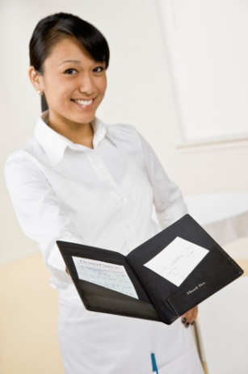
- Clear away all items in accordance with the establishment’s standards and policies. This may include directions regarding whether a tray should be used to carry these items to the waiter’s stations, or whether a clothed service plate is to be used, and whether or not items should be cleared to the waiter’s station or directly to the kitchen or bar.
Presenting and processing accounts
Naturally at the end of the dining experience customers will be required to pay for their food and beverage items.
This will be explained in more detail in Section 6 of this manual.
Thank and farewell customers courteously
All food and beverage guests should be thanked and farewelled courteously.
This applies to regulars and visitors, big-spenders and the customer who just drinks a pot of beer or squash and eats an entrée.
We must give all drinkers and diners the respect they and their patronage deserves: without these customers you don’t have a job!

The importance of the farewell
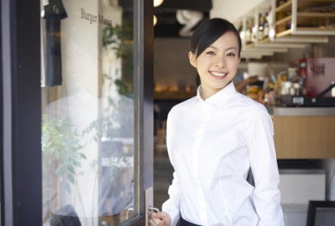
The farewelling of customers is an important part of the service cycle and one that is arguably more important than the greeting the customer receives because the farewell is often the last thing they have to remember us by.
You should also bear in mind that many customers who leave a hospitality venue, leave with nothing but have paid money for that privilege!
To illustrate this, it means that most people leave a property after having slept there, eaten there, drank there or after attending a function or entertainment event. This is totally different to most retail situations where customers leave having paid for an item they take with them and can use at home.
The point being then that the customers may have just spent a substantial amount of money, and then leave with nothing to show for it, except perhaps a full stomach. These facts underline the importance of a good farewell.

Farewelling guests
All guests should be farewelled in accordance with establishment standards and policies.
Some establishments may require their staff to walk the customers to the entrance and hold the door open, before thanking them and bidding them farewell.
Other establishments may require a more casual approach such as a smile, a wave and a simple “Thanks very much” to the guests as they are departing.
It may be standard practice to wish them “Good day” or “Good night” and “We look forward to seeing you again”, or some similar phrase.
Where appropriate you could also offer to call a taxi.
If it is raining, escorting guests to their car with an umbrella may be part of the service offered. An alternative may be to offer a complimentary coffee while the weather clears.
Whatever the standard or policy, guests should be acknowledged when they leave. Their final experience with you must be a positive one.
Work Projects
It is a requirement of this Unit that you complete Work Projects as advised by your Trainer. You must submit documentation, suitable evidence or other relevant proof of completion of the project to your Trainer by the agreed date.
4.1 To fulfil the requirements of this Work Project you are asked to research how to receive customer orders including:
- Types of glassware, service ware and cutlery suitable for menu choice
- Steps associated with adjusting the cover.
4.2. Research how to check product and/or brand preferences with customer in a courteous manner, including:
- How to identify personal preferences
- Types of pour and call brands commonly used for a range of alcoholic products.
4.3. Research how to provide clear and helpful recommendations or information to customers on selection of food or drinks including:
- Identify a range of food items and how to recommend them
- Identify a range of beverage items and how to recommend them
- Food and Wine Combinations, based on an establishment’s food and wine menu.
4.4. Research how to serve food and drink according to enterprise requirements and personal hygiene standards, including:
- Collecting food and beverage selections
- Delivering items to the table
- Serving food and beverage
- Checking customer satisfaction
- Offering additional food and beverage
- Clearing tables
- Presenting and processing accounts
- Thank and farewell customers courteously.

Summary

Provide table service
Receive customer orders:
Provide glassware, serviceware and cutlery suitable for menu choice
Adjusting the cover.
Check product and/or brand preferences with customer in a courteous manner:
Personal preference
Pour and call brands.
Provide clear and helpful recommendations or information to customers on selection of food or drinks, if required:
Recommending Food
Recommending Beverages
Food and Wine Combinations.
Serve food and drink according to enterprise requirements and personal hygiene standards:
Collecting food and beverage selections
Delivering items to the table
Serving food and beverage
Checking customer satisfaction
Offering additional food and beverage
Clearing tables
Presenting and processing accounts
Thank and farewell customers courteously.

Element 5:
Store and handle foods safely

5.1 Comply with personal hygiene standards

Introduction
Contamination is a term you will hear in all food outlets. This means that safe food has become spoiled because of how it was handled, prepared or stored.

Follow hygiene procedures
Anybody who works with food or drinks must follow the highest possible personal hygiene standards. This is one of the easiest and effective ways of making certain that food or drink does not become contaminated by bacteria (germs), physical objects (broken glass, band aid) or chemical hazards.
Ensure personal hygiene meets required standards at the beginning of and during each shift
Personal hygiene plays an important part in creating a good public image, as well as protecting the safety of our guests.
At all times, you must be aware that the human body harbours germs and bacteria. Apart from this, you work closely with customers and other members of staff. If you look crisp, clean and smart the customer will know that you carry that pride through to the way the premises is kept. Listed below are ways to make sure you meet the highest standards of personal hygiene:
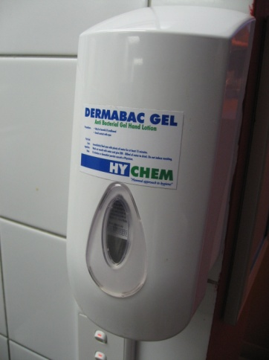
- Take daily showers
- Wear clean clothes daily
- Have clean and neat hair
- Have short, clean finger nails
- Clean your teeth regularly and ensure they are in good condition
- Keep any open cuts or wounds covered while at work by using a waterproof cover over a bandage
- Do not smoke near food and beverage preparation areas
- Wash hands on a regular basis.

Ensure hands are washed when required
Washing your hands on a regular basis is the most effective way to reduce hygiene risks in the workplace. It is essential that staff wash their hands after eating, smoking, handling garbage, handling a handkerchief or tissue or using the bathroom.
Hand Washing Technique
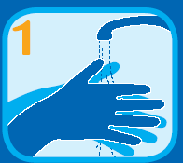 | 1. Rinse hands under hot water. Wet all surfaces.  DO NOT USE food or beverage preparation sinks to wash hands.
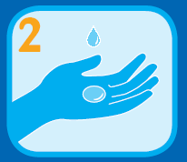 | 2. Use an anti-bacterial liquid soap from a dispenser.  DO NOT USE a bar of soap as it can spread bacteria and re-contaminate hands.
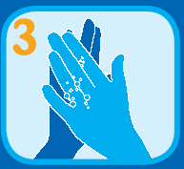 | 3. Lather up your hands and scrub them palm to palm.
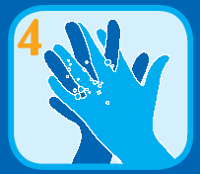 | 4. Interlace your fingers while you continue to rub your palms together.
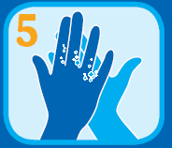 | 5. Continue to lather your hands by rubbing your palms over the back of each hand.
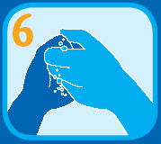 | 6. Rub the tips of your fingers, on each hand, into your palms.
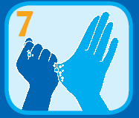 | 7. Scrub your thumbs well.
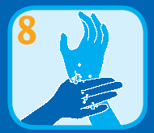 | 8. Clean your wrists.
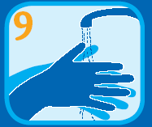 | 9. Rinse your hands with hot water.
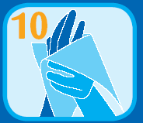 | 10. Dry with paper towel or hot air dryer.  DO NOT USE cloth towel as it holds bacteria which can re-contaminate hands.
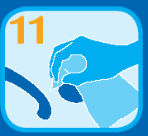 | 11. Use the paper towel to turn off the tap.

Ensure uniform is cleaned regularly and that protective clothing is worn as required

Uniforms
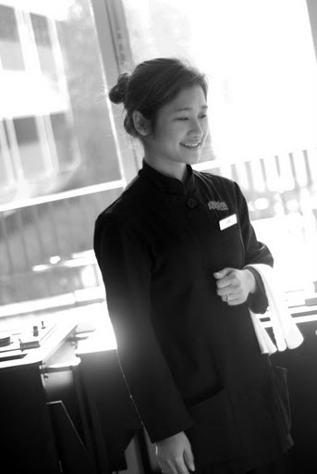
Wearing a clean uniform is not only hygienic but also provides an image of professionalism to the customer.
Wearing a clean uniform is a must for all staff and many outlets supply and clean uniforms for staff. There is nothing more distracting for the customer than seeing a staff member who not only looks but smells unclean. If a staff member cannot keep themselves and their uniform clean, it leads customers to believe that food and beverage is also kept in an unclean and unhygienic manner.
All aspects of your uniform must be given attention including hats, jackets, shirts, blouses, socks, and shoes and any other uniform requirements.
As a basic minimum requirement staff are required to wear a clean uniform for each day of work.

Protective clothing
For any service staff involved in any aspect of food preparation a wide variety of protective clothing is worn including hats, glasses, masks, hair nets, aprons, neck scarves and gloves.
This protective clothing is designed and worn by staff for two key reasons:
- Improve staff safety and reduce injury
- Keep food and beverage clear from hygienic risks

Gloves
Gloves are commonly worn in most food preparation and service areas.
Use different coloured gloves in different areas. Do not move from the toilet section to the kitchen or rooms using the same gloves.
- Gloves used for cleaning specific areas are kept for that area only
- Always wear gloves when cleaning to avoid spreading or catching disease.
- Do not handle food and money with the same gloves.

5.2 Handle food according to food safety program

Introduction
In Section 3 of this manual a number of food safety practices were detailed. This section will explore how to handle and dispose of used items in the appropriate manner.

Dispose of leftover food according to hygiene regulations and enterprise practice
Throughout the dining session and at the end of trade you may be required to dispose of leftover food used during service.
Correctly disposing of these items helps to maintain food safety and the operational effectiveness of the property
Whenever food handlers handle rubbish, it is a legal requirement that they wash their hands properly before handling food or food items/utensils again.

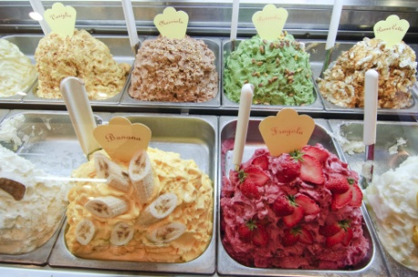
Hygiene regulations
In terms the requirements of safe food handling no food or beverages that are returned from a guest can be re-used. They must all be thrown out.
Food that is left over in terms of portion controlled butters, sugar etc. can be re-used providing the package has not been damaged, it looks presentable and (for high risk food) has not been stored in the Temperature Danger Zone for longer than 4 hours.
Butters and dairy products must be stored under refrigeration at 5ºC or below.
Proprietary sauces in the bottle can also be re-used providing the bottle, neck and cap are cleaned.
Salt and pepper in shakers can also be re-used.

Left over food
The kitchen will be responsible for dealing with left over food. That is, food that has been displayed for sale but which has not been served.
It is perfectly legal to re-use left over food provided the appropriate safe food handling practices are followed.
Your role may include returning these items, from bain maries or buffet tables, to the kitchen for processing.
The basics in relation to dealing safely with left over foods are:
- No high risk foods can be re-used if they have spent 4 hours or more in the temperature Danger Zone (5ºC – 60ºC). High risk foods are foods that are high in protein and include all meats, poultry, seafood and dairy products
- Foods that are left over must be covered, labelled and refrigerated and kept refrigerated until next required for service
- Leftover food should be used first at the next service session – stock rotation is important
- Leftover food that is to be served hot should be re-heated prior to service to 75ºC for one minute
- Where any doubt exists about the safety of the food that is left over, it should be discarded.

Enterprise requirements
Each property will have its own procedures and requirements for dealing with leftovers and disposables.
Options include:
- Throwing out all leftover food. Some properties have a standing rule that requires all leftover food to be disposed of
- Allowing staff to eat items that are left over. Some properties may allow staff to take leftover food home with them but this should not be expected. Check with your supervisor first
- Requiring high cost items to be stored for later use but allowing low-cost items to be thrown out. This may mean that meat dishes are saved while vegetables are discarded
- Separating disposables from food waste.

5.3 Maintain the workplace in a clean and tidy order

Introduction
Whilst the first and last sections of this manual focus on cleaning a food and beverage outlet at the start and the end of service, it is important that any outlet remains clean throughout service. Whist this may seem hard to achieve, especially when times are busy and customers have many requests which must be handled immediately, it is essential that dirty objects and areas are cleaned in a timely manner.
This is not only important from a hygienic point of view, but also from a customer service perspective.
Organizational policies and procedures will highlight the correct steps in cleaning each outlet and explain how to keep your workplace free of clutter or conditions that allow bacteria and vermin to thrive. Management and staff must:
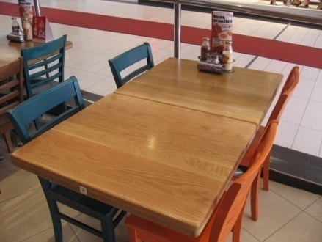
- Regularly clean and maintain the premises
- Control pests and vermin
- Implement a daily cleaning schedule
- Maintain and clean equipment (making sure any equipment used for storing or holding hot or cold food is kept at the required temperature)
- Maintain food or beverage preparation and service areas at the highest standard of hygiene
- Follow correct food storage procedures
- Follow correct garbage removal procedures
- Follow your workplace ‘no smoking’ requirements
- Do not smoke in food preparation and storage areas.

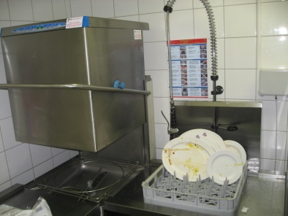
Cleaning
You may or may not be required to clean dishes or glasses that have been used as part of the service process. There is a wide variation between premises in this regard.
Some businesses will simply ask you to carry the used items back to either the kitchen or bar and off-load them. Another staff member will handle things from there.
Some premises will require you to off-load them and empty glasses (of ice, slices of lemon, decorations, remaining liquid etc.), and clear plates into a bin or waste disposal unit.
Other properties will require you to undertake the entire cleaning process for crockery, cutlery, glassware etc.

Glasses and glassware
The basic procedure is to use a glass washing machine with the procedure being:
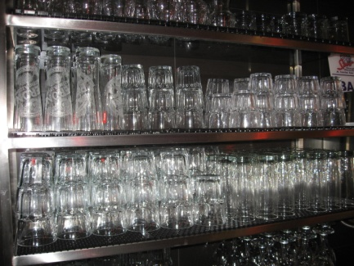
- Empty glasses and other glass items of all contents
- Load the glasses into a glass washing tray – they have to be put in upside down
- Wash the glasses in the machine when required or when the trays are full. Use the wash cycle preferred by the establishment
- Take the glasses out of the machine and either allow to air dry or hand-polish according to house requirements
- Put the clean glassware in their nominated storage areas ready for use.
Points to note regarding the glass washing machine are:
- The correct wash cycle is chosen – where options exist
- No slices of lemon etc. are allowed to block up the plug hole in the glass washing machine
- The temperature of the water being used is a minimum of 70ºC
- The machine is being supplied with the appropriate glass washing detergent, appropriately diluted (where applicable).

Crockery and cutlery
Most premises use a dish washing machine to wash crockery and cutlery and machine-specific training should be provided to you on the job.
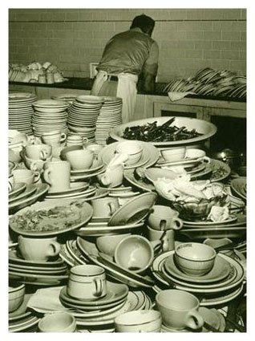
The basic cleaning procedure is:
- Remove visible food debris, for example, scrape the plates
- Rinse with warm water to remove loose dirt
- Wash with a detergent
- Rinse again to remove the detergent and debris
- Apply a sanitiser. Sanitisers are chemicals designed to kill bacteria
- Rinse to remove the sanitiser
- Allow to air dry.
Air drying is the preferred option as it eliminates using a cloth to dry surfaces, which may inadvertently introduce bacteria to the surface that has just been cleaned and sanitised.
The procedure for washing eating utensils and dishes by machine is as follows:
- Scrape and rinse items prior to stacking in trays. Use the right racks for the right items
- Wash for a minimum of 60 seconds at a temperature between 66°C and 71°C
- Rinse for a minimum of 10 seconds at a temperature of at least 77°C.
In some circumstances there will be no dishwashing machine. This is common in small businesses, and it is quite legal to use a double bowl sink providing certain requirements are observed.
When using a double bowl sink to wash eating utensils and dishes:
- One bowl must contain water at 45°C and detergent, for washing
- One bowl must contain clean water at a minimum of 77°C for sanitising
- Sanitising must involve soaking the items for a minimum of 3 minutes – it is not acceptable to just run hot water over items to remove the suds
- A thermometer must be on hand to check water temperature.
Items must once again be left to air dry, which means draining and leaving to dry while hot. Tea towels must not be used.
Operators must make sure that detergents and sanitisers are diluted according to manufacturer’s recommendations, and that all other manufacturer’s advice is adhered to.
If you are not sure how to use the dishwasher where you work, or not sure about what detergent to use for what job, or how much to dilute it – ask!

Disposing of Disposables
Disposables are ‘single use’ items.
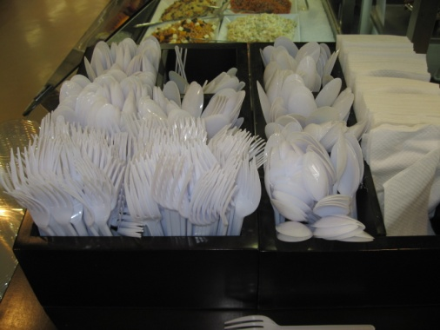
These are items intended for one use only, after which they cannot be re-used and must be discarded.
Disposables may be used as part of eat-in dining but are more prevalent where take away food sales occur.
Examples of disposable items include:
- Plastic cutlery
- Drinking straws
- Paper serviettes
- Containers for serving take away food such as aluminium foil and plastic containers, take away coffee, milk shake and other drink containers and pizza boxes. The lids to any take away containers are also included.

Dispose of recyclable items
Many properties have adopted policies that enable them to become environmentally responsible.
The basis for these policies revolves around the need to:
- Reduce - asking people to generate less waste
- Re-use - encouraging the use of a product more than once before it is discarded
- Recycle - suggesting that products can be re-made into something else.
These policies can apply not only to food and beverage items but to all waste produced by the venue.
In relation to actual food and beverages there is little that can be done in the way of recycling. These are usually disposed in the ‘normal’ way used by the property to get rid of its waste.
In some cases soft food scraps may be put through a waste disposal unit to reduce space occupied.
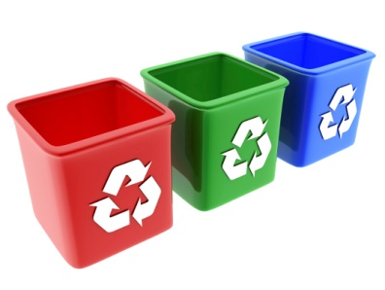
However, it is the treatment of materials used to supply raw ingredients to the property where the concept of recycling arises.
The activities of ‘Re-use’ and ‘Reduce’ fall outside the aim of this unit, but ‘recycling’ involves the sorting and disposal of waste, and sometimes its cleaning prior to separation and recycling.
Current waste management practices include the sorting of waste into the following categories in order to facilitate recycling:
- Paper – cardboard, newspapers and cardboard containers
- Plastic – soft drink, milk, juice and cordial bottles and packaging, bags
- Glass – bottles (clear, green and amber), jars and clear sauce bottles
- Steel cans – food cans and aerosol cans
- Aluminium – cans and foil
- Food waste – unusable waste scraps, trimmings and plate waste.
As a general rule, items for recycling should be cleaned (washed or rinsed) and flattened ready for collection. Each category of recyclable waste should be stored in a separate container for ease of pick-up, and to promote ease of processing.
Premises should always check with their local council to identify any local requirements that might apply.

Disposing of cleaning chemicals
As environmental considerations have become increasingly important, so too has concern over the disposal of chemicals gained in significance.
There will be a need to dispose of cleaning chemicals when:
- Chemicals have become dated
- Containers have lost their labels and you don’t know what’s inside – rather than guessing at what it is and risk using it inappropriately and unsafely
- You decide to discontinue using a certain product.
This disposal of chemicals must be done safely and according to safe environmental practices – this means:
- Cleaning chemicals must not be poured down the sink or gully trap
- Cleaning chemicals must not be thrown out with normal rubbish.

5.4 Comply with workplace measures to prevent pests entering the premises

Introduction
Contamination of food and beverage is a common concern for any food and beverage outlet and is a very serious issue.
Not only can it lead to potential deadly illness for customers, it can also result in large compensation claims, loss of business and reputation and unnecessary stress for all concerned.
The good news is that hygiene risks can easily be eliminated and controlled by establishing and following straightforward and easy hygienic practices.

Identify bacterial and other contamination food-based hygiene risks

Direct and indirect contamination
The results of food contamination can be very distressing for anyone who has experienced it. Where and how can contamination occur?
Food becomes contaminated either:
- Directly – by coming into direct contact with another bacteria contaminated food item
- Indirectly – the bacteria is transferred to the food via equipment such as knives or processors, cutting boards, food handlers or cutting boards that have come into direct contact with the contamination (insects, animals, birds, rodents, dust, refuse and waste food).

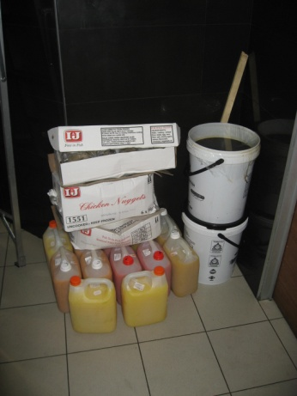
Identify hygiene risks presented by inappropriate storage of foods
Most food contamination occurs when food is exposed to potential contaminants located outside the food packaging including temperature, dust, dirt, air and dirty surfaces.
Most organizations require any food delivery, whether arriving at the loading docks, kitchens or outlets, to be stored in a timely manner. Not only does this reduce the risk of theft but ensures food is kept and maintained in a clean area at the right temperature.

Identify hygiene risks presented by poor cleaning practices

Personal hygiene and cleaning
Common causes of contamination include:
- Staff who did not maintain appropriate levels of personal hygiene by wearing dirty clothes, wearing jewellery, having dirty and long finger nails, letting their hair get dirty and not tying hair back
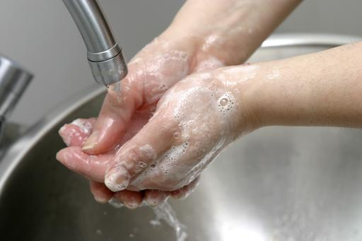
- Staff who did not wash their hands before touching food, after using the bathroom, touching their bodies or smoking
- Staff who coughed or sneezed while preparing or serving food
- Staff who prepared or served food while sick with gastric or any contagious disease, such as severe flu or hepatitis.

Cleaning of work area
Many staff perform cleaning duties as part of their position. However quite often the cleaning methods used are not sufficient enough to clean food preparation, cooking and display areas to a standard that eliminates food contamination.
Common causes of contamination due to poor cleaning of work area include:
- Cleaning with dirty cloths
- Cleaning with inappropriate cleaning agents
- Cleaning method not appropriate
- Not all surfaces are cleaned properly.

Identify hygiene risks presented by vermin and pests
Vermin and pests may include insects, animals, birds, rodents. In brief, vermin and pests cannot cause contamination if they do not come in contact with food.
Therefore it is a requirement that food is kept in secure locations when not being sold such as in fridges, freezers and dry storage areas. In these areas is it important to ensure:
- Surfaces are clean
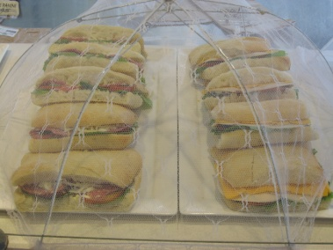
- Food is kept of the floor
- Doors are closed.
Quite often food is displayed in open areas within an outdoor food and beverage outlet. In these cases food must be covered utilizing a variety of coverings including:
- Plastic or foil wrap and covered containers
- Fly covers
- Display cabinets.

5.5 Identify and report indicators of pest presence

Introduction
All food establishments and facilities must be maintained and operated so as to prevent the entrance and harborage of vermin.
All food outlets face three chief pest concerns:
- Insects – cockroaches, flies
- Stored product pests – weevils
- Rodents – rats and mice.
Under no curcumstances is it acceptable that vermin are present in a food and beverage establishment.
Vermin are strictly illegal in all areas of the establishment, which includes the kitchen, food or equipment storage rooms, restrooms, employee locker and break rooms, customer service and seating areas, trash storage areas and exterior premises.

Dangers of vermin
They're illegal not because they are unsightly, but mainly because they are known carriers of numerous dangerous diseases causing microorganisms that can be transmitted to your food and food contact surfaces, potentially causing a serious food poisoning. They also contaminate the food with their hair, faecal droppings, urine, saliva, body parts and general filth.
All types of food facilities, even the newest, nicest, most expensive, elegant restaurant can become infested with vermin. It is fairly common because a restaurant especially, is an ideal environment for cockroaches, rats, mice, flies and other vermin and pests to thrive in.

Identifying vermin
Vermin in a food facility is a very serious problem and a public health danger, and should be immediately reported to management.
Common signs that vermin are present include:
- Visual sighting of creatures
- Sighting of droppings
- Bite marks or holes in food and beverage items or packages.

Controlling vermin
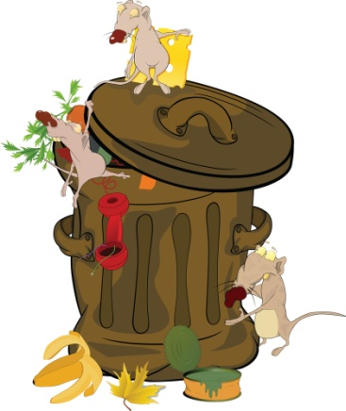
This manual has identified many food and beverage handling practices which go a long way to preventing vermin from becoming a major problem in a food and beverage establishment.
There are a number of ways in which vermin can be controlled including:
- Good sanitation practices
- Rodent and insect proofing
- Extermination and insecticide treatment.

Work Projects
It is a requirement of this Unit that you complete Work Projects as advised by your Trainer. You must submit documentation, suitable evidence or other relevant proof of completion of the project to your Trainer by the agreed date.
5.1 To fulfil the requirements of this Work Project you are asked to research how to comply with personal hygiene standards including:
- Hygiene policies and procedures
- Ensure uniform is cleaned regularly and that protective clothing is worn as required.
5.2. Research how to handle food according to food safety program including:
- Dispose of leftover food according to hygiene regulations and enterprise practices.
5.3. Research how to maintain the workplace in a clean and tidy order including:
- Cleaning to be completed
- Disposing of Disposables
- Disposing of recyclable items
- Disposing of cleaning chemicals.
5.4 Research how to comply with workplace measures to prevent pests entering the premises, including:
- Identify bacterial and other contamination food-based hygiene risks
- Identify hygiene risks presented by inappropriate storage of foods
- Identify hygiene risks presented by poor cleaning practices
- Identify hygiene risks presented by vermin and pests.
5.5 Research how to identify and report indicators of pest presence including:
- Dangers of vermin
- Identifying vermin
- Controlling vermin.

Summary

Store and handle foods safely
Comply with personal hygiene standards:
Follow hygiene procedures
Ensure uniform is cleaned regularly and that protective clothing is worn as required.
Handle food according to food safety program
Dispose of leftover food according to hygiene regulations and enterprise practices
Maintain the workplace in a clean and tidy order:
Cleaning
Disposing of Disposables
Dispose of recyclable items
Disposing of cleaning chemicals.
Comply with workplace measures to prevent pests entering the premises:
Identify bacterial and other contamination food-based hygiene risks
Identify hygiene risks presented by inappropriate storage of foods
Identify hygiene risks presented by poor cleaning practices
Identify hygiene risks presented by vermin and pests.
Identify and report indicators of pest presence:
Dangers of vermin
Identifying vermin
Controlling vermin.

Element 6:
Handle payment and carry out cash control procedures

6.1 Receive and accurately check cash float

Introduction
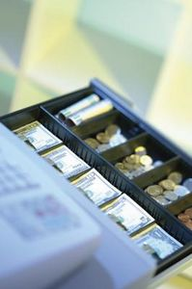
A cash float, also known as ‘the float’ is the amount of money that an establishment has deemed appropriate to commence the day’s trading for a cash register/point-of-sale (POS) terminal.
Found in the cash drawer of the cash register/POS terminal, a cash float is necessary for giving out change when completing a financial transaction, because rarely will a customer provide the exact amount of money to settle an account.
Overnight, most cash floats/cash drawers will be stored in a safe and at the beginning of each shift or day’s trading, the cash float/cash drawer will be removed by management, security, or someone from the Accounts department and either placed into the cash registers or distributed to the appropriate staff members in outlets.

Counting a cash float
When this happens, individual staff members may need to sign for their float to prove they have taken possession of it.
When signing for a float, the staff member needs to be sure the amount said to be in the float is accurate and consistent with the actual amount found in the cash drawer.
It is common practice therefore to count the float before signing for it or immediately after signing for it to ensure its contents. It is too late at the end of the shift to claim the float was short at the start of the day.
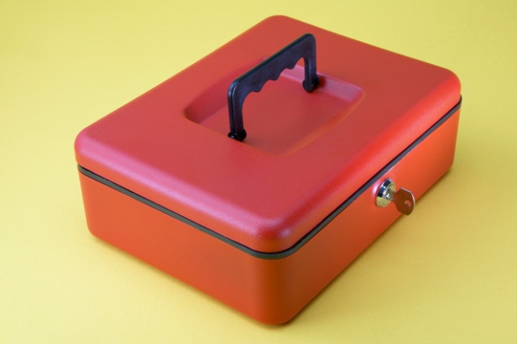
Some properties have two sheets for this process. They require the person handing over the float to count and sign in relation to the float and then the person receiving the float also has to count and sign for it.
Where a discrepancy in the amount in the float is detected, ask the person who delivered the float to double-check it.
Once you have collected your float, it is important to place your float in a secure location. This is normally in a cash drawer in a cash register.

Prepare register
A cash register is a machine that is used to accurately record transactions – both charges and methods of payments, issue accounts and receipts and to store cash and non-cash payments.
Once the float has been securely stored in the cash register it is important to prepare the register area. Tasks to be performed include ensuring there is an adequate supply of:
- Cash register paper
- Pens
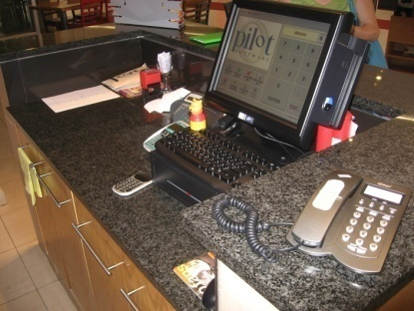
- Receipt paper
- Account folders
- Ink cartridge
- Plastic coin bags
- Sweets or other gifts normally presented with accounts to customers
- Rubbish bins
- Spare paper
- Calculator
- Currency exchange sheet, if foreign currency is permitted to be used for settlement of transactions.
The final task to be performed to ensure the cash register is ready for use is to undertake a ‘reading’ to ensure that the previous service period transactions have been closed off.

Prepare associated items
Besides the cash register there are other machines that must be checked before the start of the shift. These include:
- ETFPOS machines
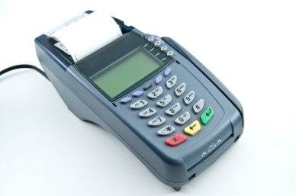
- Manual credit card machines
- In addition, it is important to have a clear understanding of information that may affect cashiering duties for the day including:
- Function sheets including event items, pricing, contact names and authorisation information.
- Methods of payment for VIP or special groups or customers
- Prices for new menu items, specials of the day or promotions.

6.2 Open and close cash register using manufacturer specifications

Introduction
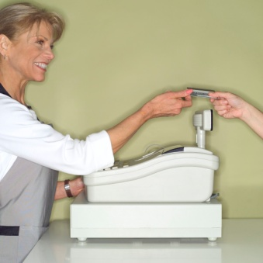
Whilst the process of opening and closing cash registers may seem like a simple process, not needing further explanation, it is important that any money or documents taken be properly secured.
During a service period you will receive large amounts of money and credit card slips through the processing of large amounts of transactions.
Theft of money and personal information from credit card slips is common throughout the world, and this is no less true in food and beverage outlets.
In your role there may be many tasks that you will perform, with processing accounts and handling money only one aspect of your day. However it is vital that security is foremost in your mind.

Secure money and documentation during trade
The following are helpful tips to employ to increase the security of cash and non-cash payments:
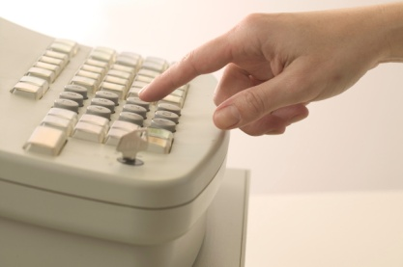
- Try not to share cash registers.
- Never leave a cash register open when unattended
- Keep cash registers out of the reach of customers
- Lock cash registers when not in use
- Keep the original note on display whilst a transaction is taking place. This reduces any discrepancies that may arise as to what monetary value the customer has given the staff member at the start of the transaction.
- Regularly store large notes under the cash till, out of display of customers
- Regularly arrange for cash registers to be cleared.

6.3 Use cash register according to standard enterprise procedures

Introduction
Food and beverage attendants may be required to process payments for meals and drinks purchased by customers.
At all times the house rules and standard procedures for processing these transactions must be strictly adhered to. These will vary between properties so it is vital to determine what applies where you work.
It is also important to remember to optimise customer service at this point so the guest enjoys a positive experience when they are paying for what they have bought.

Establish, update and finalize customer accounts

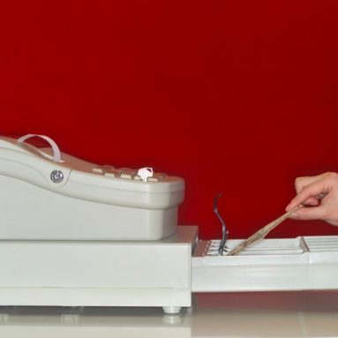
General procedures for processing accounts
Processing a customer account refers to:
- Creating an account for the customer or table
- Updating the account as items are ordered/purchased
- Finalizing the account by accepting payment.
The following procedures must be adhered to:
- When using an electronic system to process an account always make sure you follow manufacturer’s instructions. Obtain in-house training before using the system
- Review supporting dockets received to verify table/customer, make sure the dockets are legible and can be understood, and ensure only the items ordered are charged for
- Post charges (see below) promptly to ensure the account is ready when needed and to make sure money for all items bought by the customer is recovered when the account is paid
- Update the account balance or verify the updated account balance where this occurs automatically, making sure all entries are accurate and all charges have been correctly entered or processed
- Produce the final account or bill when requested by waiting staff or customer. It is important to continually update accounts during service so there is minimum waiting time at this stage
- Present account to guest/staff according to workplace policy which may require presentation of the account in a billfold, or on a plate.

Posting charges
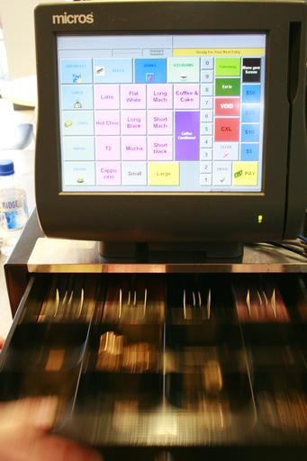
Posting charges is the process of recording transactions on a customer account. It is a term normally used where an electronic system is in use.
A ‘posting’ can be one of two types:
- A ‘debit posting’ – this increases the customer’s debt or liability to the property. It occurs when the customer has used a facility or purchased a product or service and the charges for that are added (or ‘debited’) to the customer’s account
- A ‘credit posting’. This reduces the guest’s debt or liability to the property. It occurs when a customer pays their account, partially settles their account, is given a refund or discount, or provides a deposit (such as a deposit for a booking or function). The money paid by the guest reduces their total owing and is said to have been ‘credited’ to their account.
When posting to an account (debit or credit postings) ensure:
- Speed and accuracy
- Double-check the correct account (guest, room, table, function etc.) has been updated.

Produce customer account and present for payment

Cash registers
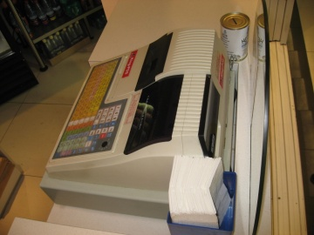
- Once the charges have been processed it should be given to the customer in a timely manner
- In take away outlets, the charges are processed in a cash register with payment requested immediately before any food or beverage is provided
- Please ensure the customer can see the register display to see charges are correctly added and the amount due displayed. In most organizations the issuing of a receipt is a standard practice and enables customers to quickly see if an account in accurate.

Account folders
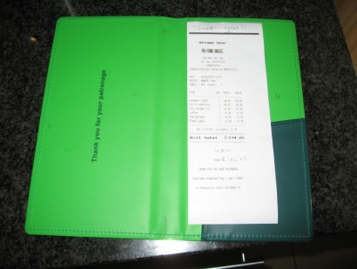
In restaurants, it is standard practice for the account to be presented to the customer at their table. In this instance accounts must be presented in an account folder and presented with a pen.
When the account folder is presented to the customer move away from the table. However it is advisable to remain in close proximity to answer any questions or to speed up the payment process, as many customers like to leave quickly.

6.4 Issue receipts according to standard enterprise procedures

Introduction
This section will explore the account management activities once the account has been given to the customer, mainly focusing on the collection and processing of payment for food and beverages consumed.

Process cash payments

Account settlement options
Depending on the services and facilities provided by your organization customers commonly settle their account by:
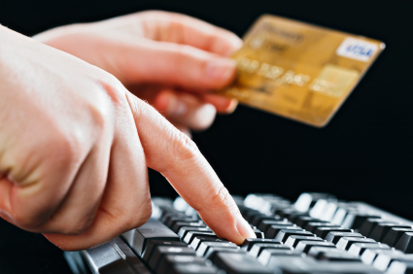
- Paying cash
- Paying via credit card through using a manual or electronic system
- Using EFTPOS facilities – ‘Electronic Funds Transfer at Point Of Sale’.
In selected situations customers may settle their accounts by:
- Charging to their room
- Charging a house account – used for functions or corporate events
- Presenting vouchers – for nominated amounts and/or items/services
- Paying by check – either a personal cheque or traveller’s cheque.
Regardless of which option a customer uses to settle their account:
- Always thank them for their patronage
- Never show annoyance if their preferred method of settlement causes additional work or effort.

Accepting cash payment
When the customer offers cash to settle an account the following will apply:
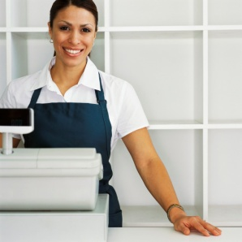
- Verify the amount tendered will cover the total of the account
- Thank customer
- Place cash on register shelf. Do not put money into cash register drawer at this point
- Register the sale (account total). This should automatically produce a receipt
- Calculate change and remove change and receipt from register
- Give change and receipt to customer. Count the change out to the customer.
- When customer has accepted their change without query, remove tendered cash from register shelf and place into register drawer.

Using EFTPOS
Many outlets have EFTPOS (Electronic Funds Transfer at Point Of Sale) terminals to accept payments (this is the same system that is used to electronically process credit card payments).
The EFTPOS system offers a banking service of deducting money from a customer’s savings or cheque account and depositing it into the establishment’s account.
When using this system to pay their account, the customer must present a relevant bank card and then enter a 4 to 6-digit PIN (Personal Identification Number) into the system for verification purposes.
Once the payment has been approved, the customer will be issued with a receipt.
With this system, the customer may have the option of having ‘Cash Out’. This means the customer can withdraw additional funds from their account over and above the amount required to settle the restaurant/bar account.
Before using an EFTPOS terminal, make sure you read the instructions for the equipment and system: familiarize yourself with its operation, and get someone to show you how to use it.

Process non-cash transactions

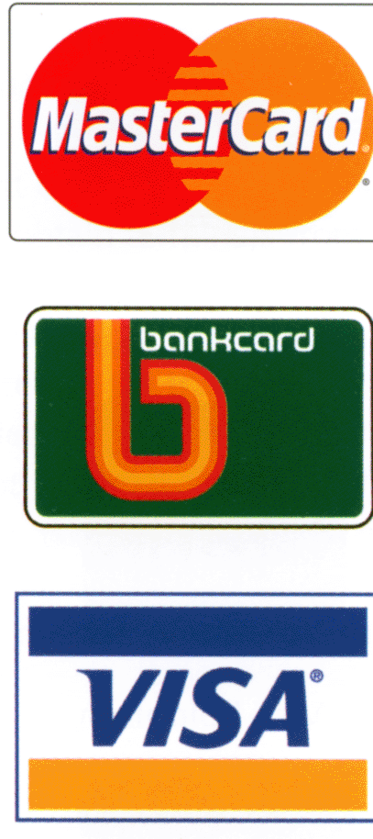
Paying via credit card
Credit card payments are processed using either a manual system or an imprint machine.
The process to take manual credit card payments is as follows:
- Confirm your establishment accepts the card
- Check card’s expiry date is still valid
- Check card against ‘Warning Bulletins’ issued by credit card companies to alert establishments of stolen or cancelled cards
- Insert the credit card into the imprint machine
- Insert the appropriate credit card slip into the imprint machine – covering the card
- Take an imprint of the card
- Confirm details are legible on the credit card slip
- Complete credit card slip with relevant details/charges, date etc.
- If the account’s total amount is over the establishment’s ‘floor limit’, call the credit card company to receive an authorization number, which must be written on the slip
- Present completed credit card slip to the customer for their signature
- Compare signature on slip to that on card
- Present customer with their receipt (middle section of credit card slip)
- Place remaining copies of slip into the cash drawer.
The process to use the EFTPOS system to process credit card payments is as follows (or some variation of it):
- The customer’s card is swiped at the terminal
- The account balance is then entered into the keypad – refer to individual operator/instructional manual for more detail on this step
- The system then processes the credit card payment
- Once payment has been ‘approved’, the guest either signs for the transaction or enters their PIN (Personal Identification Number)
- When signatures or PIN have been verified, the guest is issued with their receipt and a copy of the slip/print-out is placed into the cash drawer of the register.

Process non common transactions

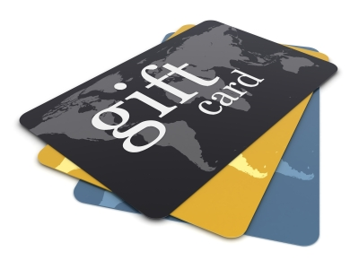
Paying by voucher
Some properties accept vouchers in full or part-payment for food and beverage items and services purchased by the customer.
Vouchers are common in some food and beverage outlets that may be attached to hotels or other products and services where package deals that include meals and drinks have been negotiated.
The customer presents their vouchers to settle (or partially settle) their account.
When accepting payment by vouchers it is important you make sure the voucher is valid and is being used in accordance with any conditions that may apply (for example, ‘dinner only’, ‘food only’, ‘redeemable only in the dining room’).
Note:
- Customers do not receive cash as change. If they do not use the full value of their voucher – the voucher is fully surrendered when tendered as payment
- Customers are required to pay for all items purchased above the value of their voucher
- Customers are required to pay for all items not covered by the voucher.

Paying by personal cheque
Every property will have their own policy about accepting personal cheques.
Generally, most properties will not accept personal or business cheques as payment unless prior arrangement has been made. This allows management to ensure the person or business has sufficient funds to cover the cheque, and enables them to decide if they will ‘take the risk’.
Accepting payment by cheque may expose the property to loss if the check is dishonored by the bank.
Some establishments will accept payment by check from regular customers. Management will usually know where these people live or where they work to enable recovery of the debt if the cheque is dishonored.

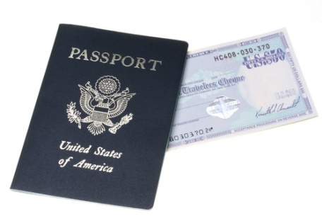
Paying by traveller’s cheque
Properties accepting traveller’s checks usually advertise the fact that they do so. Properties are not legally obliged to accept payment via traveller’s cheque.
If your property does accept traveller’s cheques, it is critical the second signature is placed on the cheque while you watch. Compare this to the first signature that already exists on the cheque.
Any traveler’s cheque presented to you with two signatures already on it must be refused.

Foreign currency
Some properties are prepared to accept payment via foreign currency.
Agreement must occur regarding the conversion rate before this method of payment is accepted.
Generally the customer is required to convert the cash into local currency and settle their account as per cash settlement.

Process gratuities
Customers may leave a tip for service staff in appreciation of good service.
Tips are also known as ‘gratuities’.
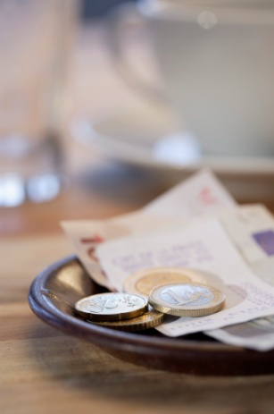
Most properties have internal rules dictating how tips are dealt with. Two basic options exist:
- Individual staff keep all tips they receive – there is no sharing of tips with other staff
- All tips are pooled into a central pool of money and then shared amongst all staff according to a pre-determined percentage. In this option kitchen staff and beverage attendants may share in tips given to food and beverage attendants.

Issue change and receipts
When dealing with money it is extremely important to manage the process in a professional and ethical manner.
For some customers from foreign countries, they may not be familiar with the currency itself, service charges, taxes and tipping guidelines which may be straightforward for a local resident.
As an ethical staff member it is important to:
- To charge the correct amount for a sale
- To return change automatically. It is at the discretion of the customer if a gratuity is given.
- Provide a receipt and explanation of charges if required
- Remind customers to collect their change
- Accurately record all transactions and store money securely.

6.5 Carry out reconciliation of takings accurately and report errors to supervisor

Introduction
Now that the operational aspect of the shift has been completed and the outlet looks clean and the reports have been prepared, it is now the priority to close off the financial transactions for the day and to safely and securely transport all payments and corresponding paperwork to the appropriate location.
Reconciling takings is the process where staff are required to match actual physical takings, both cash and non cash received, against the takings recorded in recording machines, being computers or cash registers.

Ensure security of cash
Before you start to commence the reconciliation process it is important to secure the takings. As you will be required to handle cash, normally in large amounts, during this process, it is imperative it is conducted in a secure area.

During reconciliations
All cash register reconciliations must be done in a secure location to deter and guard against theft or robbery.
It would be inappropriate, for security reasons, for reconciling to take place in front of guests or in an open space that poses a security risk.
Most properties will have a set time and location as to when and where reconciling will take place, and may even allocate a security staff member to accompany the cash drawer to that location for counting.
All properties will have some set procedures for processing and balancing financial transactions and it is vital for all staff members to be familiar with and adhere to these specific organizational procedures. If you are unsure about any aspect of the procedure then ask your supervisor.

Other cash security practices
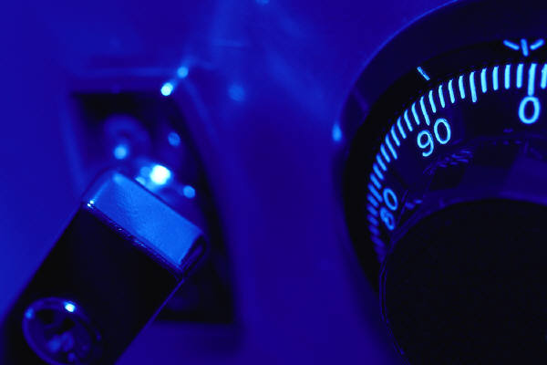
To further protect cash on the premises, a property may require:
- All cash moved within the property to be moved by two people
- Cash registers never to be left unattended
- All takings to be secured in a designated safe
- Removal of large amounts of cash from registers during trading times and the movement of this cash to a safe.

Determine register/point-of-sale terminal readings
As previously mentioned, the reconciliation process is determined to compare actual takings against takings recorded in equipment such as computers, through the use of industry specific software and cash registers or cash drawers.
The first step is to determine what takings the electronic equipment has recorded.

Obtaining the register/terminal reading
Cash registers are the most common equipment used in food and beverage outlets and therefore is the focus of this section. It is important to note that organisations may use a variety of software programs which perform similar reconciliation functions.
The majority of properties use cash register/terminal systems that have the capacity to provide an ‘X’ or a ‘Z’ reading.
An ‘X’ reading provides a reading/report on all the financial transactions processed through the cash register/terminal during the shift or day.
A ‘Z’ reading provides a final report on all the financial transactions that have been processed through the register/terminal during the shift or day, and this reading also clears the register’s memory of those transactions, leaving the register ready for the next day’s/shift’s transactions.
A ‘Z’ reading zeroes the register. An ‘X’ reading does not zero the register/reading.
Keys are required to access the ‘X’ and ‘Z’ read facilities.
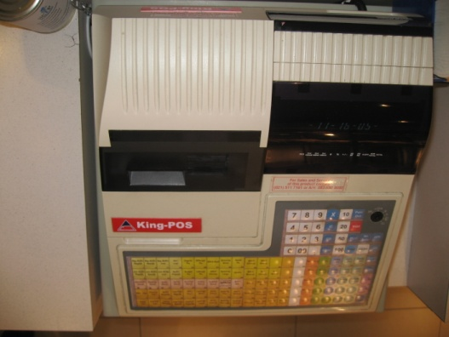
Sometimes these keys are left in the register all the time, and sometimes management has sole control over these keys.
If the keys are left in the register, you should never use them to read the register unless performing reconciliation. Your action in reading the register will be recorded on the audit roll and management may misinterpret your interest in the takings as being connected to fraudulent activity.

‘Z reading’
Some properties have a standard procedure of zeroing the cash register at the end of every day or every session’s trading.
This means the amount shown on the audit tape when the register is read represents the actual sales for that period and that period only. This is called a ‘Z’ reading.
Where registers are zeroed each day, the last reading imprinted on the audit roll should be 0000.00 to prove the register has been zeroed at the end of trade, and the first reading on the tape for the next day should also be 0000.00 to prove (for that session) that the register had been re-set to zero before trade commenced.

‘X reading’
In other situations, properties run a cumulative total on the cash register.
This means the total on the cash register is never zeroed.
The takings from every session accumulate and the total increases every session or shift.
In order to calculate the takings for today’s session, therefore, you need to know the total from the previous session. Deducting the previous total from the current total gives the amount that should be in the cash register (that is, the ‘expected takings’).
This is called an ‘X’ read.
Many properties use this ‘cumulative total’ approach to register readings as it makes it more difficult for staff to identify what the takings are, and this can help deter thieves.

Separate cash float from takings
The second step of the reconciliation process is to count the ‘actual’ takings for the service period.
To do this, what we must first do is to count out and remove the cash float from the cash drawer.

Cash float slips
Organizations may use a ‘Cash Float Slip’ to assist with counting and removing the float from the takings.
This slip allows the person reconciling the takings to count out the coins and notes for the float and keep a tally as they count.

Sometimes there will not be enough of a particular coin, or note, to make up the float exactly as required. In such cases, you may have to exchange money between the cash drawer and the establishment’s safe. Only authorised staff members will have access to the safe.
Once the float has been established, you must then put the float back into the cash drawer or into the safe. You may be required to sign the float out when it is returned to the office or placed in the safe.
The remaining money can now be counted to establish the ‘actual’ takings.

Determine cash and non-cash payments

The ‘Cash Summary’ sheet
A ‘Cash Summary Sheet’ is used to assist with recording the takings from an individual register/terminal. As mentioned, this sheet may be combined with a ‘Shift Summary’.
The Cash Summary sheet is used to record the cash takings and non-cash takings from each register every time the register is balanced. It contains space for you to write in:
- The amount of cash by different denominations for coins and notes
- The type and amount of non-cash takings
- The register reading (where a ‘Z’ reading is done) or readings and totals (where an ‘X’ reading is done)
- Any discrepancy or variance between expected takings/cash and actual takings/cash
- The date, number and location of the register/terminal to which the figures relate.

Determine cash payments
When the float has been removed, start counting the coins beginning with the lowest denomination.
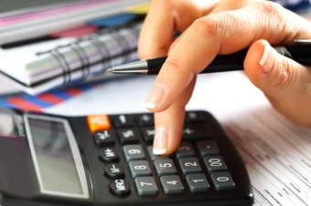
Coins are placed into appropriate coin bags and the total amount of bagged coin is documented on the Cash Summary Sheet.
Next count the notes.
Notes should be separated into different note denominations and positioned so they all face the same way, and the same way up. Then, the different note types are bundled into wads of ten notes.
Each wad/bundle of ten should then be folded in half and secured with a rubber band.
Continue this process, counting and bundling notes into bundles of ten, until all notes have been counted. Any notes that could not be bundled into tens, should then be bundled together.
Once all notes have been counted and placed into individual bundles, count the individual bundles, plus any loose notes, to arrive at a total amount for each note type.
Again, the total amounts should then also be entered onto the Cash Summary Sheet.
Once all cash (notes and coins) has been counted, tally up all non-cash payments.

Determine non cash payments
All vouchers and coupons should be added up and the total amount entered against the appropriate line on the Cash Summary Sheet.
All credit card payments should be added up and the total amount entered on the Cash Summary Sheet, too.
All EFTPOS cash transactions are added up, receipt numbers noted, and the total EFTPOS amount entered on the Cash Summary Sheet.

Balance actual revenue against expected revenue

Determining the final balance
Once all cash and non-cash payments have been calculated and the amounts entered on the Cash Summary Sheet, you then compare these individual amounts against the register reading.
A ‘Z’ reading will provide a comprehensive listing of the different cash and non-cash financial transactions processed, and an overall total amount for all transactions for that shift or day.
It is your responsibility to determine whether or not the amount of money, cash and non-cash, actually counted matches the expected takings total.
This reconcilation process is at the heart of balancing the takings,
To physically balance the takings, you should first add up the Cash Summary Sheet to arrive at individual balances for all cash and non-cash transactions, and to arrive at an overall ‘Grand Total’ balance for the period from that register/terminal.
These figures should then be compared with the appropriate figures as found on the audit roll reading.
Where the figures match, the register has balanced. This means the cash register takings ‘balance’ against the expected takings figure.

Identify discrepancies/variations
However, there will be times when the takings, cash and non-cash payments, do not match the figures stated on the reading/audit roll.
When this occurs, there is a discrepancy or ‘variance’. Actual takings are either ‘over’ the audit roll amount or the expected takings figure or ‘under’ it. This can also be known as ‘overs and unders’.
On completion of the Cash Summary Sheet you will be required to sign it.

Investigate and, where possible, resolve differences
Your responsibilities may involve investigating the reason for any variances that are identified, or you may simply be required to forward all the money and accompanying paperwork to the supervisor or office for them to investigate and resolve.

To locate the cause of a discrepancy, the following steps may be of assistance.
- Recount the coins and notes to confirm their totals are correct
- Recount the non-cash transactions to confirm their totals are correct
- Recalculate figures on the Cash Summary Sheet to ensure the problem is not an arithmetic one
- Check for any over-rings. An over-ring happens when a staff member accidentally rings up an amount on a cash register, and no payment is received. Usually, most establishments require their staff to insert ‘Over-ring slips’ into the cash register when these occur to explain why and when the over-ring happened, and who did it. Over-rings must be taken into consideration when balancing the takings.

Report variations as required by host organization policy
Sometimes, no matter how hard you try, the causes of discrepancies cannot be found.
When this happens, note the discrepancy, whether over or under, on the Cash Summary Sheet and bring the matter to the supervisor’s attention for further investigation.

Record takings

The Daily Takings sheet
A Daily Takings Sheet is the form used to record the takings where revenue is obtained from more than one cash register in a service area.
Relevant details from individual Cash Summary sheets are transcribed onto this sheet to provide an overview of total takings from the area.
When completing this sheet ensure:
- Day and date are recorded
- Special circumstances that may have impacted on sales are also added
- Separation of takings is accurate – cash, credit cards, vouchers, complimentaries, discounts, refunds, allowances etc
- Overs and unders are recorded
- All sources of revenue from every register are recorded
- Your name/signature is added.

Forward cash and documentation for further processing
Now that the reconciliation is complete, the final step is to safely transport the cash and documentation to the desired location. This is different for different outlets. At times you may be required to arrange security to accompany you to the central location or you may be required to handover to an appropriate person.
In many cases, you are to supervise that the cash and the documentation is stored together in a secure package, which has been signed off by yourself to clearly state when you have ceased control of the package. This package is normally locked to protect its contents.
Work Projects
It is a requirement of this Unit that you complete Work Projects as advised by your Trainer. You must submit documentation, suitable evidence or other relevant proof of completion of the project to your Trainer by the agreed date.
6.1 To fulfil the requirements of this Work Project you are asked to research how to receive and accurately check cash float including:
- Counting a cash float
- Prepare register
- Prepare associated items.
6.2. Research how to open and close cash register using manufacturer specifications including:
- Secure money and documentation during trade.
6.3. Research how to use cash register according to standard enterprise procedures including:
- Establish, update and finalize customer accounts
- Produce customer account and present for payment.
6.4. Research how to issue receipts according to standard enterprise procedures including:
- Process cash payments
- Process non-cash transactions
- Process non common transactions
- Process gratuities
- Issue change and receipts.
6.5 Research how to carry out reconciliation of takings accurately and report errors to supervisor, including:
- Ensure security of cash
- Determine register/point-of-sale terminal readings
- Separate cash float from takings
- Determine cash and non-cash payments
- Balance actual revenue against expected revenue
- Identify discrepancies/variations
- Investigate and, where possible, resolve differences
- Report variations as required by host organization policy
- Record takings
- Forward cash and documentation for further processing.

Summary

Handle payment and carry out cash control procedures
Receive and accurately check cash float:
Counting a cash float
Prepare register
Prepare associated items.
Open and close cash register using manufacturer specifications:
Secure money and documentation during trade.
Use cash register according to standard enterprise procedures:
Establish, update and finalize customer accounts
Produce customer account and present for payment.
Issue receipts according to standard enterprise procedures:
Process cash payments
Process non-cash transactions
Process non common transactions
Process gratuities
Issue change and receipts.
Carry out reconciliation of takings accurately and report errors to supervisor:
Ensure security of cash
Determine register/point-of-sale terminal readings
Separate cash float from takings
Determine cash and non-cash payments
Balance actual revenue against expected revenue
Identify discrepancies/variations
Investigate and, where possible, resolve differences
Report variations as required by host organization policy
Record takings
Forward cash and documentation for further processing.

Element 7:
Close down food service area

7.1 Store and/or prepare equipment for the next service, in accordance with enterprise procedures

Introduction
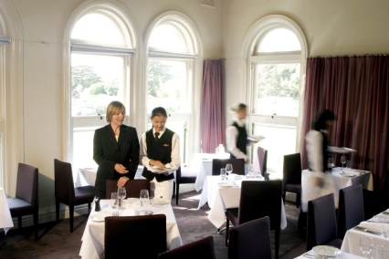
At the end of service the room must be serviced to make it partially ready for the next shift.
The procedures can include:
- Clearing, cleaning, tidying, dismantling equipment, storing furniture and turning various items of equipment off
- Reading the registers/POS terminals and reconciling the takings as well as securing the takings and all relevant documentation
- Preparing the area for the next session by setting up for the next service which may including ordering stock and stowing stock away as required ready for the next session
- Holding a debriefing session to review and evaluate the service session that has just been finalised
- Handing over the room to the next shift.

Storing and preparing equipment
As previously mentioned, there are various pieces of equipment and different service items that must be prepared, cleaned, maintained and attended to before and during a shift.
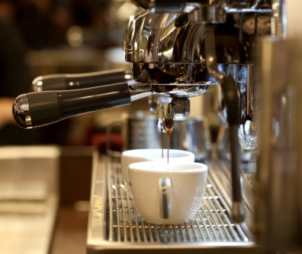
At the end of the shift, specific and regular tasks may be required. These pieces of equipment and items may need to be:
- Cleaned and left out ready for the next shift
- Cleaned and stored away ready for use some time in the future
- Turning off specified electrical items or adjusting them in line with house requirements.
Equipment and other items that may require such attention includes:
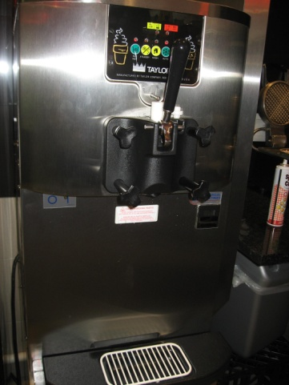
- Coffee machines
- Tea making facilities
- Bain-maries
- Toasters
- Menus and wine lists
- Condiments and sauces
- Cutlery
- Crockery
- Glassware
- Linen.
All equipment and items must be cleaned in accordance with manufacturer’s instructions. Refer to these instructions for specific directions in every instance.
All storage must occur in accordance with establishment standards which may include:
- Ensuring staff and equipment safety in accordance with identified risk management procedures and OSH responsibilities
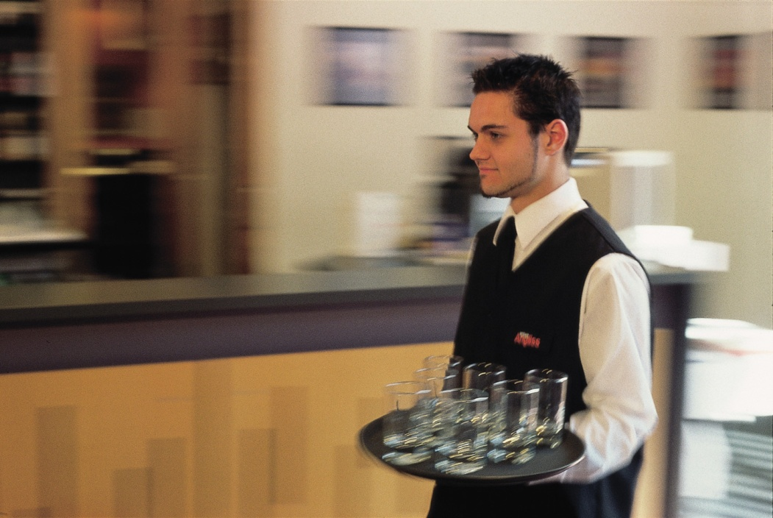
- Ensuring all items are cleaned before storage. No item should be stored in an unclean condition. This can attract pests, delay the use of the item when it is needed and make it harder to clean at a later date
- Ensuring that food-related items are protected from contamination
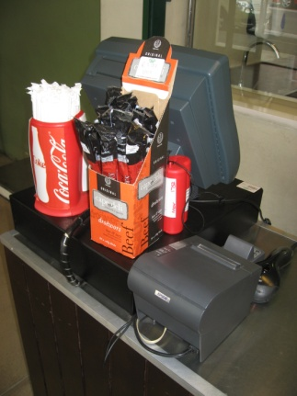
- Making sure items are returned to their nominated locations so that other staff will know where they are when these items are needed
- Checking individual items as part of the storage process. Where you identify an item that is unsafe, not working properly or is damaged, you should notify your supervisor
- Checks may also include:
- Refilling salt and pepper shakers
- Filling up drinking straw containers
- Refilling tooth pick containers
- Cleaning items individual items.

7.2 Clear, clean or dismantle area in accordance with enterprise procedures and safety requirements

Introduction
Once equipment and other items are cleaned and stored correctly, the focus now is on ensuring the work area is clean, tidy and hygienic. Whilst Section 1 of this manual describes a range of tasks to undertake to get an area ready for service, none of these can take place unless the work area itself is clean and tidy.

Clearing and cleaning
Various areas in a restaurant need to be cleaned, cleared or dismantled at the end of service sessions.
These procedures must be completed in accordance with establishment standards and comply with all safety requirements.
Sometimes cleaning staff perform these functions and sometimes waiting and bar staff do.
In some cases, these tasks are completed at the end of the shift, and in other cases, the duties are left until the start of the next shift.
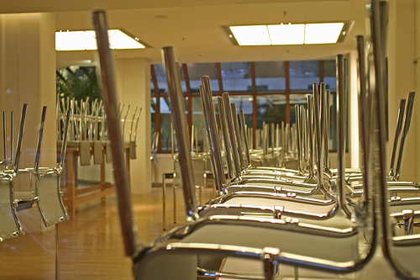
Some of those areas may include:
- Stripping tables – including removal of all table items, and the tablecloth. Part of this process may include checking the seats of chairs to ensure they are clean and tidying the area immediately around each table. In some cases you may be required to put the chairs on the tables to facilitate a full clean of the floor by cleaners
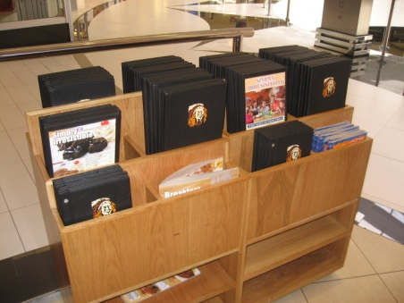
- Around the coffee machine where coffee grounds and spillage are common, and there is normally a need to do a general ‘clean and tidy’. Where required, replacements and top-up of items such as coffee, sugar, crockery etc. should occur
- The waiter’s stations – to clean and replenish supplies
- Laundry areas – in cases where service staff are responsible for laundering of the dining room/bar linen they may have basic cleaning and tidying responsibilities including checking levels of chemicals and linen supplies
- Kitchen food service area. The tasks here should be restricted to service-related activities such as refilling condiments, tidying, replacing used items back into this area
- Restroom facilities. Commonly the primary responsibility for cleaning this area belongs to the cleaners but waiting staff may have end of shift duties such as:
- Checking to make sure no patrons remain in these areas after the premises have closed
- Checking to see if any items have been left there
- Checking to identify damage or cleaning needs that demand immediate action
- Replenishment of toilet supplies, as appropriate
- Furniture – basic requirements may include:

- Relocating tables and chairs to their ‘original’ position. Note that some properties simply leave tables and chairs as they are and do not relocate them until the seating plan for the next session is developed
- Taking table tops of tables. Where the venue adds table tops tables, it is a standard requirement that these table tops are removed and stored at the end of the session
- Removing extra chairs that have been brought in. A dining area that normally seats 80 may have had an additional 6 chairs brought in for a session to cater for special needs. These 6 chairs have to be put back where they were taken from
- Removing high chairs. Where patrons have requested a high chair it is standard practice to replace these chairs back into storage
- Fixtures and fittings. A check on these should be made which may include:
- Checking for damage
- Watering plants as required
- Clearing papers or rubbish and used glasses etc.
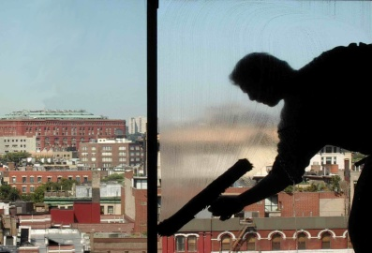
- Windows and doors – spot cleaning as required and checking to ensure they are closed and locked
- All floor areas – picking up loose rubbish and checking to identify areas that require special attention
- Displays – including re-stocking display items and securing items
- Guest waiting area and reception – spot cleaning and tidying
- Garbage area – removing garbage from internal rubbish bins and replacing bin liners.
As mentioned above:
- Where you identify an item that is unsafe, not working properly or is damaged, you should notify the appropriate person
- Clearing and cleaning duties should incorporate other checks such as OSH checks, security checks, safety inspections to save time.

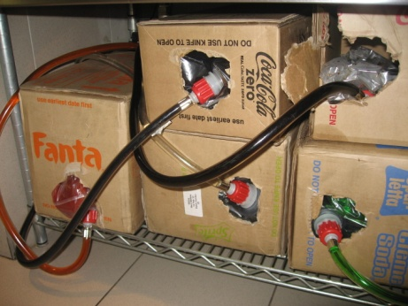
Dismantling items
Where necessary, staff may be required to dismantle:
- Post-mix stations – for cleaning
- Espresso machines – for cleaning
- Table tops – to return table tops top storage
- Bain maries – for cleaning.

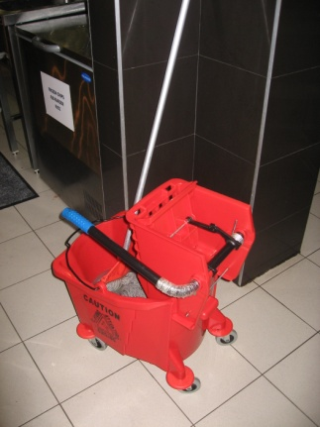
Storing cleaning equipment away after use
After cleaning duties have been completed, all cleaning items, equipment and chemicals must be stored away in the appropriate place so that others can use them when required.
Usually items will simply be replaced back to the area from where they were obtained.
Things to note when storing items away after cleaning tasks include:
- Stowing items neatly and tidily. Don’t just throw items into a room. Treat them with care and respect and ensure they are easy for the next user to get at
- Checking the equipment for faults or damage. Where items are not working properly this must be reported immediately to your supervisor so that arrangements for repair, or some other alternative, can be made. Special attention must be paid to electrical equipment
- Cleaning the equipment used. This can include:
- Emptying vacuum bags
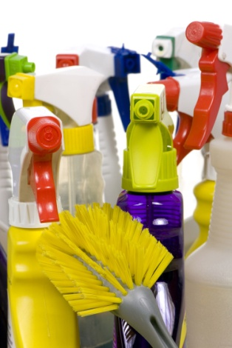
- Emptying the tanks of wet vacuum cleaners
- Wiping down exterior surfaces
- Drying equipment, where appropriate
- Washing and sanitising mops and hanging them out to dry
- Cleaning brooms
- Checking supply level of cleaning chemicals. Notify your supervisor where supplies of these are running low. You may be required to complete a requisition for these, or you may be expected to obtain the necessary supplies for the store room
- Checking supplies of cleaning materials such as cloths, trigger spray bottles, cleaning pads, scourers, protective gloves and obtaining what is required.

7.3 Set up area correctly for the next service, in accordance with enterprise procedures and requirements

Introduction
At the end of each shift, the dining area may need to be set up for the next shift: sometimes this is left for the next shift to do.
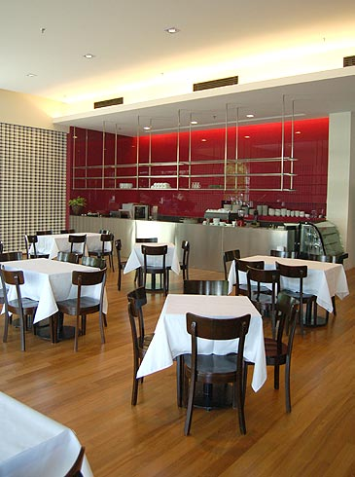
As mentioned, Section 1 of this manual will detail the majority of steps undertaken to prepare for an upcoming shift, so they won’t be repeated in this section.
Set up may involve minimal work if the next shift is going to be serving guests with the same or similar type or style of menu and floor plan, however setting up for the next shift may involve a great deal more effort and time if the type of service or style of menu is different.
Therefore there may be some activities that have not been mentioned that need to take place, especially if the next service offering is different to the one that has just finished.

Setting up for a breakfast shift
Sometimes the evening shift service staff will have to partially set up for the breakfast shift the following morning.
This may include having to:
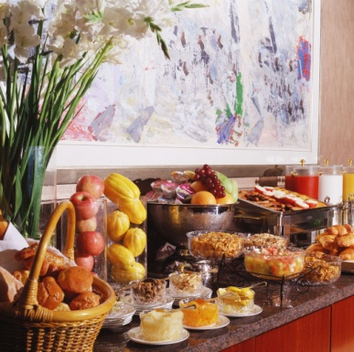
- Re-lay all tables and set covers for a breakfast menu
- Place breakfast menus on tables or at other designated locations in the room
- Place sealed portion-control condiments (such as sugar, jam and honey) on to service areas or customer tables
- Set up the breakfast buffet with the appropriate equipment, displays and non-perishable food items such as cereals etc.
- Re-stock refrigerated and non-refrigerated items that will be needed to service the breakfast menu.

Setting up for a function
Sometimes staff may have to set up the dining area for a function.
These requirements will vary depending on the type and style of menu, service style, and other requirements to meet the demands of the client for the function.
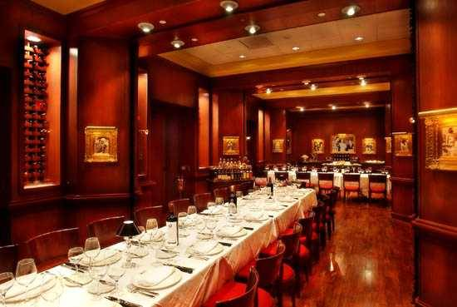
A ‘Function Sheet’ should be used to direct activities which may include a need to:
- Rearrange all tables and chairs
- Set covers on tables according to the menu
- Set up a buffet and equipment needed to service it
- Stock specific food and beverage items
- Clear an area for entertainment or displays.

Enterprise procedures and requirements
Regardless of the set up activities that are taking place, it is essential that any organisational procedures and policies be followed by all staff. Whilst these will vary for different organisations and for different shifts, some common requirements include:
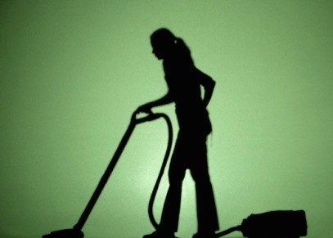
- Ensuring safety of premises and furniture, equipment etc.
- Preserving food safety
- Ensuring security of the premises during set up. Most premises are closed to the public during these preparation times but need to open as required to allow access by suppliers to the area. This need for access obviously has the potential to jeopardise security so special attention needs to be paid to security at these times
- Following identified sequences for room preparation. Properties will normally have a staged way of setting up a room so following the identified procedures is a necessity
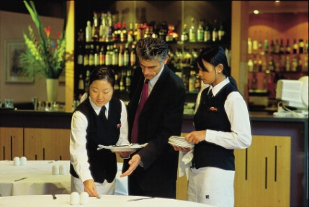
- Communicating with others to integrate total property needs
- Completing necessary documentation such as requisitions forms, ‘change required’ slips, maintenance requests etc.
- Adhering to imposed labour budget restrictions such as making sure that certain staff knock off when required as opposed to dragging out their work time to gain extra pay.

7.4 Review and evaluate services with colleagues, where appropriate, identifying possible improvements

Introduction
It is recommended that there is a debriefing session at the completion of every service session.
The debriefing is a short meeting (5 – 10 minutes) where management and staff can review and evaluate the previous session with a view to congratulating staff on their work and effort, and identifying areas where improvements to service can occur.

Reviewing and evaluating the service session
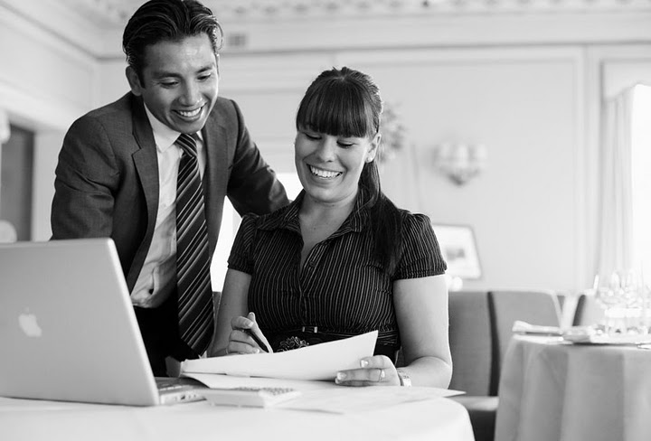
Prime concerns at this meeting should be:
- Communication between food and beverage staff
- Communication between food and kitchen staff
- Cooperation between staff in all food and beverage areas
- Integration of service between food and beverage staff.
The supervisor leads the session. Where the food and beverage staff have separate supervisors, the two supervisors conduct the debriefing jointly and:
- Congratulate staff on work that has been well done during service. This can be generic in nature or it may single out individual staff who performed really well
- Highlight and lead discussion on problems and issues that arose with a view to determining what went wrong and how a similar event can be avoided in the future
- Provide the staff with feedback from their perspective of how the session went. Provide feedback they have captured from others such as customers, management or other departments
- Review the quality of service delivery provided with a view to identifying changes that could lead to possible improvements in service delivery
- Encourage staff to identify issues of concern to them, including identification of problems they have found with equipment, suspicious persons, procedures that are not working effectively, lack of cooperation etc.
- Present issues and details of what can be expected in the next session such as pre-warning staff about a function, a revised starting time for the next shift, expected customer numbers, proposed special events etc.
- Thank staff for their efforts and contribution.

7.5 Provide handover to incoming colleagues and share any relevant information

Introduction
A handover is a situation where the department remains open but the staff working in that department change.
While it is uncommon and often inadvisable for all the staff to change when there is a handover (as it is best if there is some continuity of staff) this situation can sometimes occur, especially where there is only one staff member running a department.

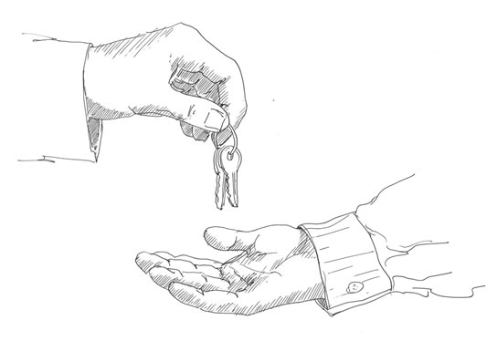
Providing handover
There may be times when a shift has to be handed over to an incoming colleague.
During such times, all relevant information should be shared with incoming staff.
The intention should be to achieve the handover without the guests even being aware that it has happened, or with minimal disruption to them.

The only allowable departure from this is where you have developed a special relationship with guests, and it seems appropriate to say “goodbye” to them. In these cases, not to do so may be interpreted as being rude and impersonal.
It is imperative that the flow of service continues.

Pre-handover checks
Prior to doing a handover, the outgoing shift should ensure:
- The department is clean and in good order. This includes all areas including floors, counters, desks, equipment
- Available stock has already been put away – new, incoming staff should not be responsible for this unless there has been an extremely busy session that has prevented outgoing staff from doing this
- Where the department handles cash payments, there must be change in the register sufficient for the next shift to at least start their shift without experiencing a shortage of change. Where necessary change should be ordered to supplement what is already there.

Sharing relevant information

Information that may need to be addressed and passed on could include:
- Status of the customer’s orders and service – what’s been served, where they are up to, what’s happening in the kitchen or bar in relation to the order. Incoming staff need to be briefed, for example, on what Table 4 has ordered, what has been served so far and how long it has been since their last course was cleared
- Availability of beverage products and supplies – what is running low, what has run out, how many serves of XYZ there are, including what action (if any) has been taken to secure extra supplies
- Changes or alterations to the menu. This should include sharing details about today’s specials, items that have been added at the last minute or just for today including items that the kitchen wants promoted
- Any customer complaints – who has complained and about what, any complaints that seem to be part of a trend and information about what action has been taken in response to these complaints
- Roles for incoming staff members so that individual workers know exactly what they are to be doing for the upcoming shift. For example are they doing food? Beverage? Both? Acting as runners? Accepting payment? Which station are they working?
- Information about specific pieces of equipment or utensils with attention to issues such as malfunctions, damage or lack of equipment
- Discussing financial transactions including identification of:
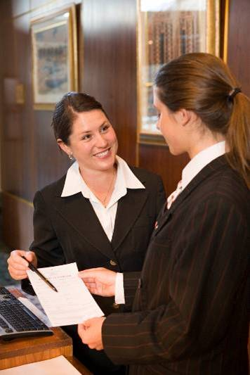
- Who has already paid
- Tables/guests where advanced deposits have been received
- Any guests who have indicated that they alone and no-one else at the table are to get the account
- People who may be dining on vouchers
- Guests who are in-house guests and can be expected to charge to their rooms
- Tables where accounts have been presented but not yet paid
- The status of every account or table in the room.
Work Projects
It is a requirement of this Unit that you complete Work Projects as advised by your Trainer. You must submit documentation, suitable evidence or other relevant proof of completion of the project to your Trainer by the agreed date.
7.1 To fulfil the requirements of this Work Project you are asked to research how to store and/or prepare equipment for the next service, in accordance with enterprise procedures, including:
- Storing and preparing equipment.
7.2. Research how to clear, clean or dismantle area in accordance with enterprise procedures and safety requirements, including:
- Clearing and cleaning
- Dismantling items
- Storing cleaning equipment away after use.
7.3. Research how to set up area correctly for the next service, in accordance with enterprise procedures and requirements, including:
- Setting up for a breakfast shift
- Setting up for a function
- Enterprise procedures and requirements.
7.4. Research how to review and evaluate services with colleagues, where appropriate, identifying possible improvements, including:
- Reviewing and evaluating the service session.
7.5 Research how to provide handover to incoming colleagues and share any relevant information, including:
- Providing handover.

Summary

Close down food service area
Store and/or prepare equipment for the next service, in accordance with enterprise procedures:
Storing and preparing equipment.
Clear, clean or dismantle area in accordance with enterprise procedures and safety requirements:
Clearing and cleaning
Dismantling items
Storing cleaning equipment away after use.
Set up area correctly for the next service, in accordance with enterprise procedures and requirements:
Setting up for a breakfast shift
Setting up for a function
Enterprise procedures and requirements.
Review and evaluate services with colleagues, where appropriate, identifying possible improvements:
Reviewing and evaluating the service session.
Provide handover to incoming colleagues and share any relevant information:
Providing handover.

Presentation of written work

1. Introduction
It is important for students to present carefully prepared written work. Written presentation in industry must be professional in appearance and accurate in content. If students develop good writing skills whilst studying, they are able to easily transfer those skills to the workplace.

2. Style
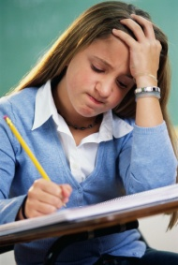
Students should write in a style that is simple and concise. Short sentences and paragraphs are easier to read and understand. It helps to write a plan and at least one draft of the written work so that the final product will be well organized. The points presented will then follow a logical sequence and be relevant. Students should frequently refer to the question asked, to keep ‘on track’. Teachers recognize and are critical of work that does not answer the question, or is ‘padded’ with irrelevant material. In summary, remember to:
- Plan ahead
- Be clear and concise
- Answer the question
- Proofread the final draft.

3. Presenting Written Work
Types of written work
Students may be asked to write:
- Short and long reports
- Essays
- Records of interviews
- Questionnaires
- Business letters
- Resumes.
Format
All written work should be presented on A4 paper, single-sided with a left-hand margin. If work is word-processed, one-and-a-half or double spacing should be used. Handwritten work must be legible and should also be well spaced to allow for ease of reading. New paragraphs should not be indented but should be separated by a space. Pages must be numbered. If headings are also to be numbered, students should use a logical and sequential system of numbering.
Cover Sheet
All written work should be submitted with a cover sheet stapled to the front that contains:
- The student’s name and student number
- The name of the class/unit
- The due date of the work
- The title of the work
- The teacher’s name
- A signed declaration that the work does not involve plagiarism.
Keeping a Copy
Students must keep a copy of the written work in case it is lost. This rarely happens but it can be disastrous if a copy has not been kept.
Inclusive language
This means language that includes every section of the population. For instance, if a student were to write ‘A nurse is responsible for the patients in her care at all times’ it would be implying that all nurses are female and would be excluding male nurses.
Examples of appropriate language are shown on the right:
Mankind | Humankind
Barman/maid | Bar attendant
Host/hostess | Host
Waiter/waitress | Waiter or waiting staff

Recommended reading
Arduser, Lora and Brown, Douglas R; 2004 (1st edition); The Waiter and Waitress and Waitstaff Training Handbook: A Complete Guide to the Proper Steps in Service for Food and Beverage Employees; Atlantic Publishing Group Inc
Dahmer, Sondra and Kahl, Kurt; 2008 (2nd edition); Restaurant Service Basics; Wiley
Fuller, John; 1980 (1st edition); Gueridon and Lamp Cookery; Hutchinson
Johnston, R and Clark G, 2008 (3rd Edition), Service Operations Management. Pearson Education
Kotschevar, Lendal and Luciani, Valentino; 2006 (2nd edition); Presenting Service: The Ultimate Guide for the Foodservice Professional; Wiley
Lillicrap, Dennis and Cousins, John; 2010 (1st edition); Essential Food and Beverage Service: Levels 1 and 2; Hodder Arnold
Walker, John R; 2008 (5th Edition); Introduction to Hospitality; Prentice Hall
Zeithaml, Valarie A; 2009 (1st edition); Delivering Quality Service; Free Press
In addition
The following is sourced from ‘Trove: National Library of Australia’ at http://trove.nla.gov.au/.
Clyne, Carol Murphy & Clyne, Vincent 2014, Modern buffet presentation, Wiley, Hoboken, N.J
Hayes, David K 2014, The professional restaurant manager
Payment, Simone 2014, Careers in restaurants, First Edition, New York Rosen Publishing

Trainee evaluation sheet

Take food orders and provide table service
The following statements are about the competency you have just completed.
Please tick the appropriate box | Agree | Don’t Know | Do Not Agree | Does Not Apply
There was too much in this competency to cover without rushing.
Most of the competency seemed relevant to me.
The competency was at the right level for me.
I got enough help from my trainer.
The amount of activities was sufficient.
The competency allowed me to use my own initiative.
My training was well-organized.
My trainer had time to answer my questions.
I understood how I was going to be assessed.
I was given enough time to practice.
My trainer feedback was useful.
Enough equipment was available and it worked well.
The activities were too hard for me.

The best things about this unit were:

The worst things about this unit were:

The things you should change in this unit are:

Trainee self-assessment checklist
As an indicator to your Trainer/Assessor of your readiness for assessment in this unit please complete the following and hand to your Trainer/Assessor.

Take food orders and provide table service
 |  | Yes | No*
Element 1: Prepare food and/or food and beverage outlet for service
1.1 | Check food service area and customer facilities for cleanliness prior to service, in accordance with enterprise procedures, and where required, take corrective action/s
1.2 | Check and prepare equipment for service
1.3 | Check cleanliness and condition of tables and all table items, prior to service and take necessary corrective action
Element 2: Take and process orders
2.1 | Provide a helpful and attentive approach to customers
2.2 | Take and record orders accurately and legibly
2.3 | Convey orders promptly to the kitchen and/or bar
2.4 | Give customers advice on product selections, if required
Element 3: Prepare and pack take away food and beverages
3.1 | Present and pack food and beverage items in accordance with enterprise procedures and relevant health regulations
3.2 | Apply safe food handling practices in accordance with enterprise procedures and relevant health regulations
3.3 | Dispose of spoiled products in accordance with enterprise procedures and relevant health regulations
3.4 | Comply with correct food handling and food safety procedures
Element 4: Provide table service
4.1 | Receive customer orders
4.2 | Check product and/or brand preferences with customer in a courteous manner
4.3 | Provide clear and helpful recommendations or information to customers on selection of food or drinks, if required
4.4 | Serve food and drink according to enterprise requirements and personal hygiene standards
Element 5: Store and handle foods safely
5.1 | Comply with personal hygiene standards
5.2 | Handle food according to food safety program
5.3 | Maintain the workplace in a clean and tidy order
5.4 | Comply with workplace measures to prevent pests entering the premises
5.5 | Identify and report indicators of pest presence
Element 6: Handle payment and carry out cash control procedures
6.1 | Receive and accurately check cash float
6.2 | Open and close cash register using manufacturer specifications
6.3 | Use cash register according to standard enterprise procedures
6.4 | Issue receipts according to standard enterprise procedures
6.5 | Carry out reconciliation of takings accurately and report errors to supervisor
Element 7: Close down food service area
7.1 | Store and/or prepare equipment for the next service, in accordance with enterprise procedures
7.2 | Clear, clean or dismantle area in accordance with enterprise procedures and safety requirements
7.3 | Set up area correctly for the next service, in accordance with enterprise procedures and requirements
7.4 | Review and evaluate services with colleagues, where appropriate, identifying possible improvements
7.5 | Provide handover to incoming colleagues and share any relevant information

Statement by Trainee:
I believe I am ready to be assessed on the following as indicated above:
Signed: _____________________________ | Date: ____________

Note:
For all boxes where a No* is ticked, please provide details of the extra steps or work you need to do to become ready for assessment.





